**Hands-On 9**

**Code**

**//File : App.js**

import React from 'react';

import './App.css';

import ListofPlayers from './ListofPlayers';

import IndianPlayers from './IndianPlayers';

function App() {

  const flag = false; // Change to false to see the other component

  return (

    <div className="App">

      {flag ? <ListofPlayers /> : <IndianPlayers />}

    </div>

  );

}

export default App;

**//File : ListofPlayers.js**

import React from 'react';

const ListofPlayers = () => {

  const players = [

    { name: 'Jack', score: 50 },

    { name: 'Michael', score: 70 },

    { name: 'John', score: 40 },

    { name: 'Ann', score: 61 },

    { name: 'Elisabeth', score: 61 },

    { name: 'Sachin', score: 95 },

    { name: 'Dhoni', score: 100 },

    { name: 'Virat', score: 84 },

    { name: 'Jadeja', score: 64 },

    { name: 'Raina', score: 75 },

    { name: 'Rohit', score: 80 }

  ];

  // Filter players with score <=70

  const players70 = [];

  players.map(item => {

    if (item.score <= 70) {

      players70.push(item);

    }

    return null;

  });

  return (

    <div>

      <h2 className="sectionTitle">List of Players</h2>

      <ul>

        {players.map((item, index) => (

          <li key={index}>

            Mr. {item.name} <span>{item.score}</span>

          </li>

        ))}

      </ul>

      <h2>List of Players having Scores Less than 70</h2>

      <ul>

        {players70.map((item, index) => (

          <li key={index}>

            Mr. {item.name} <span>{item.score}</span>

          </li>

        ))}

      </ul>

    </div>

  );

};

export default ListofPlayers;

**//File : IndianPlayers.js**

import React from 'react';

// Merge two arrays using spread operator

const T20Players = ['First Player', 'Second Player', 'Third Player'];

const RanjiTrophyPlayers = ['Fourth Player', 'Fifth Player', 'Sixth Player'];

export const IndianPlayers = [...T20Players, ...RanjiTrophyPlayers];

const IndianPlayersComponent = () => {

  // Odd & Even team players using destructuring

  const oddPlayers = ['Sachin1', 'Virat3', 'Yuvaraj5'];

  const evenPlayers = ['Dhoni2', 'Rohit4', 'Raina6'];

  return (

    <div>

      <h2>Odd Players</h2>

      <ul>

        <li>First : {oddPlayers[0]}</li>

        <li>Third : {oddPlayers[1]}</li>

        <li>Fifth : {oddPlayers[2]}</li>

      </ul>

      <h2>Even Players</h2>

      <ul>

        <li>Second : {evenPlayers[0]}</li>

        <li>Fourth : {evenPlayers[1]}</li>

        <li>Sixth : {evenPlayers[2]}</li>

      </ul>

      <h2>List of Indian Players Merged:</h2>

      <ul>

        {IndianPlayers.map((player, index) => (

          <li key={index}>Mr. {player}</li>

        ))}

      </ul>

    </div>

  );

};

export default IndianPlayersComponent;

**Output**

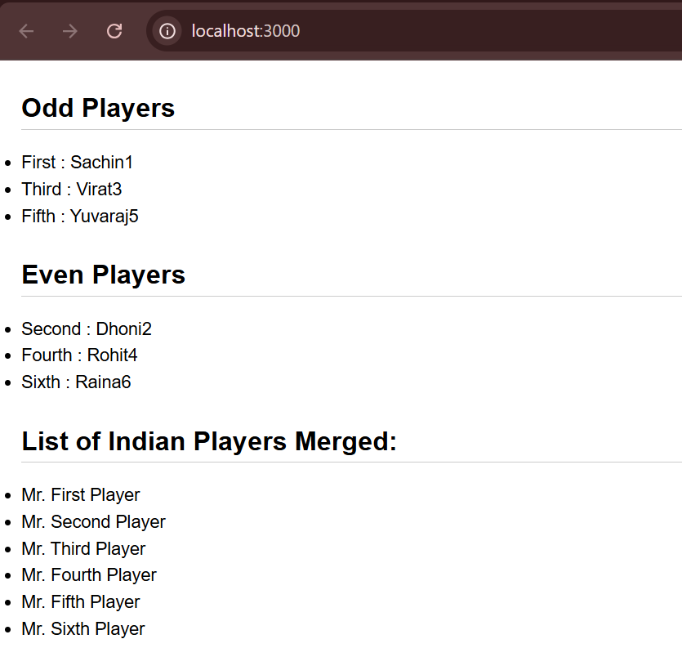 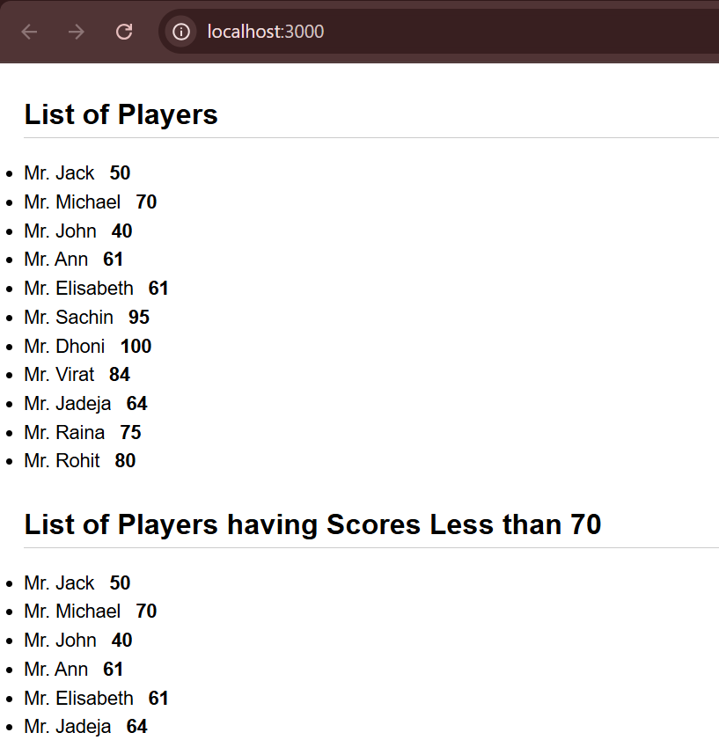

**Hands-On 10**

**Code**

**//File : OfficeSpace.css**

.textRed {

  color: red;

}

.textGreen {

  color: green;

}

**//File : App.js**

import React from 'react';

import './OfficeSpace.css';

import officeImg from './office.jpeg';

function App() {

  const element = "Office Space";

  // Single office item

  const ItemName = { Name: "DBS", Rent: 50000, Address: "Chennai" };

  // Decide color based on Rent

  let colors = [];

  if (ItemName.Rent <= 60000) {

    colors.push('textRed');

  } else {

    colors.push('textGreen');

  }

  return (

    <div className="App">

      <h1>{element} , at Affordable Range</h1>

      <img src={officeImg} width="25%" height="25%" alt="Office Space" />

      <h2>Name: {ItemName.Name}</h2>

      <h3 className={colors.join(' ')}>Rent: Rs. {ItemName.Rent}</h3>

      <h3>Address: {ItemName.Address}</h3>

    </div>

  );

}

export default App;

**Output**

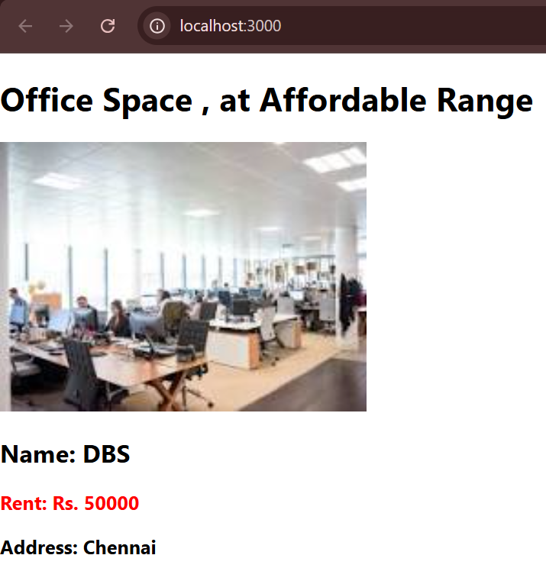

**Hands-On 11**

**Code**

**//File : CurrencyConvertor.js**

import React, { useState } from 'react';

function CurrencyConvertor() {

  const [rupees, setRupees] = useState('');

  const [currency, setCurrency] = useState('');

  const rates = {

    euro: 90,

    dollar: 75,

    yen: 0.6

  };

  const handleSubmit = () => {

    const rate = rates[currency.toLowerCase()];

    if (rate) {

      const converted = (parseFloat(rupees) / rate).toFixed(2);

      alert(`Converted amount: ${converted} ${currency}`);

    } else {

      alert("Currency not supported! Try euro, dollar, or yen.");

    }

  };

  return (

    <div style={{ marginTop: '20px' }}>

      <h2 className='currency-convertor-heading'>Currency Converter !!</h2>

      <div style={{ margin: '10px 0' }}>

        <label style={{ marginRight: '10px' }}>Rupees:</label>

        <input

          type="number"

          placeholder="Amount"

          value={rupees}

          onChange={(e) => setRupees(e.target.value)}

        />

      </div>

      <div style={{ margin: '10px 0' }}>

        <label style={{ marginRight: '10px' }}>Currency:</label>

        <textarea

          rows="1"

          placeholder="Currency"

          value={currency}

          onChange={(e) => setCurrency(e.target.value)}

        />

      </div>

      <button onClick={handleSubmit}>Convert</button>

    </div>

  );

}

export default CurrencyConvertor;

**//File : App.js**

import React, { useState } from 'react';

import './App.css';

import CurrencyConvertor from './CurrencyConvertor';

function App() {

  const [counter, setCounter] = useState(0);

  // multiple functions to be called when incrementing

  const increment = () => {

    setCounter(counter + 1);

  };

  const sayHello = () => {

    alert("Hello! Have a nice day!");

  };

  const handleIncrement = () => {

    increment();

    sayHello();

  };

  // decrement

  const decrement = () => {

    setCounter(counter - 1);

  };

  // say welcome with parameter

  const sayWelcome = (msg) => {

    alert(`Welcome: ${msg}`);

  };

  // synthetic event

  const handlePress = () => {

    alert("I was clicked");

  };

  return (

    <div className='App'>

      <div>

        {/* <h2>Counter Example</h2> */}

        <p>Counter: {counter}</p>

        <button onClick={handleIncrement}>Increment</button>

        <button onClick={decrement}>Decrement</button>

      </div>

      <div>

        {/* <h2>Say Welcome Example</h2> */}

        <button onClick={() => sayWelcome("welcome")}>Say Welcome</button>

      </div>

      <div>

        {/* <h2>Synthetic Event Example</h2> */}

        <button onClick={handlePress}>Click On Me</button>

      </div>

      <CurrencyConvertor />

    </div>

  );

}

export default App;

**Output**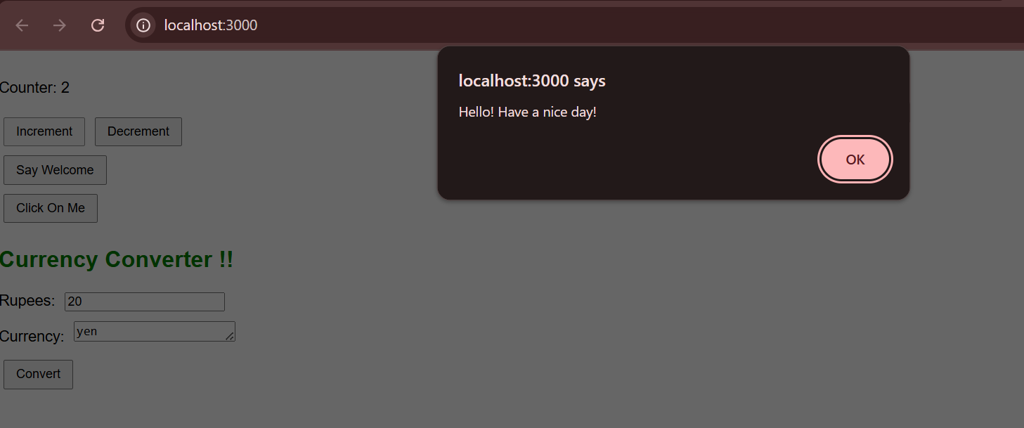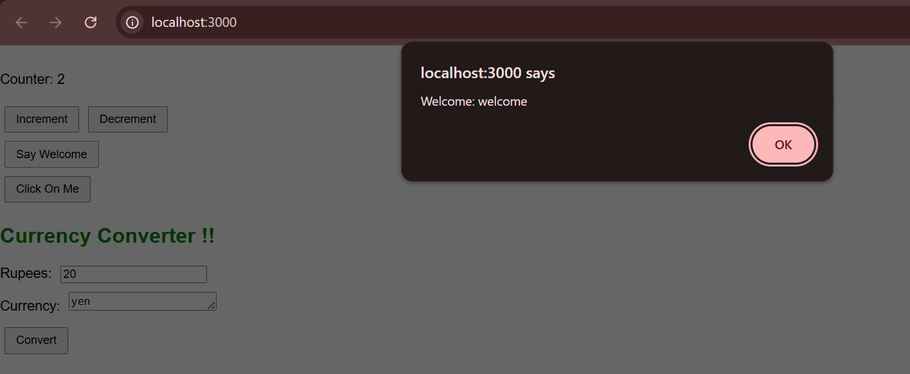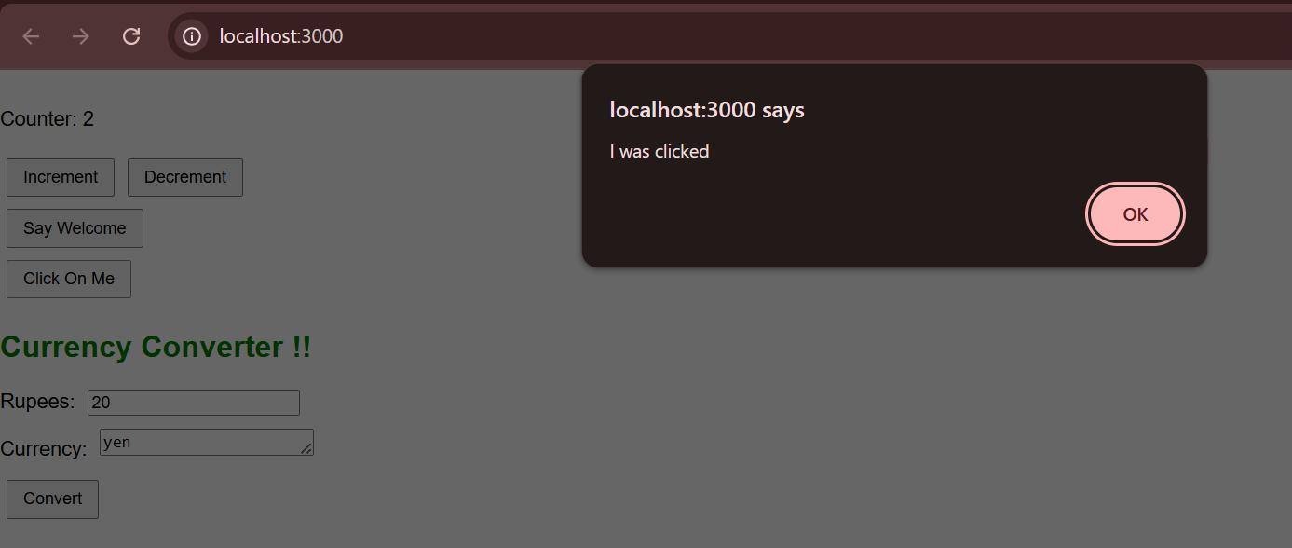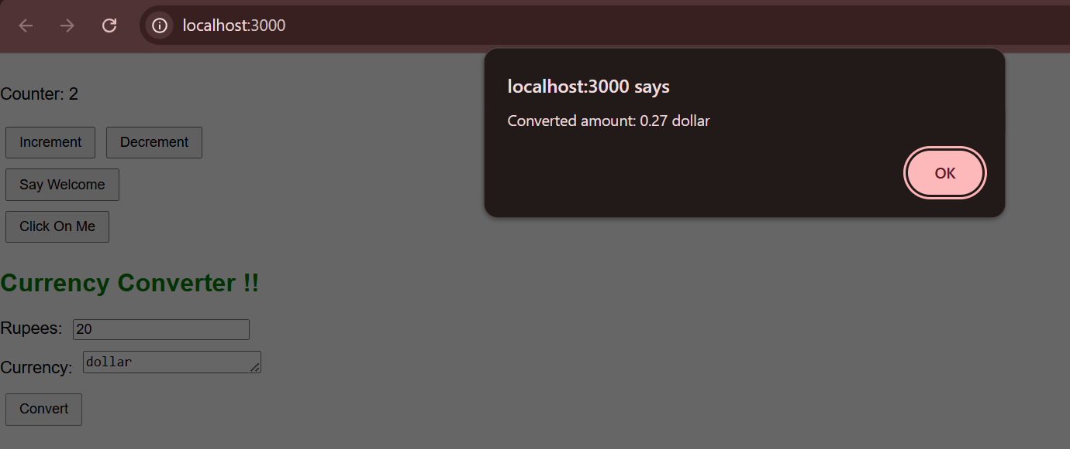

**Hands-On 12**

**Code**

**//File : Greeting.js**

import React from "react";

import UserGreeting from "./UserGreeting";

import GuestGreeting from "./GuestGreeting";

function Greeting(props) {

  const isLoggedIn = props.isLoggedIn;

  if (isLoggedIn) {

    return <UserGreeting />;

  }

  return <GuestGreeting />;

}

export default Greeting;

**//File : UserGreeting.js**

import React from "react";

function UserGreeting() {

return <h1>Welcome back</h1>;

}

export default UserGreeting;

**//File : GuestGreeting.js**

import React from "react";

function GuestGreeting() {

return <h1>Please sign up.</h1>;

}

export default GuestGreeting;

**//File : FlightList.js**

import React from "react";

function FlightList() {

return (

<div>

<h2>Available Flights:</h2>

<ul>

<li>Flight 101: New York to London</li>

<li>Flight 202: Paris to Tokyo</li>

<li>Flight 303: Sydney to Dubai</li>

</ul>

</div>

);

}

export default FlightList;

**//File : TicketBooking.js**

import React from "react";

function TicketBooking() {

return (

<div>

<h2>Book Your Ticket</h2>

<p>You are eligible to book tickets now.</p>

</div>

);

}

export default TicketBooking;

**//File : App.js**

import React, { useState } from "react";

import Greeting from "./Greeting";

import FlightList from "./FlightList";

import TicketBooking from "./TicketBooking";

function App() {

const [isLoggedIn, setIsLoggedIn] = useState(false);

const handleLogin = () => setIsLoggedIn(true);

const handleLogout = () => setIsLoggedIn(false);

return (

<div style={{ textAlign: "center", marginTop: "50px" }}>

<Greeting isLoggedIn={isLoggedIn} />

{isLoggedIn ? (

<>

<button onClick={handleLogout}>Logout</button>

<TicketBooking />

</>

) : (

<>

<button onClick={handleLogin}>Login</button>

<FlightList />

</>

)}

</div>

);

}

export default App;

**Output**

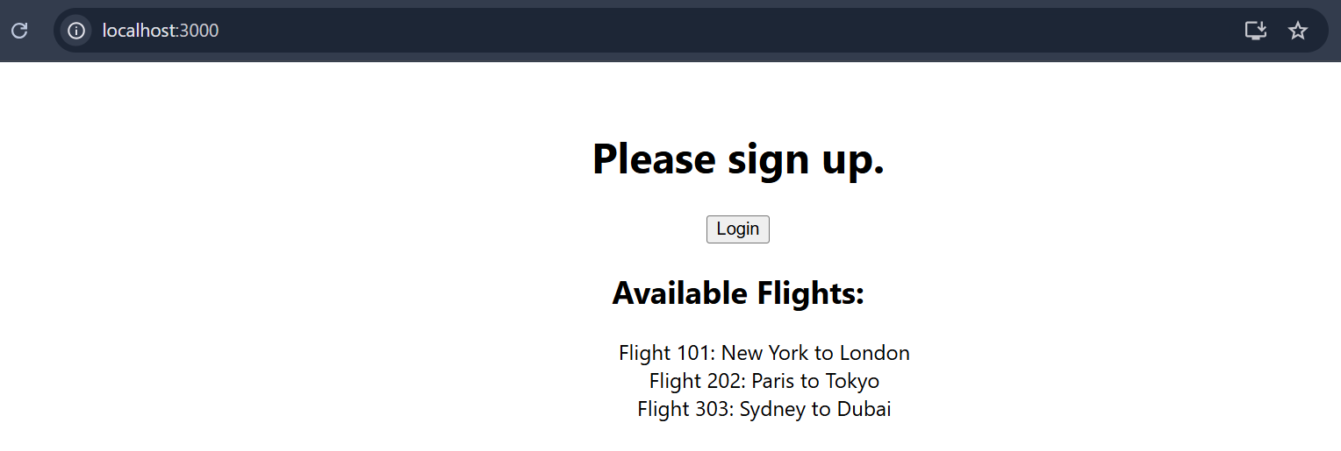

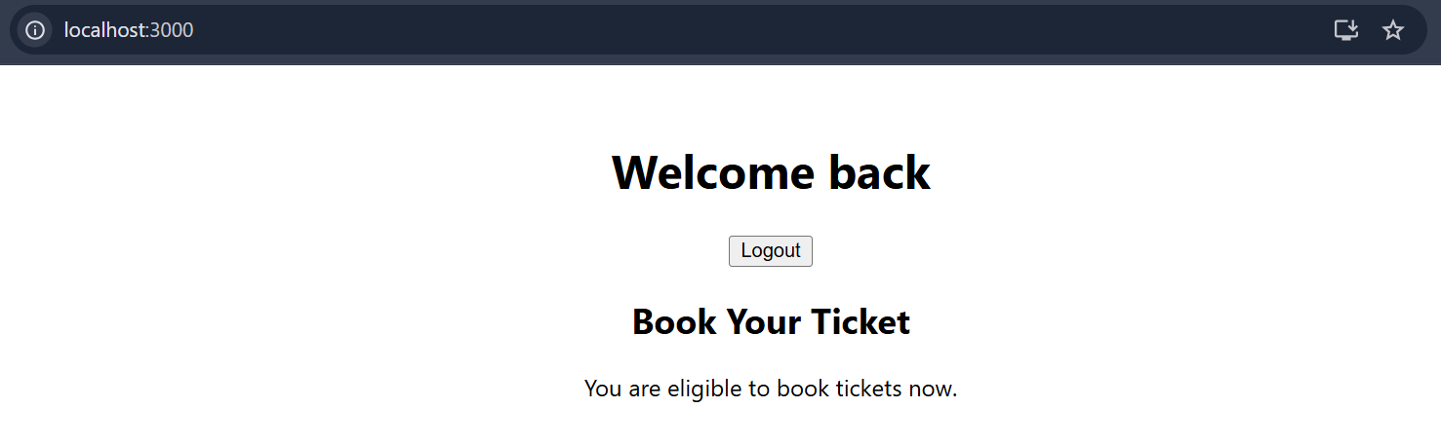

**Hands-On 13**

**Code**

**//File : components/BookDetails.js**

import React from "react";

function BookDetails({ books }) {

return (

<div className="section">

<h1>Book Details</h1>

{books.length > 0 ? (

books.map((book) => (

<div key={book.id}>

<h3>{book.bname}</h3>

<h4>{book.price}</h4>

</div>

))

) : (

<p>No books available.</p>

)}

</div>

);

}

export default BookDetails;

**//File : components/CourseDetails.js**

import React from "react";

function CourseDetails({ courses }) {

return (

<div className="section">

<h1>Course Details</h1>

{courses.length > 0 && courses.map((course, index) => (

<div key={index}>

<h3>{course.name}</h3>

<p>{course.date}</p>

</div>

))}

</div>

);

}

export default CourseDetails;

**//File : components/BlogDetails.js**

import React from "react";

function BlogDetails({ blogs }) {

return (

<div className="section">

<h1>Blog Details</h1>

{blogs.map((blog) =>

blog.isVisible ? (

<div key={blog.id}>

<h2>{blog.title}</h2>

<h4>{blog.author}</h4>

<p>{blog.content}</p>

</div>

) : null

)}

</div>

);

}

export default BlogDetails;

**//File : components/Data.js**

export const books = [

{ id: 101, bname: "Master React", price: 670 },

{ id: 102, bname: "Deep Dive into Angular 11", price: 800 },

{ id: 103, bname: "Mongo Essentials", price: 450 },

];

export const courses = [

{ name: "Angular", date: "4/5/2021" },

{ name: "React", date: "6/3/20201" },

];

export const blogs = [

{

id: 1,

title: "React Learning",

author: "Stephen Biz",

content: "Welcome to learning React!",

isVisible: true,

},

{

id: 2,

title: "Installation",

author: "Schewzdenier",

content: "You can install React from npm.",

isVisible: true,

},

];

**//File : App.css**

.container {

display: flex;

justify-content: space-around;

padding: 20px;

}

.section {

border-left: 4px solid green;

padding-left: 20px;

}

**//File : App.js**

import React, { useState } from "react";

import BookDetails from "./components/BookDetails";

import CourseDetails from "./components/CourseDetails";

import BlogDetails from "./components/BlogDetails";

import { books, courses, blogs } from "./components/Data";

import "./App.css";

function App() {

const [showBooks, setShowBooks] = useState(true);

const [showCourses, setShowCourses] = useState(true);

const [showBlogs, setShowBlogs] = useState(true);

return (

<div className="container">

{showCourses && <CourseDetails courses={courses} />}

{showBooks ? <BookDetails books={books} /> : <p>Books are hidden.</p>}

{showBlogs && blogs.length > 0 && <BlogDetails blogs={blogs} />}

</div>

);

}

export default App;

**Output**

