**Deploy Application on Cloud**

**Project objective:**

As a developer, deploy your Spring Boot application on Cloud.

**Screenshots**

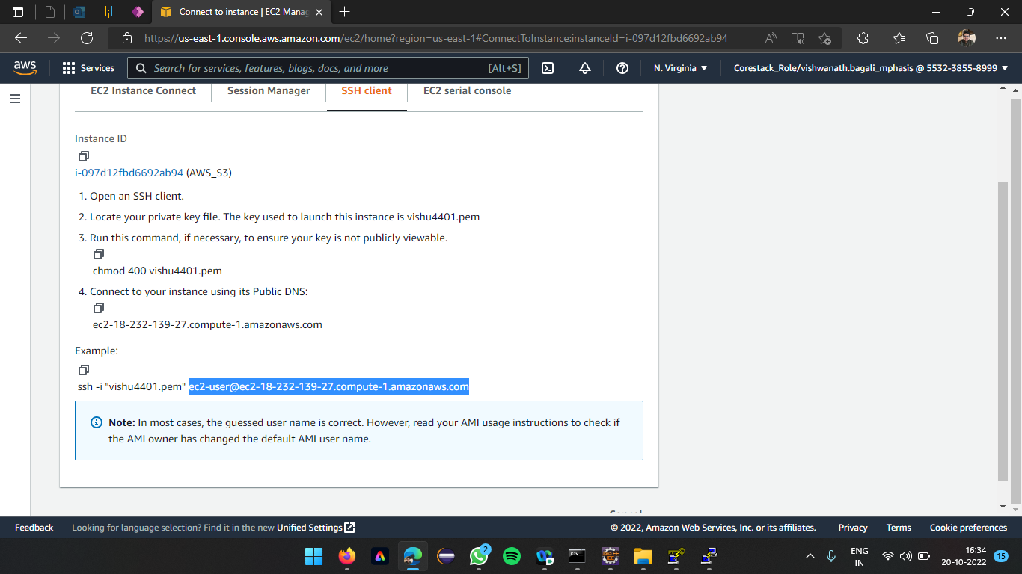

An instance named AWS_S3 is created, this highlighted text is used for connection

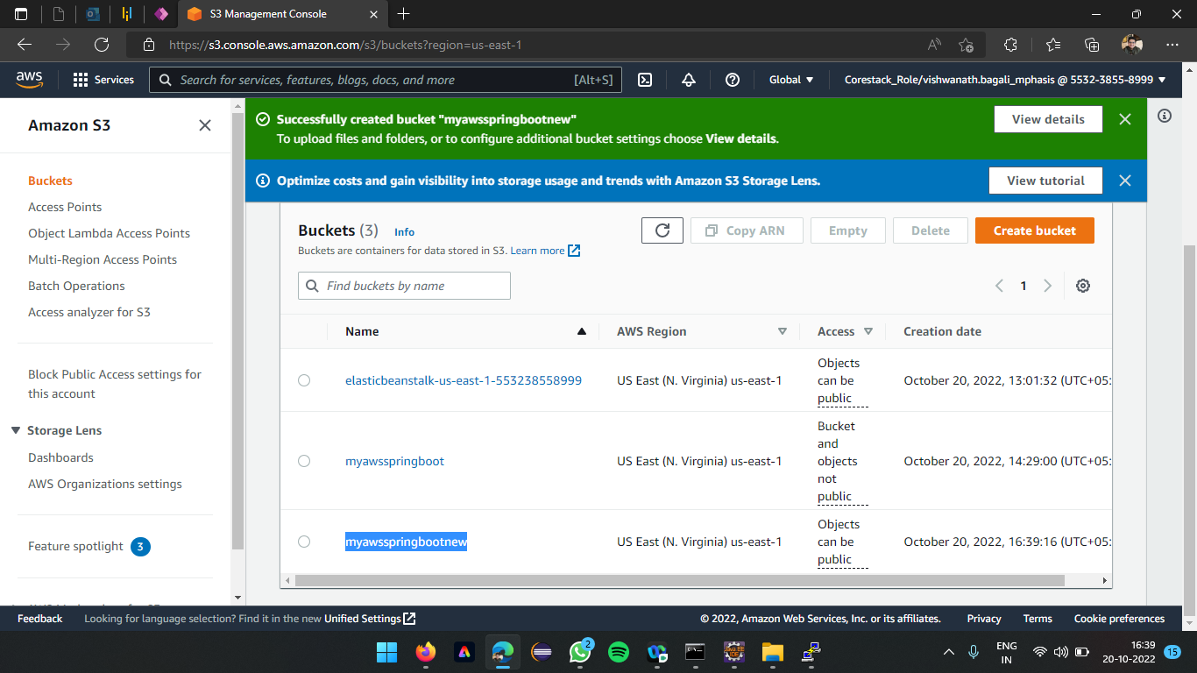

Bucket creation to upload the file(jar) and launch the connected instance

The jar file is uploaded into the s3 bucket (Status of file uploaded successfully)

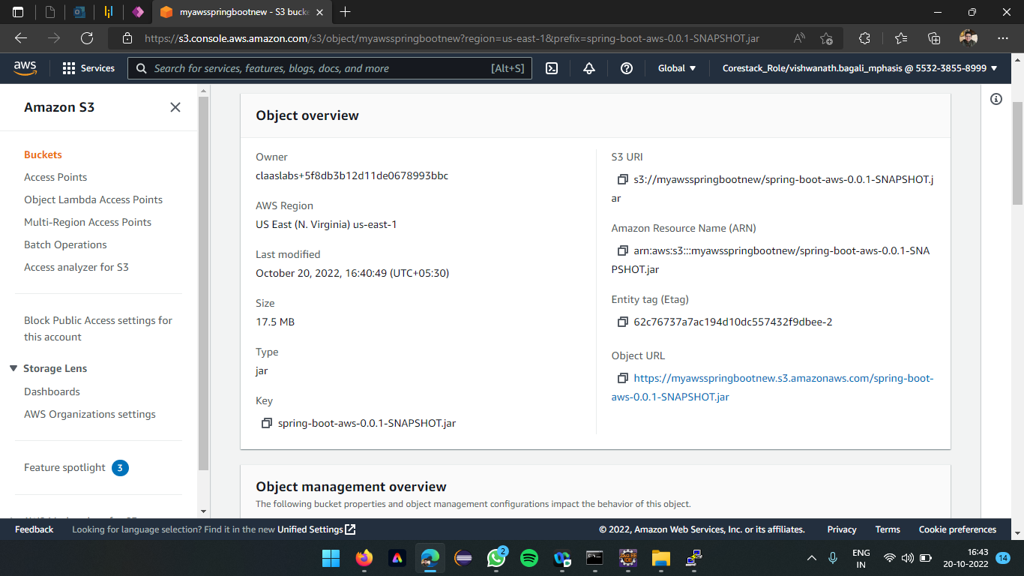

Object Overview of s3 bucket after file uploading, object URL can be used to fetch the file on cloud to deploy on to the cloud

Forbidden error after the trying to access the snapshot, due to the bucket is not provided to access publicly

After the Putty is provided with valid credentials the user is prompted for Security alert to launch the instance to run the commands

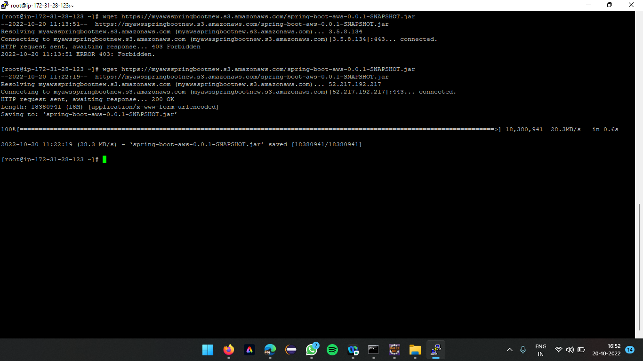

After successfully assign public permission to the bucket, the connection is successfully connected

ls command is used to check whether the file is fetched on the console, along with that the jar file is executed using the command java -jar spring-boot-aws-0.0.1-SNAPSHOT.jar

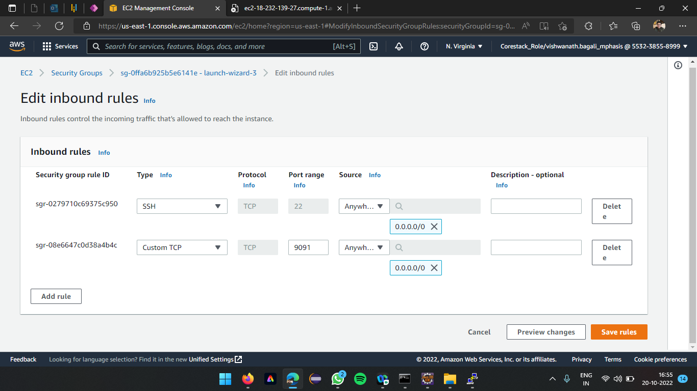

Edit inbound rule by adding the type Custom TCP with Port range 9091

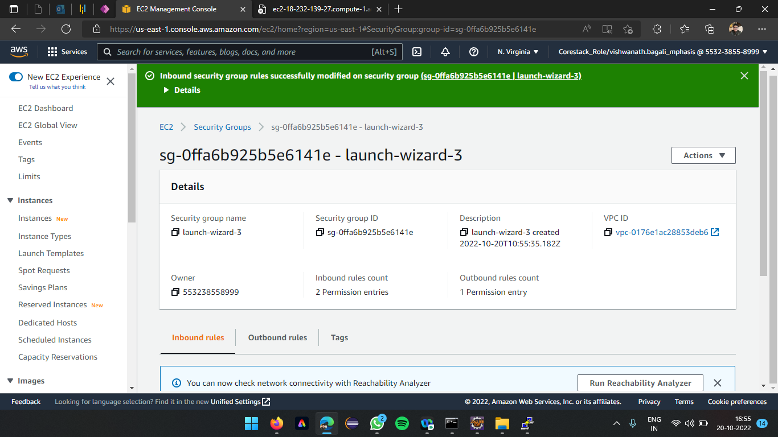

Save the rules, with security groups of inbound rules changed

Output of the instance launched with an IP address 18.232.139.27 and port number 9091