**Phase-5**

**Deploying ELK Stack on Docker Container**

**DESCRIPTION**

**Project objective:**

You have to deploy ELK Stack on a Docker container to implement continuous monitoring.

**Screenshots**

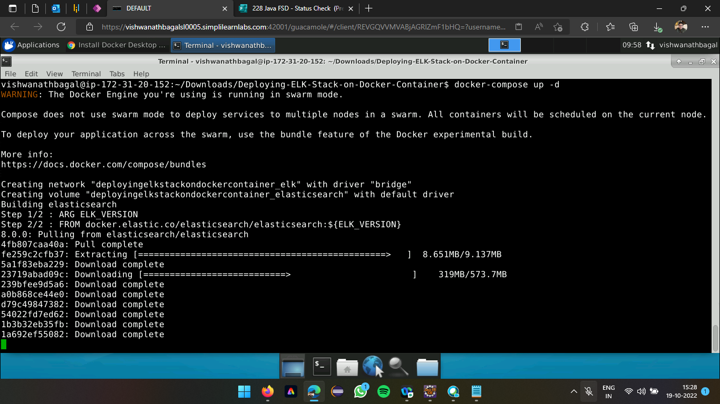

**Executing docker-compose up -d**

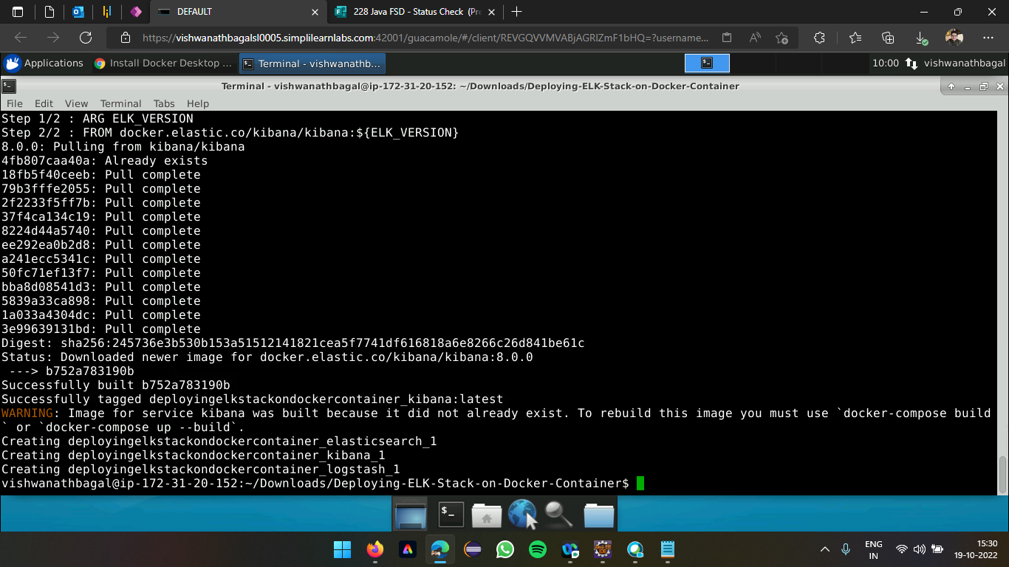

**Aggregating the containers (Elasticsearch, Logstash, Kibana)**

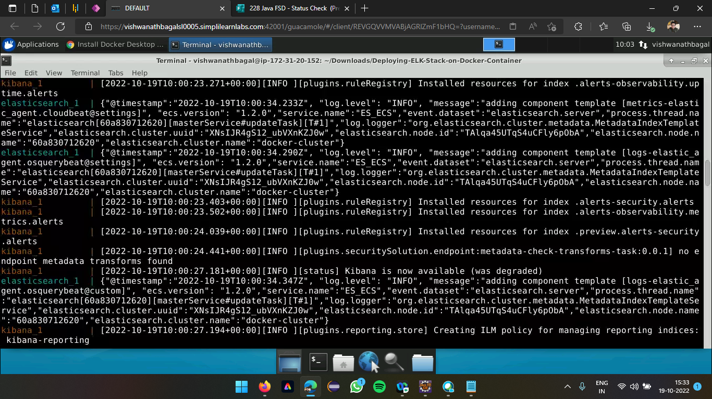

**Installation of resources for ELK (Kibana)**

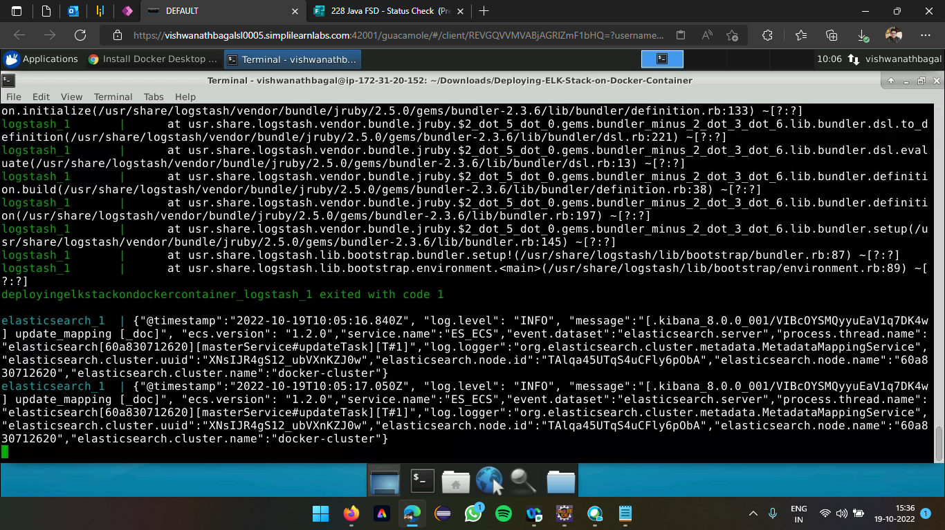

**Installation of resources for ELK (Logstash)**

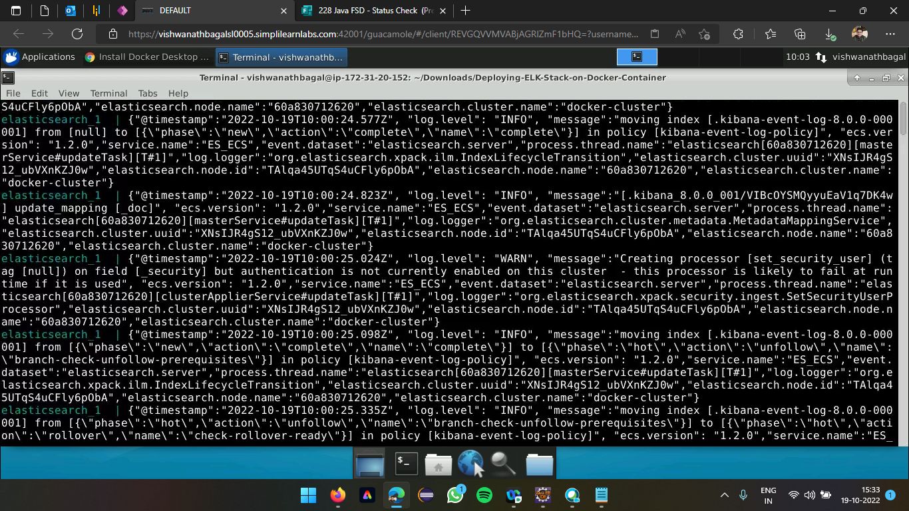

**Installation of resources for ELK (Elasticsearch)**

**Accessing the Kibana through browser using localhost:5601**

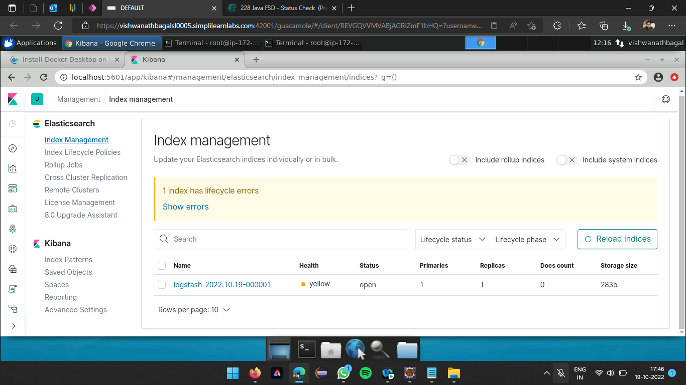

**Index management of Kibana displaying status of Logstash launched**

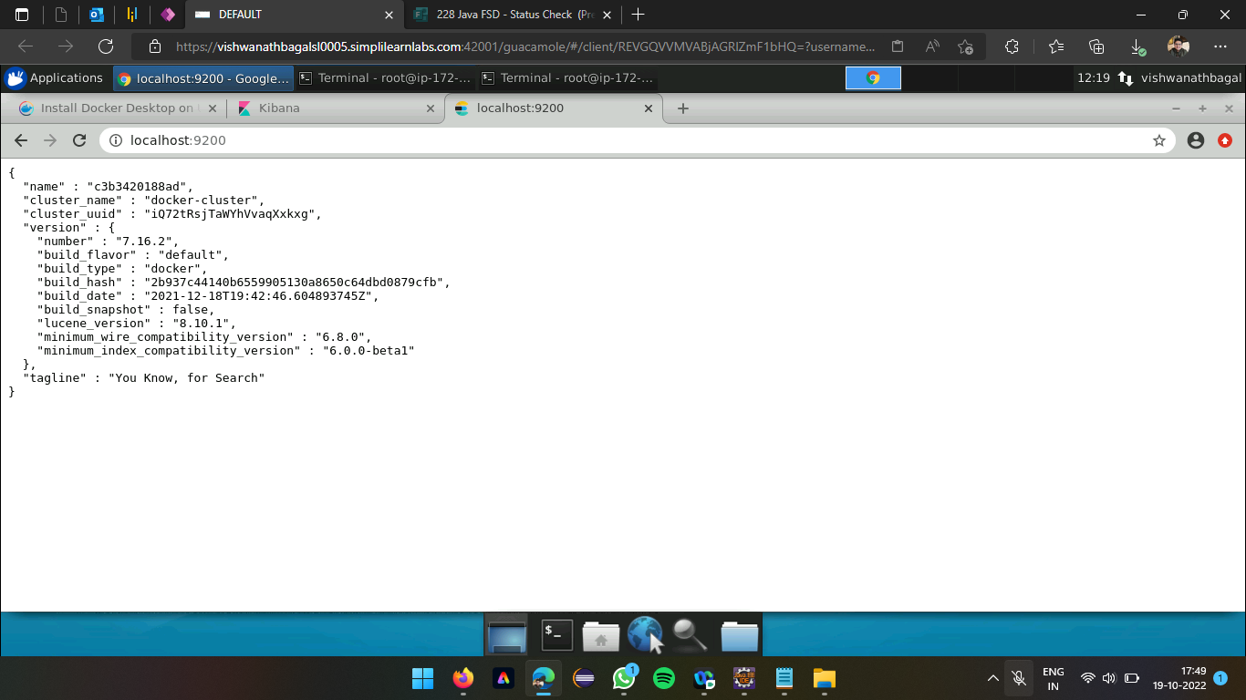

**Container details of Elasticsearch after resources installation**

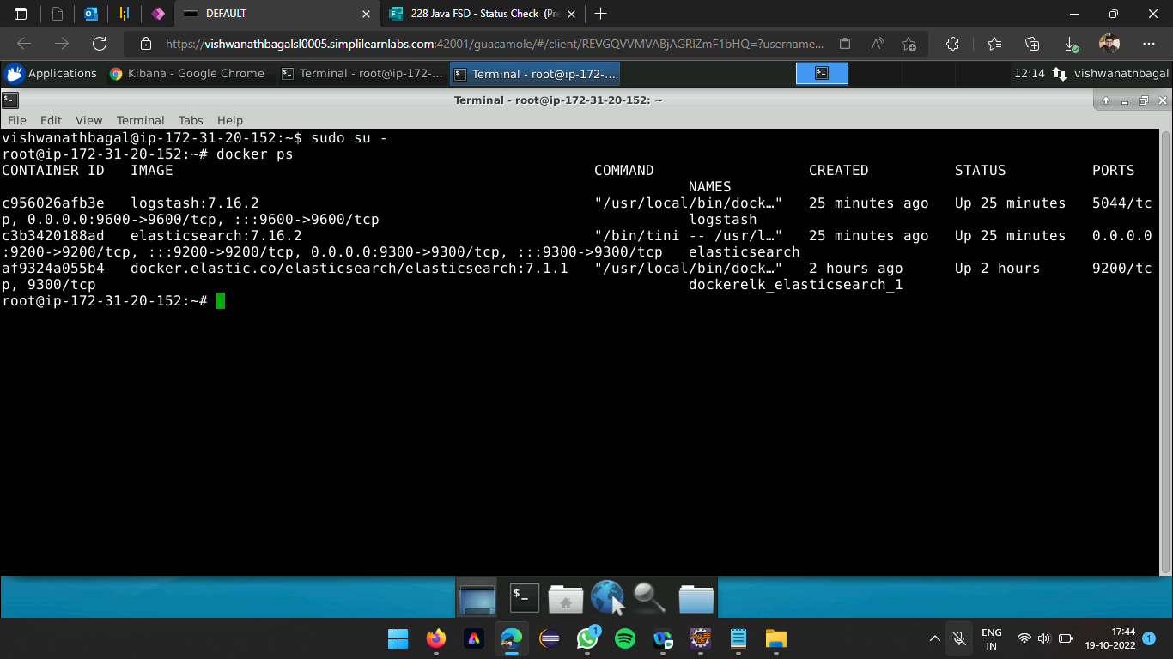

List containers. The "size" information shows the amount of data (on disk) that is used for the writable layer of each containerloaded using docker ps command