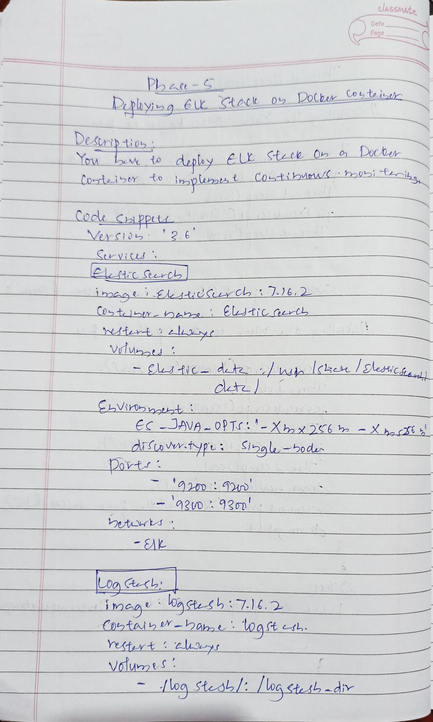
elasSMAte

Date
Page

 | PhaS |  |  |  | Cotoi
RDy |  | 6 | toce 02 ^{DoCho} |  | Cotoi
Destripi0 |  |  | ELE Stce O |  | cer
Ic | to depley |  |  |  | cer
Ic |  |  |  |  | itL .
Cortei5eY | to | iplets |  | COLtibvir | itL .

Cocle CPprt
Versio 2.6

Suyic

Vlunt

CLVinbbalt
EC-JAVA -OPTS:-Xhx 2K6 2 -Xha

dis w.fype: Sjhalu-bodur
Dovts

20: 93o

EAL

imea aFtush:716.2

VolumtS

/loq stedb/: /oa stsb-div

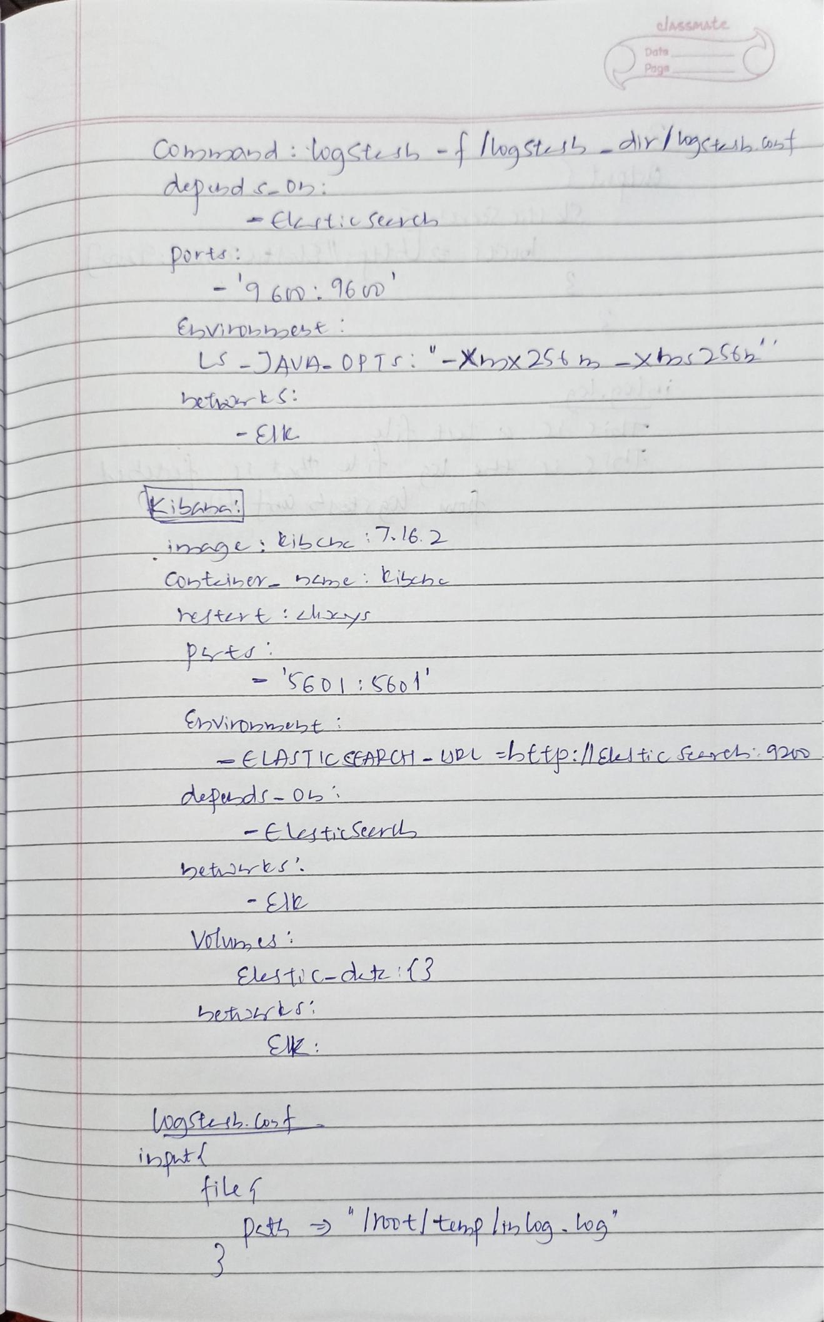
olssmate
Date
Page

_{CO hobod:} wasta Ab -/ogSts dr/sb a
- d c Db

Ports
'6 6 v

-AVA-OP7 -Xhx 25 - xhotSt

- El

Contein btmeLLh

hutrt:hyr

-S6D S6ol-

iDnavhti-
- E LAST IC CEAPC-UDL =bffp:lgltic cee 24

dwpd - 0

-Elustr Steri

heth es'

Valwn ts
EsLi - dt {3

ibt

kiu

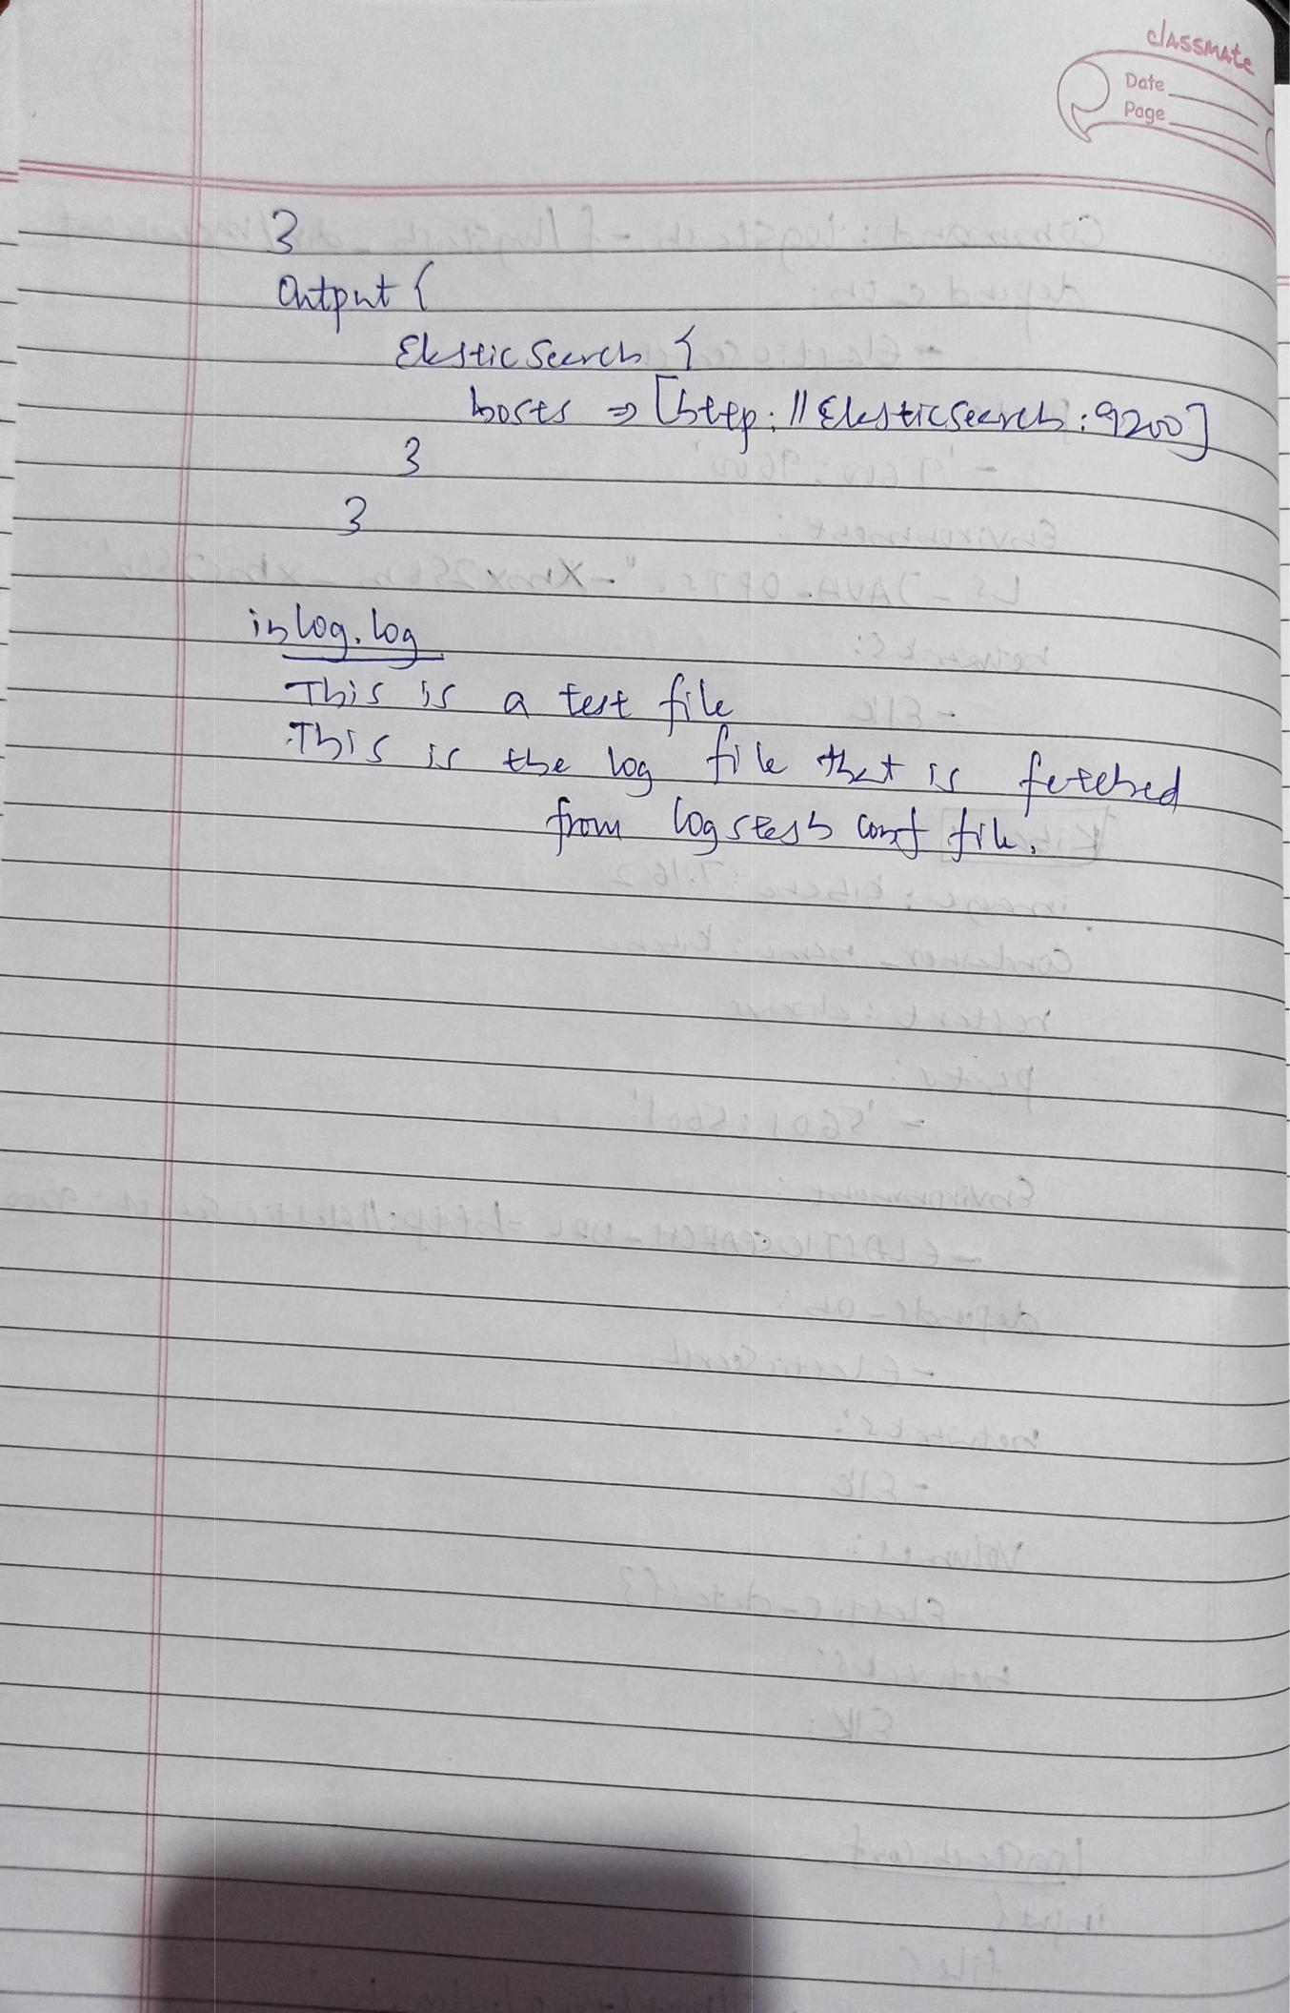

tput

 | bcts |  | Lttp:EAAticSe
2
i loa. log | X
Thi | a | tut
15ii | th | loa | t | i
_{Date}laSSMAte

Page

:92

tehud

