**CAPSTONE PROJECT - 2**

**Drive Your Way**

**DESCRIPTION**

Design and develop an online car selling and buying portal.

**Scenario:**

**Drive Your Way Ltd.** is a company working in the business of selling and buying old cars. However, due to the pandemic and lockdown, their business took a hit. They were not able to achieve the decided targets. So, they have decided to go online to increase the revenue.

**Screenshots**

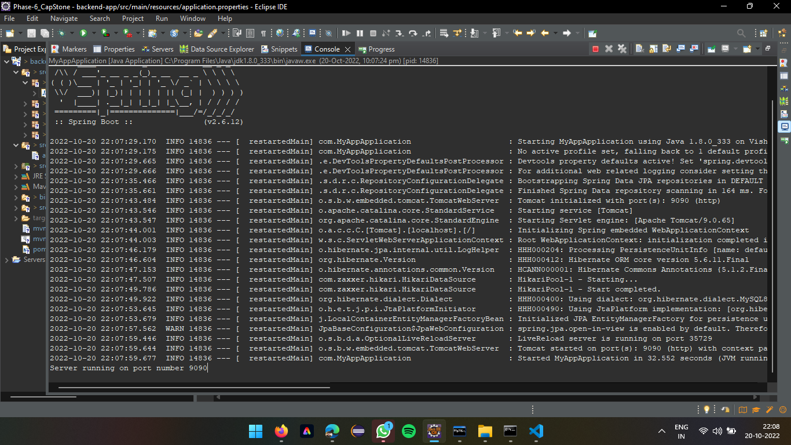

SpringBoot (Back-end) Application running successfully without any errors on Port number 9090

Angular (Front-end) Application running on VSC without any errors on Port number 4200

Login Page running on port number 4200

SpringBoot Application execution on Port 9090

Frontend Application SignUp Page

Signup as an admin is not possible, so an error is thrown to alert user to login as a user

User registration successful

LoginPage, the error displayed for invalid credentials entered by the user

Successful login of the User

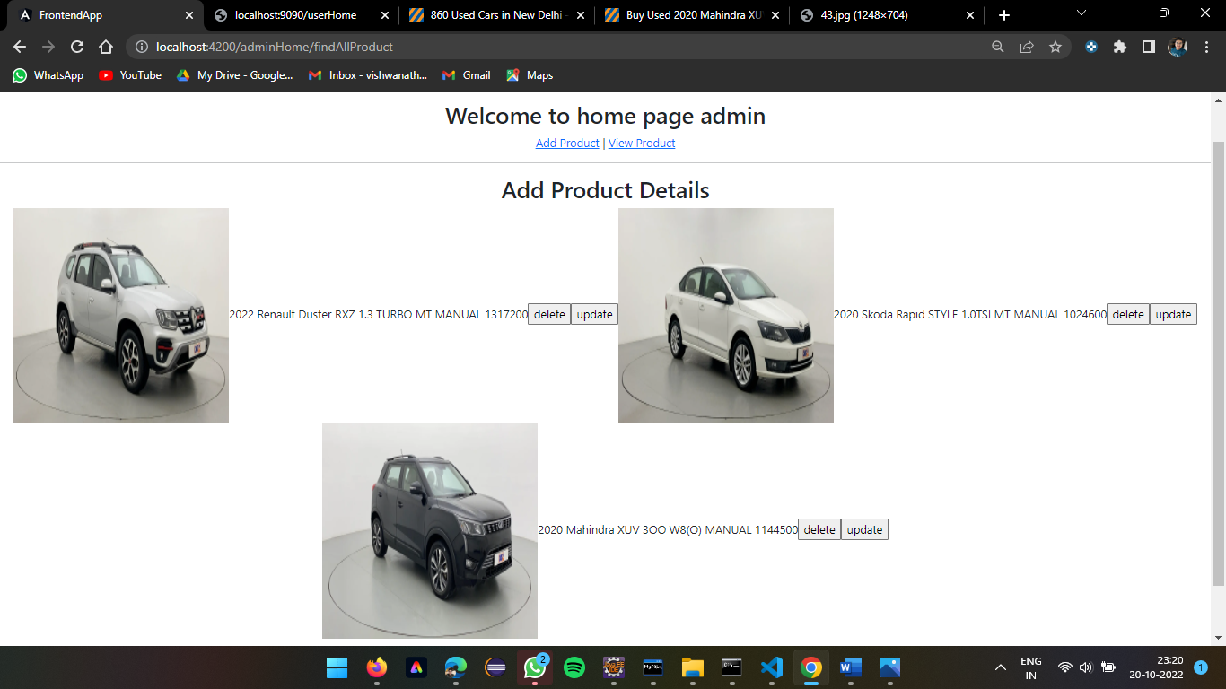

Adding cars into the Admin Page

Users can access the same products added by the admin and can buy them

Users can also add the cars so that the admin can modify or check them

Admin page displays the car added by the user and perform delete operation or update the car

MySql command line, displays the users registered and the cars added to the page