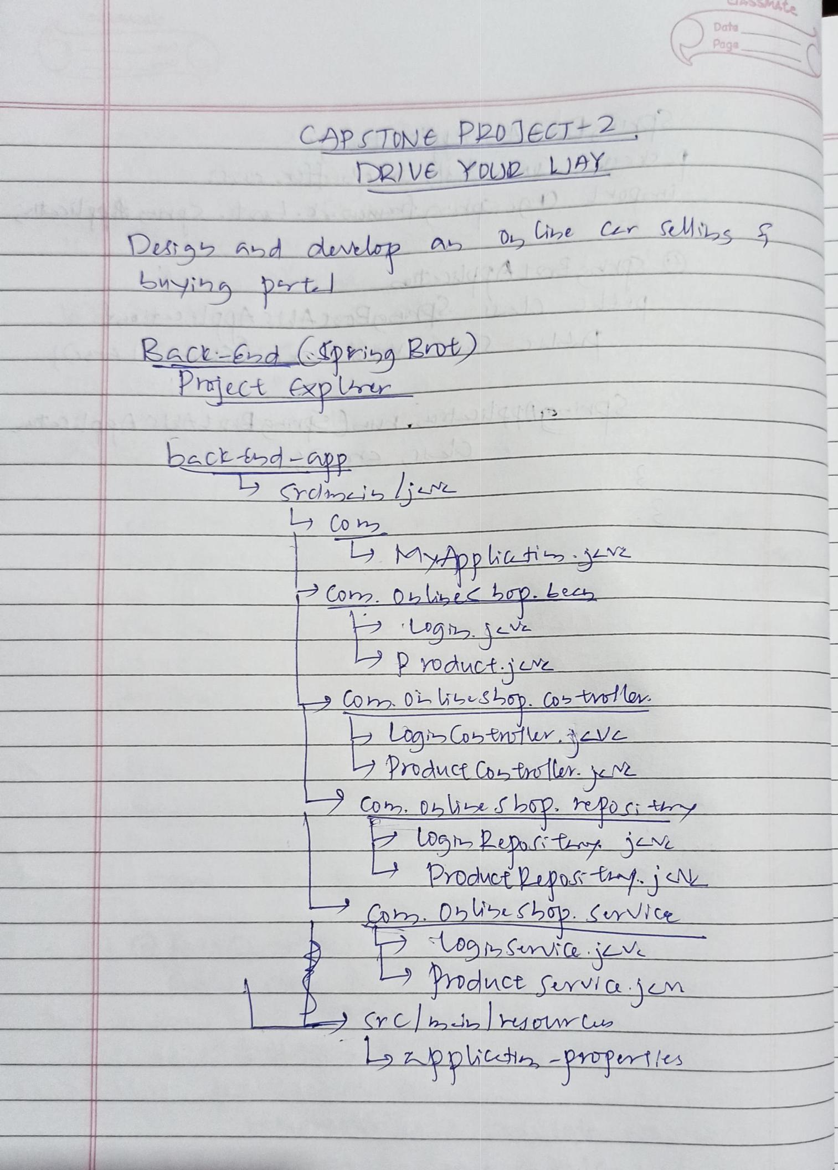
Data

Page

CAPSTUNe P2DJECT2

DR)VE YDUD LJAY

DAtab 6bd dnelap A

yihpt

Du ie Cer Uis S

Kac d pibg Rrot)
Preiect xplu

bectd-p

Co 2
MApp iai

ConDLlibi Lp. Lecs

yoduct jL
CO 0i Sboy. os olor

LogiCabtiur.àV
Prduct Cotl

Co. DbieShY. pocitoy

Product poK
0bW5uSh02. vlCe

mduce furviajm

bzpplittin, -PUpriles

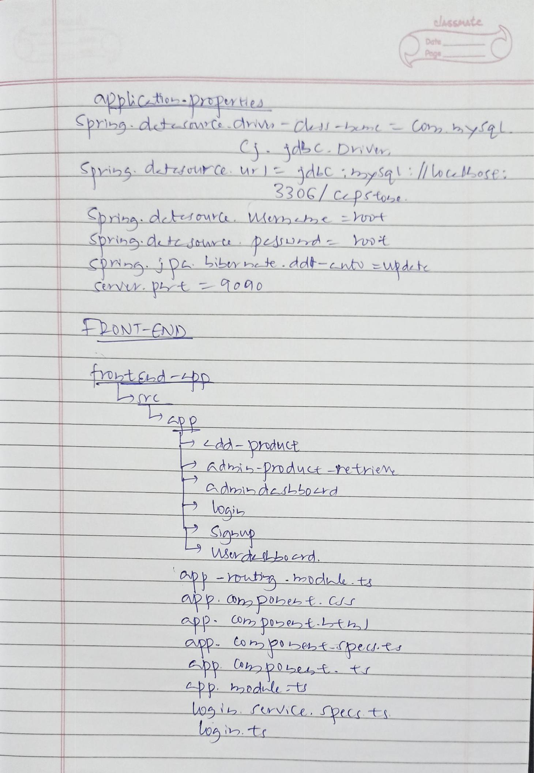
elssAte

Dathe
Pege

applicio-2rtperties
^{Sprig} dttnCe.driv-Cu-bmt Co byfgL
C dbC. DiVt
Spib dtticurCe ur ) dLCbySg\:/ o tMore
330G/C ptot
Spriba detsouC Menmbe t

SpYindte saiurt peADhd wot

PONT-END

otd

Ldd-Produt
Adhib-pnduct-tietie
dmibdeLboerd
Loai

Cp- ti -hebduk t

Pp (Oho Phebt. CJS

app Om Doebt . thl
^{ORp} ^{Co} P0eh{-[pe.cd. Rs

uoeb frvice, pect

Lo i .t

