AICTE | IBM SkillsBuild
Data Analytics with AI Internship 2026
PROJECT REPORT
Customer Churn Analysis and Prediction
Using the IBM Telco Customer Churn Dataset
Submitted by: Vishuddhi Jain
Institute: Jaypee Institute of Information Technology, Noida
Program: B.Tech Information Technology
Date: 23 October 2026

Abstract
Telecom companies lose a large share of their customers every year, and winning a new customer costs more than keeping an existing one. This project studies the IBM Telco Customer Churn dataset, which has 7,043 customers and 21 columns, to understand which customers leave and to predict who is likely to leave next.
The data was cleaned, explored with charts, and used to train three models: Logistic Regression, Random Forest and Gradient Boosting. All three reach a ROC-AUC of about 0.84 on unseen data. Random Forest was chosen as the final model because it finds about 75% of the customers who actually churn while keeping a reasonable number of false alarms.
The analysis shows that churn is concentrated among month-to-month customers, customers in their first year, fiber optic users, and customers paying by electronic check. Customers without tech support or online security also leave more often. Based on these results, the report suggests practical retention steps and shows how the model can score customers into Low, Medium and High risk groups.

1. Introduction
Customer churn means a customer stops using a company's service. For a subscription business such as a telecom provider, every lost customer takes away monthly income, and replacing that customer through marketing and sign-up offers is expensive. If the company knows early which customers are likely to leave, it can contact them with an offer or fix a problem before they go.
This project uses data analytics and machine learning to answer two questions: what do customers who leave have in common, and can we predict them in advance?

2. Objectives
- Clean and understand the Telco customer data.
- Find the factors most closely linked to churn using charts and summary statistics.
- Build and compare machine learning models that predict churn.
- Identify the most important features behind the predictions.
- Turn the findings into clear actions the business can take.

3. Dataset
The dataset is the IBM Telco Customer Churn sample data, available at github.com/IBM/telco-customer-churn-on-icp4d. Each row is one customer. The columns fall into four groups:
- Customer details: gender, senior citizen, partner, dependents.
- Services: phone service, multiple lines, internet service type, online security, online backup, device protection, tech support, streaming TV and streaming movies.
- Account details: tenure in months, contract type, paperless billing, payment method, monthly charges, total charges.
- Target: Churn (Yes or No).
Of the 7,043 customers, 1,869 churned, which is a churn rate of 26.5%. This means the classes are imbalanced, with roughly one churner for every three customers who stay.

4. Tools and Technologies
Tool | Use in this project
Python 3 | Programming language
pandas, NumPy | Loading, cleaning and transforming data
Matplotlib, Seaborn | Charts and visualisation
scikit-learn | Model training, cross-validation and evaluation
Jupyter Notebook | Running the code and presenting results

5. Methodology

5.1 Data cleaning
The TotalCharges column was stored as text because 11 rows contained a blank space. All 11 were new customers with a tenure of 0 months who had not been billed yet, so their total charges were set to 0 and the column was converted to numbers. There were no duplicate customer IDs and no other missing values. Churn was converted to 1 and 0, and the SeniorCitizen column was changed from 1 and 0 to Yes and No so it is treated like the other category columns.

5.2 Exploratory data analysis
Churn rates were compared across contract type, internet service, payment method, support services, billing type and tenure. The distributions of tenure, monthly charges and total charges were compared between customers who stayed and those who left.

5.3 Feature preparation
The customer ID was dropped because it carries no information. Category columns were converted to 0/1 columns using one-hot encoding, which gave 30 input features. The data was split 80/20 into training and test sets (5,634 and 1,409 customers), keeping the same churn rate in both. The three numeric columns were scaled for Logistic Regression. During cross-validation, scaling is fitted within each training fold so validation-fold statistics do not leak into preprocessing.

5.4 Models
Three models were trained: Logistic Regression, Random Forest (300 trees) and Gradient Boosting. Logistic Regression and Random Forest used balanced class weights so the smaller churn group is not ignored. Because most customers do not churn, accuracy alone can look good even for a weak model, so the models were also compared on precision, recall, F1 score and ROC-AUC.

6. Results and Analysis

6.1 What the data shows
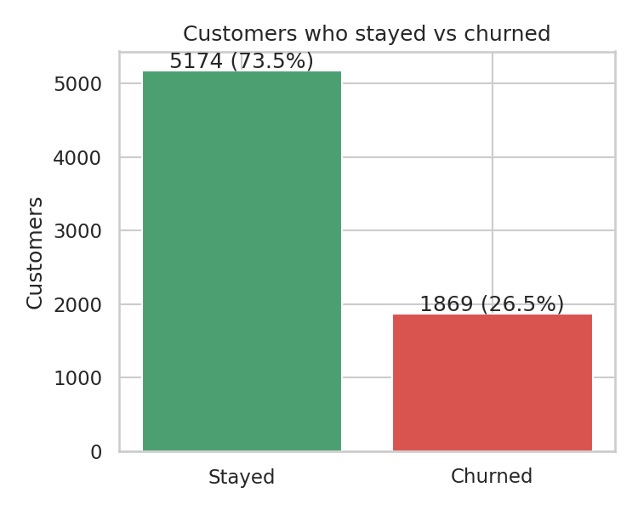
Figure 1: Customers who stayed and customers who churned
Overall, 26.5% of customers churned. The charts below show how that rate changes between groups.
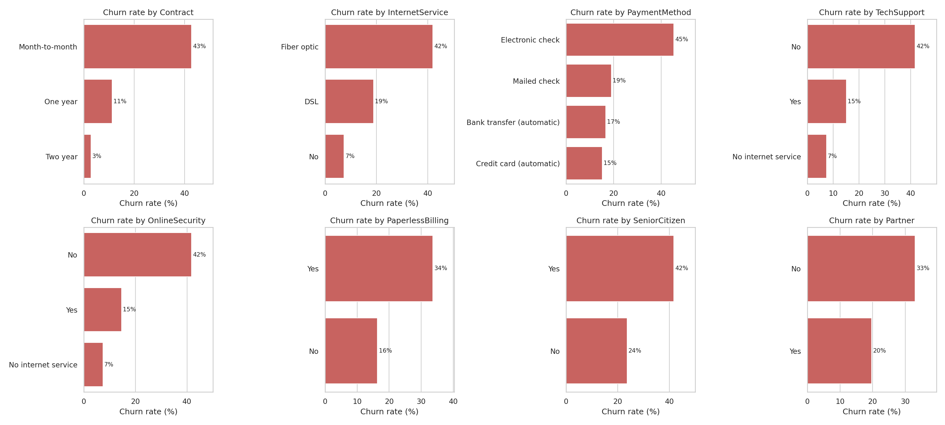
Figure 2: Churn rate by customer and service attributes
Factor | Group | Churn rate
Contract | Month-to-month | 42.7%
 | One year | 11.3%
 | Two year | 2.8%
Internet service | Fiber optic | 41.9%
 | DSL | 19.0%
 | No internet | 7.4%
Payment method | Electronic check | 45.3%
 | Mailed check | 19.1%
 | Bank transfer (automatic) | 16.7%
 | Credit card (automatic) | 15.2%
Tech support | No | 41.6%
 | Yes | 15.2%
Online security | No | 41.8%
 | Yes | 14.6%
Table 1: Churn rate by key factors
Contract type shows the biggest gap. Customers on month-to-month plans leave at more than fifteen times the rate of customers on two-year contracts. Fiber optic customers churn at more than twice the rate of DSL customers, even though they pay more. Customers who pay by electronic check churn at about three times the rate of customers on automatic payments. Customers without tech support or online security leave about 2.7 times as often as those who have them.
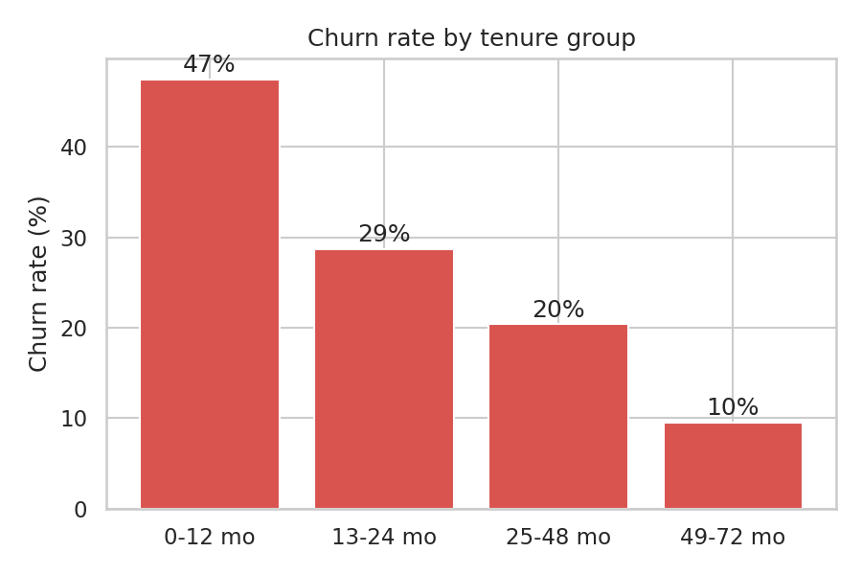
Figure 3: Churn rate by tenure group
Churn is highest in the first year (47.4%) and falls steadily to 9.5% for customers who have stayed more than four years. On average, customers who churned had been with the company for 18 months, compared with 37.6 months for those who stayed. They also paid more per month on average (74.4 compared with 61.3).
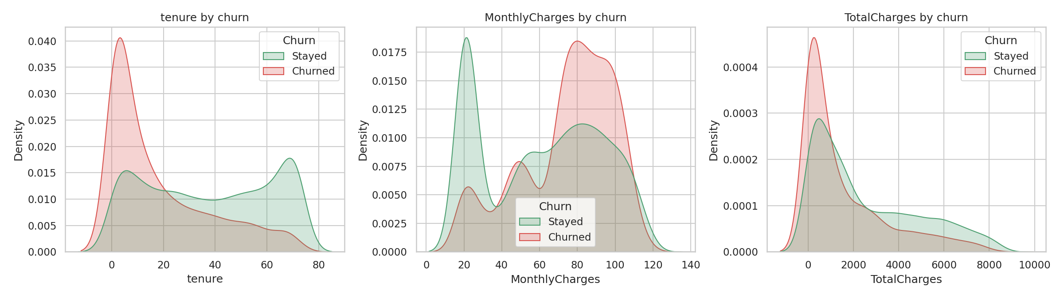
Figure 4: Tenure, monthly charges and total charges by churn

6.2 Model comparison
Model | Accuracy | Precision | Recall | F1 | ROC-AUC
Logistic Regression | 0.738 | 0.504 | 0.783 | 0.614 | 0.842
Random Forest | 0.774 | 0.556 | 0.749 | 0.638 | 0.844
Gradient Boosting | 0.798 | 0.655 | 0.508 | 0.572 | 0.842
Table 2: Test set performance of the three models
The three models have similar ROC-AUC on the held-out comparison split. Five-fold stratified cross-validation on the training split produced ROC-AUC values close to 0.85 for all three models in the saved run. The main practical difference is precision versus recall. Gradient Boosting has the highest accuracy, but catches only about half of churners. Logistic Regression catches the most churners but raises more false alarms. Random Forest has the best F1 score in the saved comparison and recall of about 0.75, so it is used for the remaining demonstration.
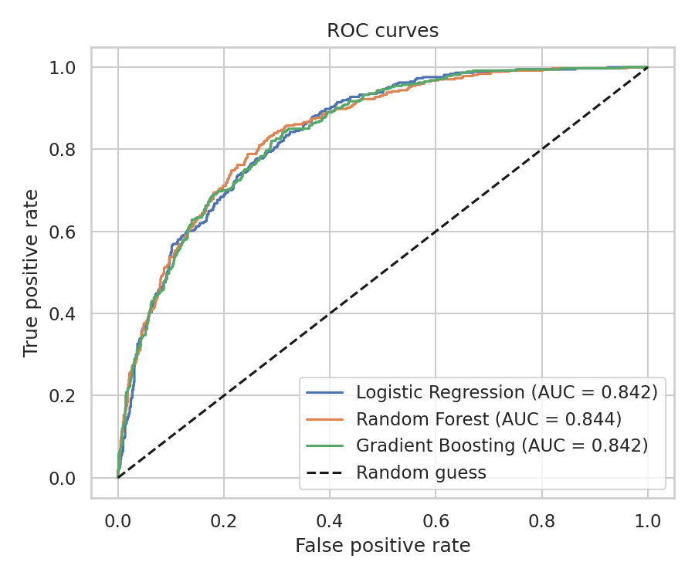
Figure 5: ROC curves for the three models

6.3 Final model performance
Class | Precision | Recall | Customers (test)
Stayed | 0.90 | 0.78 | 1,035
Churned | 0.56 | 0.75 | 374
Table 3: Random Forest results by class
The Random Forest correctly finds about 75% of the customers who churn. Its precision for the churn class is 0.56, which means roughly 56 out of every 100 customers it flags really do leave. For a retention campaign this is a reasonable trade-off, since contacting a customer who would have stayed anyway costs far less than losing one who leaves.
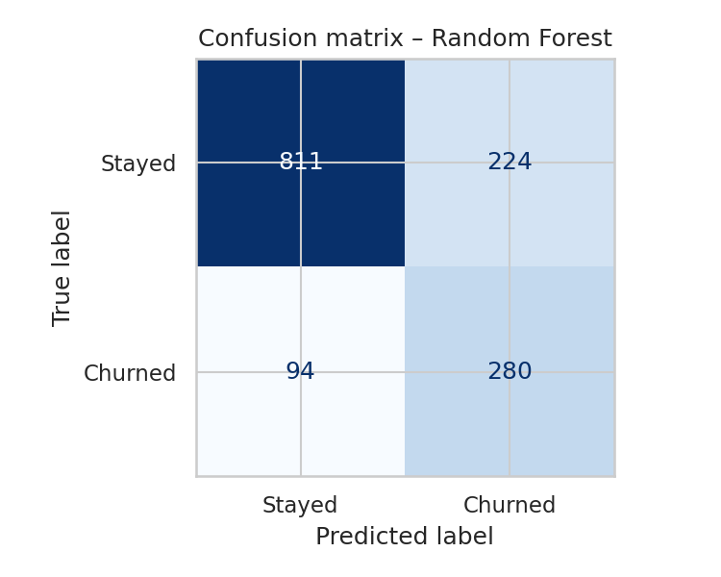
Figure 6: Confusion matrix for the Random Forest on the test set

6.4 Most important features
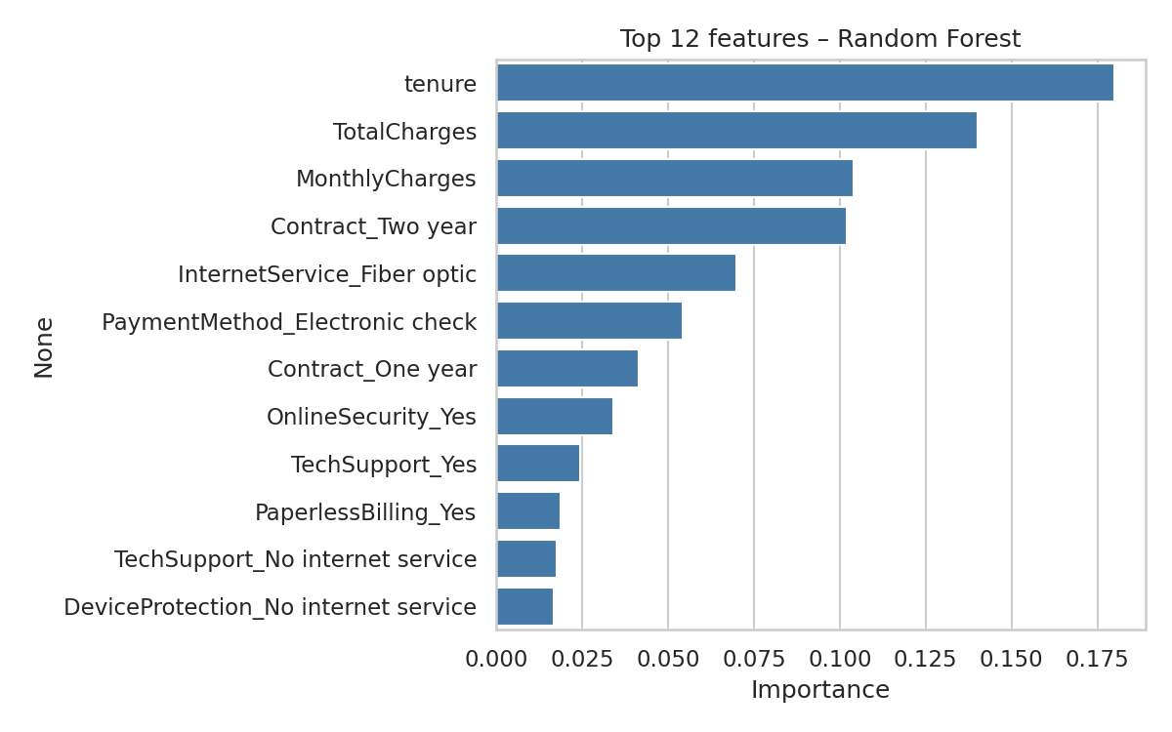
Figure 7: Top 12 features in the Random Forest
Tenure, total charges, monthly charges and contract type are the strongest predictors, followed by fiber optic internet and electronic check payment. The Logistic Regression coefficients agree: two-year and one-year contracts and longer tenure push the prediction towards staying, while fiber optic internet, electronic check payment, streaming services and paperless billing push it towards churning.

6.5 Customer risk scoring
To show how the model could be used, each customer in the test set was given a churn probability and placed in a risk band. Only test customers were used so the model had never seen them during training.
Risk band | Probability | Customers | Actual churn rate
Low | Below 0.3 | 685 | 7.0%
Medium | 0.3 to 0.6 | 351 | 28.0%
High | Above 0.6 | 373 | 61.0%
Table 4: Actual churn rate in each risk band (test set)
The bands separate customers clearly. Only 7% of Low risk customers left, compared with 61% of High risk customers. A retention team could start with the High band, which holds about a quarter of the test customers but most of the churn.

7. Recommendations
- Offer discounts or added value to move month-to-month customers to annual plans.
- Improve first-year onboarding with a welcome call and a check-in after the first bill.
- Investigate fiber service quality and value for money, given the higher churn rate in this group.
- Offer tech support and online security bundles or introductory trials.
- Consider a small incentive for switching from electronic checks to automatic payments.
- Prioritize high-risk customers for retention outreach and review false positives.

8. Limitations and Future Work
- This is a single historical snapshot; it shows associations rather than causes and omits complaints, outages, and competitor offers.
- Results come from one split and model choice uses that split’s F1, so performance may be optimistic. Use cross-validation or a validation set for selection and an untouched test set for final evaluation.
- Future work includes hyperparameter and threshold tuning, SHAP explanations, retention-cost analysis, a dashboard, and retraining/monitoring on recent data.

9. Conclusion
Churn is concentrated among month-to-month and short-tenure customers, fiber-optic users, electronic-check payers, and customers without support add-ons. In the saved 80/20 split, Random Forest achieved 0.774 accuracy, 0.749 churn recall, and 0.638 F1. The findings suggest targeted onboarding, contract incentives, and support offers, subject to validation on recent data.
References
IBM Telco Customer Churn dataset: https://github.com/IBM/telco-customer-churn-on-icp4d
Pedregosa et al. (2011), “Scikit-learn: Machine Learning in Python,” Journal of Machine Learning Research, 12.
pandas documentation: https://pandas.pydata.org/docs/; Seaborn documentation: https://seaborn.pydata.org/.

