B.tech. PROJECT-I (ICICC22) Report

On

ML Based Heart Disease Prediction OF Heart Disease Using Clinical Data

Submitted By
Palak Singh 2022UIC3522
Khusboo 2022UIC6519
Ankit Kumar Sharma 2022UIC3592
Vishal 2022UIC3613

Project-I in partial fulfillment of requirement for the award of B.Tech. in
Instrumentation & Control Engineering



Division of Instrumentation & Control Engineering
NETAJI SUBHAS UNIVERSITY OF TECHNOLOGY
NEW DELHI-110078
DECEMBER 2025

Netaji Subhas University OF Technology

Instrumentation And Control Engineering

CERTIFICATE OF ORIGINALITY
We hereby declare that the project report entitled ML Based Prediction OF Heart Disease Using Clinical Data submitted to Netaji Subhas University OF Technology in partial fulfillment of the requirements for the award of the degree in Instrumentation And Control Engineering, is a record of original work done by our team.
I further declare that the content of this report has not been submitted, in part or in full, to any other University or Institute for the award of any degree or diploma. All sources of information and data used in this report have been duly acknowledged and cited.
I understand that plagiarism is a serious academic offense and implies the presentation of another person's work as one's own. I accept full responsibility for the originality of the work submitted.
Date: 01 DECEMBER 2025 Place: NSUT

Signed By
Palak Singh 2022UIC3522
Khusboo 2022UIC6519
Ankit Kumar Sharma 2022UIC3592
Vishal 2022UIC3613

Abstract

Cardiovascular disease (CVD) remains the leading cause of global mortality, yet early detection is often hindered by the complexity of interpreting high-dimensional metabolic and demographic data. This study presents the development of a robust, end-to-end machine learning pipeline for predicting heart disease risk, leveraging data from the National Health and Nutrition Examination Survey (NHANES).
The methodology prioritized data integrity and interpretability. An initial exploratory data analysis (EDA) and feature engineering phase removed redundant multicollinear features and corrected legacy encoding inconsistencies. Unsupervised learning, specifically K-Means clustering (k=6), was utilized to discover latent patient profiles, revealing distinct risk archetypes driven by age-related hypertension versus metabolic syndrome (diabetes and obesity).
To address the significant class imbalance inherent in medical datasets (1:17 sick-to-healthy ratio), multiple supervised learning strategies were rigorously evaluated, including SMOTE (Synthetic Minority Over-sampling Technique) and class-weighted cost functions. Three distinct architectures were benchmarked: an Artificial Neural Network (ANN), Extreme Gradient Boosting (XGBoost), and Random Forest.
Results demonstrated that standard accuracy metrics were misleading due to the imbalance. While SMOTE-based approaches yielded high precision but poor recall, a Random Forest classifier optimized via Threshold Tuning emerged as the superior production model. By manually calibrating the decision threshold to 0.26, the final model achieved a Recall of 81% with a manageable False Positive rate, effectively prioritizing patient safety over raw accuracy. This project establishes a scalable, explainable framework for ML-assisted diagnostic screening, successfully balancing the trade-off between sensitivity and specificity in a clinical context.

Table of Contents

1. Introduction .................................................................................................................. 1
- 1.1 Problem Statement
- 1.2 Objectives
- 1.3 Scope of the Study
2. Literature Review ........................................................................................................ 3
- 2.1 Overview of Cardiovascular Disease Prediction
- 2.2 Existing Machine Learning Approaches
- 2.3 Limitations of Current Models
3. Data Acquisition and Understanding ..................................................................... 5
- 3.1 Dataset Description
- 3.2 Feature Dictionary
- 3.3 Initial Data Quality Assessment
4. Data Preprocessing and Feature Engineering ..................................................... 8
- 4.1 Data Cleaning & Handling Missing Values
- 4.2 Addressing Legacy Encoding Issues
- 4.3 Feature Selection & Redundancy Removal
- 4.4 Data Scaling & Normalization
- 4.5 Handling Class Imbalance
5. Exploratory Data Analysis (EDA) .......................................................................... 11
- 5.1 Statistical Distributions
- 5.2 Correlation Analysis
- 5.3 Unsupervised Learning: Patient Clustering
  - 5.3.1 K-Means Clustering Results
  - 5.3.2 Identification of Risk Profiles
6. Methodology ............................................................................................................... 14
- 6.1 Experimental Setup (Train/Test Split 80:20)
- 6.2 Model Architectures
  - 6.2.1 Artificial Neural Network
  - 6.2.2 Extreme Gradient Boosting
  - 6.2.3 Random Forest Classifier
- 6.3 Evaluation Metrics
7. Results and Discussion ............................................................................................ 16
- 7.1 Comparative Analysis of Models
- 7.2 The Failure of SMOTE
- 7.3 Optimization of the Random Forest
- 7.4 Final Model Performance
- 7.5 Feature Importance Analysis
8. Conclusion ................................................................................................................. 21
- 8.1 Summary of Findings
- 8.2 Clinical Implications
- 8.3 Future Work
9. References ................................................................................................................. 23
10. Appendix .................................................................................................................. 24
- A.1 Python Source Code
- A.2 Full Cluster Profile Tables

List of Figures
Figure 4.1 Missing Values Map ……………………………………………..………………………………….8
Figure 4.2: Correlation Heatmap of Original Features (Identifying Redundancy) ..........………………………9
Figure 5.1: Histograms of Key Medical Indicators (Age, BMI, Glucose) ..........................................................11
Figure 5.3.A: The Elbow Method & Silhouette Score Analysis for K-Means .....................................................12
Figure 5.3.B: PCA Visualization of Patient Clusters (k=6) ..................................................……………..……..13
Figure 6.1: Neural Network Learning Curves (Loss vs. Epochs & Recall vs Epoch) .........................................14
Figure 7.1.A: Confusion Matrix: Artificial Neural Network (Weighted Penalty 15) ..........................................16
Figure 7.1.B: Score Vs Penalty: Artificial Neural Network…………………………………………………….16
Figure 7.1.C Confusion Matrix: XGBoost ……………………………………………………………………...17
Figure 7.1.D Precision Vs Recall Tradeoff Curve ……………………………………………………………....17
Figure 7.2 Confusion Matrix XGBoost+SMOTE……………………………………………………………….18
Figure 7.3 Confusion Matrix: Balanced Random Forest…………………………………...………………….. 19
Figure 7.5: XGBoost Feature Importance Plot (Gain Metric) ............................................................................. 20

List of Tables
Table 3.2: NHANES Dataset Feature Dictionary and Descriptions ....................................................................5
Table 10A.3 Full Clusters Profile……………………………………………………………………………….25

Chapter 1: Introduction 1

1.1 Problem Statement
Cardiovascular diseases (CVDs) remain the leading cause of morbidity and mortality worldwide, placing an immense burden on global healthcare systems. While the primary risk factors—such as hypertension, diabetes, and dyslipidemia—are well established, accurate early detection in the general population remains a significant challenge. Traditional clinical risk scores often rely on linear assumptions and limited variables, potentially failing to capture the complex, non-linear metabolic interactions that precipitate heart disease.
From a Data Science perspective, developing automated predictive models for CVD presents specific engineering hurdles. Real-world medical datasets, such as the National Health and Nutrition Examination Survey (NHANES), are characterized by high dimensionality, noise (legacy data inconsistencies), and severe class imbalance. In this dataset, positive cases of heart disease represent only ~5% of the population (a 1:17 ratio). Standard machine learning algorithms trained on such data tend to bias heavily towards the majority class ("Healthy"), achieving high accuracy scores while failing to identify the minority class ("Sick")—a catastrophic failure mode in a medical diagnostic context. There is an urgent need for a machine learning framework that not only predicts risk accurately but also transparently manages the trade-off between diagnostic sensitivity (Recall) and the rate of false alarms (False Positives).
1.2 Objectives
The primary objective of this study is to design and implement a robust, end-to-end Machine Learning pipeline for the risk stratification of coronary heart disease. To achieve this, the project focuses on the following specific aims:
- Data Harmonization: To develop an automated preprocessing pipeline that identifies and corrects legacy encoding errors (e.g., inverted binary flags) and removes multicollinear redundancies to create a "Gold Standard" dataset.
- Latent Pattern Discovery: To utilize unsupervised learning techniques (K-Means Clustering) to reverse-engineer patient risk profiles and validate whether distinct biological archetypes (e.g., age-driven vs. metabolic-driven risk) exist within the data.
- Algorithmic Benchmarking: To rigorously compare the performance of distinct architectures—specifically Artificial Neural Networks (ANN), Extreme Gradient Boosting (XGBoost), and Random Forest—on tabular medical data.
- Optimization for Safety: To implement and evaluate advanced techniques for handling class imbalance, including Synthetic Minority Over-sampling Technique (SMOTE), Cost-Sensitive Learning (Class Weights), and Probability Threshold Tuning, ensuring the final model prioritizes patient safety (High Recall).
1.3 Scope of the Study
This research is conducted using the NHANES dataset, a nationally representative survey of the United States population.

2

- Inclusions: The analysis focuses exclusively on tabular data, encompassing demographic indicators (Age, Gender), physiological measurements (Blood Pressure, BMI), and laboratory biomarkers (Cholesterol, Glucose, Hemoglobin, Kidney/Liver function).
- Methodology: The project utilizes the Python ecosystem (Scikit-Learn, TensorFlow/Keras, XGBoost) for all data engineering and modeling tasks.
- Target Variable: The study treats heart disease prediction as a binary classification problem (Presence vs. Absence of Coronary Heart Disease).
- Exclusions: This study is a retrospective analysis of historical data and does not involve clinical trials or image-based diagnosis (MRI/CT scans). The model is intended as a decision-support tool for screening, not a replacement for clinical diagnosis.

Chapter 2: Literature Review 3

2.1 Overview of Cardiovascular Disease Prediction
Cardiovascular diseases (CVDs), encompassing coronary heart disease (CHD), stroke, and heart failure, remain the leading cause of global mortality, accounting for approximately 17.9 million deaths annually (World Health Organization). Traditionally, risk stratification has relied on established clinical scoring systems such as the Framingham Risk Score (FRS) and the ACC/AHA Pooled Cohort Equations. These models typically utilize linear regression techniques to weigh a limited set of variables—age, gender, total cholesterol, HDL cholesterol, systolic blood pressure, and smoking status—to estimate a 10-year risk probability.
While effective for general population screening, these linear models face significant limitations. They often fail to capture complex, non-linear interactions between metabolic risk factors (e.g., the interplay between insulin resistance and dyslipidemia). Furthermore, they may not generalize well across diverse populations or account for "silent" risk factors present in comprehensive metabolic panels, leading to both under-diagnosis in younger, metabolically unhealthy individuals and over-treatment in healthy elderly populations.
2.2 Existing Machine Learning Approaches
In recent years, Machine Learning (ML) has emerged as a powerful alternative to traditional statistical models, capable of processing high-dimensional data and identifying non-linear patterns.
- Support Vector Machines (SVM): Several studies have demonstrated the efficacy of SVMs in separating healthy and high-risk patients by mapping data into higher-dimensional spaces. However, SVMs are computationally expensive and lack interpretability, acting as "black boxes" to clinicians.
- Artificial Neural Networks (ANN): Deep learning approaches have shown superior accuracy in large-scale datasets. Research utilizing NHANES data has successfully employed Multi-Layer Perceptrons (MLP) to predict mortality risk. However, these models require massive datasets to avoid overfitting and often struggle with the "class imbalance" inherent in medical data.
- Ensemble Methods (Random Forest & XGBoost): Decision-tree-based ensembles are currently the state-of-the-art for tabular medical data. They offer a balance between high accuracy and interpretability (via feature importance scores). Recent literature highlights XGBoost as a particularly effective tool for handling missing values and outliers common in electronic health records (EHR).
- Deep Learning on NHANES: A significant benchmark in this domain was established by Dutta et al. [11], who proposed a Convolutional Neural Network (CNN) architecture specifically for NHANES heart disease prediction. Their study addressed the severe class imbalance (reported as 35:1 in their specific subset) by utilizing a two-layer CNN structure. While Deep Learning is typically reserved for image data, they demonstrated its applicability to tabular clinical data, achieving a sensitivity (detection rate for sick patients) of approximately 77%. This study highlighted the potential of neural architectures but also underscored the difficulty of breaking the 80% sensitivity barrier in highly imbalanced datasets.
2.3 Limitations of Current Models
Despite the advancements in ML, significant gaps remain in the practical application of these models for CVD prediction:

4

- The Class Imbalance Problem: Most medical datasets are heavily skewed, with the "healthy" class vastly outnumbering the "sick" class (ratios often exceeding 1:10 or 1:20). Standard ML algorithms optimize for
- overall accuracy, often achieving 90%+ accuracy by simply classifying everyone as healthy. This results in high "False Negative" rates, which is clinically unacceptable.
- Data Leakage and Bias: Many proposed models in the literature inadvertently include features that act as proxies for the target variable (e.g., "taking heart medication") or socioeconomic bias (e.g., "insurance status"), leading to inflated performance metrics that do not hold up in real-world screening scenarios.
- Lack of Safety Optimization: Academic studies often focus on maximizing F1-Score or Accuracy. However, in clinical screening, Recall (Sensitivity) is the paramount metric. A model that misses a sick
- patient is far more dangerous than one that falsely flags a healthy one. There is a lack of research focusing on Threshold Tuning specifically to prioritize patient safety over statistical perfection.

Chapter 3: Data Acquisition and Understanding 5

3.1 Dataset Description
The dataset utilized in this study is derived from the National Health and Nutrition Examination Survey (NHANES), a major program of the National Center for Health Statistics (NCHS). NHANES is designed to assess the health and nutritional status of adults and children in the United States through a combination of interviews and physical examinations.
The specific subset of data used for this project aggregates multiple survey cycles to provide a robust sample size for machine learning.
- Source: Publicly available NHANES data repositories.
- Sample Size: The raw dataset initially contained 37,079 patient records.
- Data Type: Tabular data consisting of continuous (e.g., Blood Pressure) and categorical (e.g., Gender, Diabetes Status) variables.
- Target Variable: CoronaryHeartDisease (Binary Classification: 0 = Healthy, 1 = Diagnosed with Coronary Heart Disease).

3.2 Feature Dictionary
The dataset comprises 47 distinct features spanning demographic, physiological, and laboratory domains. The key features selected for analysis are categorized below:
Category | Feature Name | Description | Units/Encoding
Demographics | Age | Patient age in years | Years
 | Gender | Biological sex | 1=Male, 2=Female
Vitals | Systolic | Systolic Blood Pressure | mmHg
 | Body-Mass-Index | Calculated from Height & Weight | kg/m²
 | X60-sec-pulse | Resting Heart Rate | Beats/min
Metabolic Panel | Glucose | Plasma Glucose Level | mmol/L
 | Cholesterol | Total Serum Cholesterol | mg/dL
 | Creatinine | Kidney function indicator | µmol/L
 | Triglycerides | Blood fat levels | mg/dL
Blood Count | Hemoglobin | Oxygen-carrying protein | g/dL
 | Platelet-count | Clotting cell count | 1000 cells/µL
 | Lymphocyte | White blood cell subtype (Immunity) | %
History | Diabetes | History of Diabetes diagnosis | 1=Yes, 2=No (Legacy)
 | Vigorous-work | Engagement in heavy physical labor | 1=Yes, 2=No (Legacy)

3.3 Initial Data Quality Assessment
A rigorous Exploratory Data Analysis (EDA) was conducted to assess the suitability of the raw data for machine learning. Three critical quality issues were identified:
- Legacy Encoding Inconsistencies: Unlike modern boolean standards (0/1), several binary features in NHANES (such as Diabetes and Blood-Rel-Stroke) used a legacy encoding scheme where 1 = Yes and 2 = No. This inverted numerical relationship posed a significant risk for gradient-based algorithms (like Neural Networks), which might incorrectly interpret "2" (No) as having "more" of the attribute than "1" (Yes).
- Multicollinearity: Significant redundancy was observed in the physiological features. For example, Weight and Height were perfectly correlated with Body-Mass-Index, and Red-Blood-Cells showed a correlation of >0.95 with Hemoglobin. Retaining these redundant features would increase computational cost without adding predictive value.
- Severe Class Imbalance: The distribution of the target variable CoronaryHeartDisease revealed a profound imbalance:
6
7

  - Healthy Class: ~95.4% of records.
  - Disease Class: ~4.6% of records.
  - Implication: This 1:17 ratio indicated that standard "Accuracy" would be a misleading metric, as a naive model could achieve 95% accuracy by simply predicting "Healthy" for everyone. This necessitated the use of advanced sampling techniques and recall-focused optimization.

Chapter 4: Data Preprocessing and Feature Engineering 8

4.1 Data Cleaning & Handling Missing Values
Real-world clinical data is rarely complete. Initial inspection revealed missing values across several metabolic panels (e.g., LDL Cholesterol, Glycohemoglobin), likely due to patients opting out of specific blood tests.
- Imputation Strategy: A Mean Imputation strategy was employed using the SimpleImputer class. Missing continuous values were replaced with the mean of their respective columns. This approach preserves the overall distribution of the data while ensuring that no patient records were discarded due to partial data loss, maintaining sample size for the minority class.
- Identifier Removal: The SEQN (Sequence Number) column was immediately dropped as it is a randomized patient identifier with no predictive power, serving only to introduce noise.
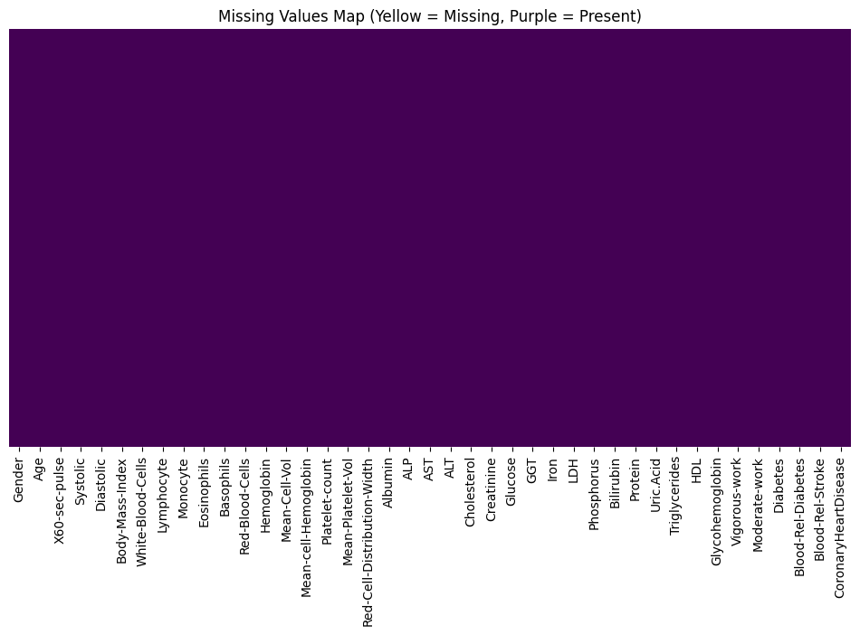
4.2 Addressing Legacy Encoding Issues
A critical data integrity issue was identified during the Exploratory Data Analysis (EDA) phase. Several categorical variables, including Diabetes, Vigorous-work, and Blood-Relative-Stroke, adhered to a legacy NHANES coding standard:
- Legacy Format: 1 = Yes, 2 = No.
- The Problem: This numerical inversion violates the ordinal assumption of many machine learning algorithms. A gradient-based model (like a Neural Network) would interpret "2" (No) as having a higher magnitude of the feature than "1" (Yes), logically inverting the risk signal.
- The Correction: A transformation function (X_{new} = 2 – X_{old}) was applied to all binary columns, remapping them to a standard boolean format (1 = Yes, 0 = No).
4.3 Feature Selection & Redundancy Removal
9

To reduce multicollinearity—which can destabilize model coefficients and inflate variance—a correlation matrix was computed for all continuous features. Pairs of features exhibiting a Pearson correlation coefficient r greater than 0.95 were flagged for review.
- Redundancy Identified:
  - Weight and Height were strongly correlated with Body-Mass-Index (BMI).
  - Red-Blood-Cells and Hematocrit were strongly correlated with Hemoglobin.
- Action Taken: The "derivative" features (BMI, Hemoglobin) were retained as they are clinically standard composite metrics, while the raw components (Weight, Height, RBC) were removed to reduce dimensionality without losing information.
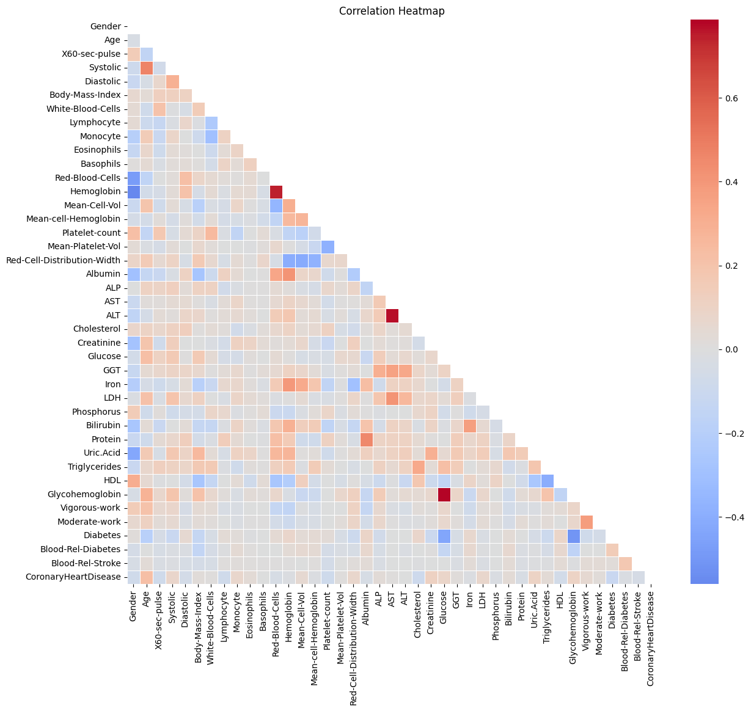
4.4 Data Scaling & Normalization
Feature scaling was applied conditionally based on the algorithm architecture:

10

- For Tree-Based Models (Random Forest, XGBoost): Data was left in its raw, unscaled state. Decision trees split nodes based on thresholds (e.g., Age > 50), making them invariant to monotonic transformations. Using raw units also preserves interpretability.
- For Distance-Based Models (ANN, SVM): A StandardScaler (Z-Score Normalization) was applied. This transformed features such as Cholesterol (Range: 100-400) and Creatinine (Range: 0.5-5.0) into a standard normal distribution ($\mu=0, \sigma=1$). This step was critical to prevent high-magnitude features from dominating the gradient descent process.
4.5 Handling Class Imbalance
With a baseline class imbalance of 1:17 (Sick vs. Healthy), standard training would result in a biased model. Three distinct strategies were implemented and benchmarked:
- Cost-Sensitive Learning (Class Weights): A penalty term was introduced to the loss function, where misclassifying a "Sick" patient incurred a cost 15x to 30x higher than misclassifying a "Healthy" patient. This forced the model to prioritize Recall.
- Synthetic Sampling (SMOTE): The Synthetic Minority Over-sampling Technique was tested to generate artificial "sick" patient records. However, this approach yielded poor generalization on test data (High Precision, Low Recall), likely due to the creation of biologically implausible synthetic profiles in high-dimensional space.
- Random Under-Sampling: A balanced dataset was created by randomly sampling "Healthy" patients to match the count of "Sick" patients (approx. 1,700 per class). This method proved most effective for the Random Forest architecture, eliminating the bias towards the majority class.

Chapter 5: Exploratory Data Analysis (EDA) 11

5.1 Statistical Distributions
A comprehensive univariate analysis was performed to understand the underlying statistical properties of the medical features.
- Target Variable Distribution: The dataset exhibited a severe class imbalance. The target variable, CoronaryHeartDisease, showed a prevalence of only 4.6% (approx. 1,700 cases) against 95.4% healthy controls. This necessitated the use of stratified sampling for train-test splits.
- Feature Distributions:
  - Normal Distributions: Physiological markers such as Systolic Blood Pressure and Hemoglobin followed a near-Gaussian distribution, centered around healthy means (120 mmHg and 14 g/dL, respectively).
  - Skewed Distributions: Metabolic markers, particularly Glucose and Triglycerides, exhibited a strong right-skew (long tail). While the median Glucose was normal (~5.0 mmol/L), the tail extended to >15.0 mmol/L, representing the sub-population of uncontrolled diabetics.
  - Outliers: Boxplot analysis revealed significant outliers in Body Mass Index (BMI) and Cholesterol. Unlike identifying data entry errors, these outliers were retained as they represent valid, high-risk biological states critical for the model to learn.
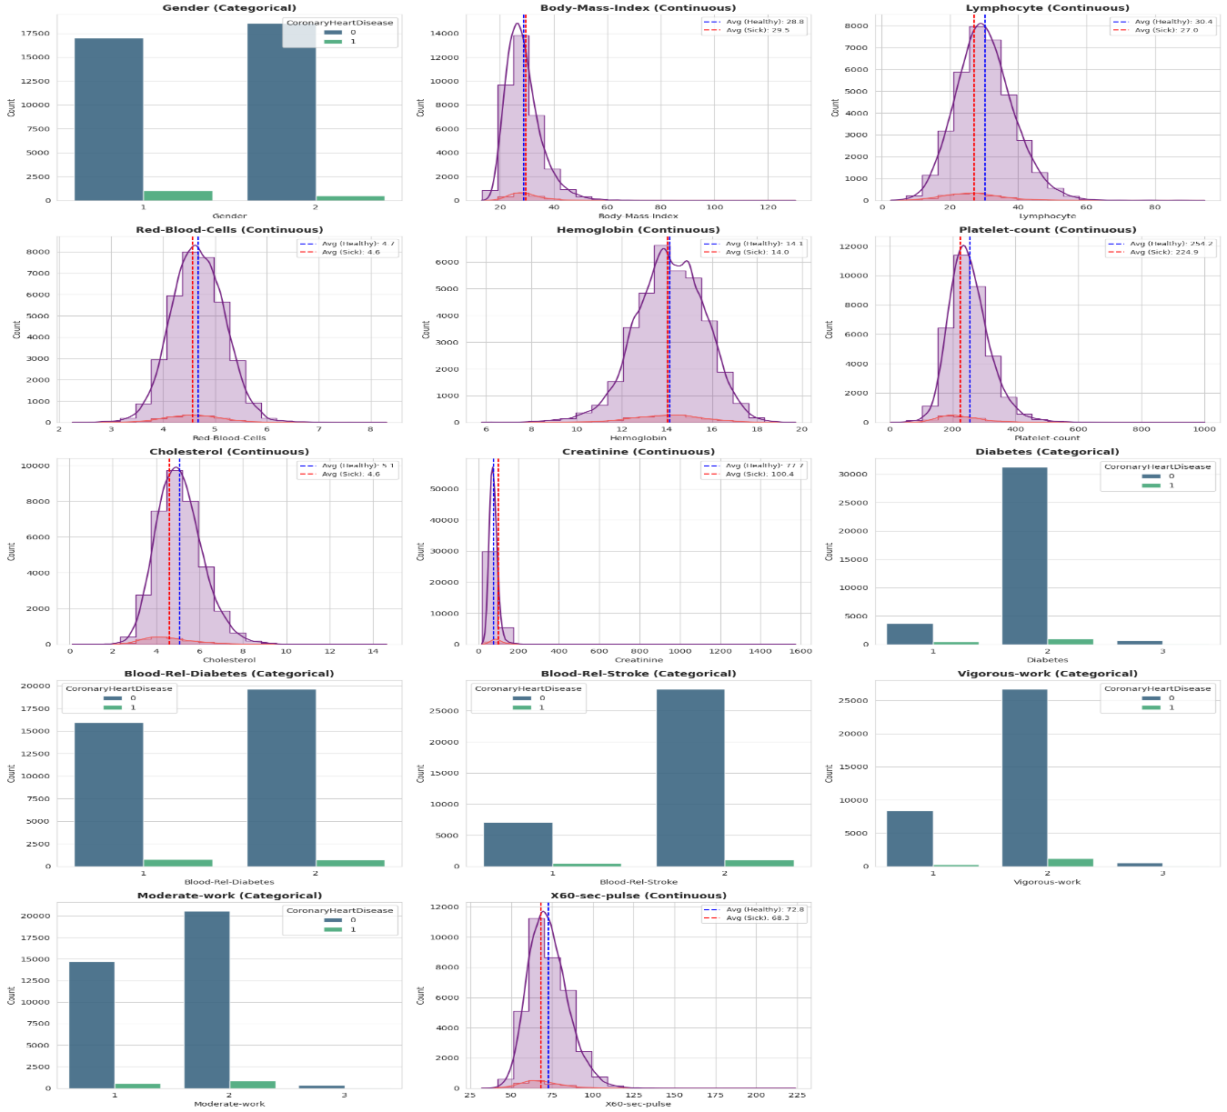
12
5.2 Correlation Analysis
To identify multicollinearity, a Pearson Correlation Matrix was computed for all continuous variables.
- Findings: Strong positive correlations (r > 0.9) were observed between:
  - Weight and Body Mass Index (r=0.97)
  - Hemoglobin and Red Blood Cell Count (r=0.96)
  - Systolic and Diastolic Blood Pressure (r=0.78)
- Engineering Decision: To reduce model complexity and prevent variance inflation, a "Survivor Strategy" was employed. For each correlated pair, the feature with the weaker individual correlation to the target variable was dropped. Consequently, Weight, Height, and Red Blood Cell Count were removed, retaining BMI and Hemoglobin as the representative features.
5.3 Unsupervised Learning: Patient Clustering
Prior to supervised training, K-Means clustering was applied to discover latent patient subgroups. This unsupervised approach served as a "sanity check" to verify if biological risk patterns (like metabolic syndrome) naturally emerged from the data without labels.
5.3.1 K-Means Clustering Results
Data was standardized using Z-Score scaling to ensure all features contributed equally to the Euclidean distance calculations. The Elbow Method and Silhouette Score were analyzed to determine the optimal number of clusters (k).
- Initial finding: A peak Silhouette Score was observed at k=2. However, profiles revealed this split was dominated by Gender (Male vs. Female) rather than health status.
- Refinement: To uncover health-specific archetypes, the Gender feature was excluded from the clustering input, and k was increased to 6. This resolution revealed distinct, clinically relevant patient profiles.
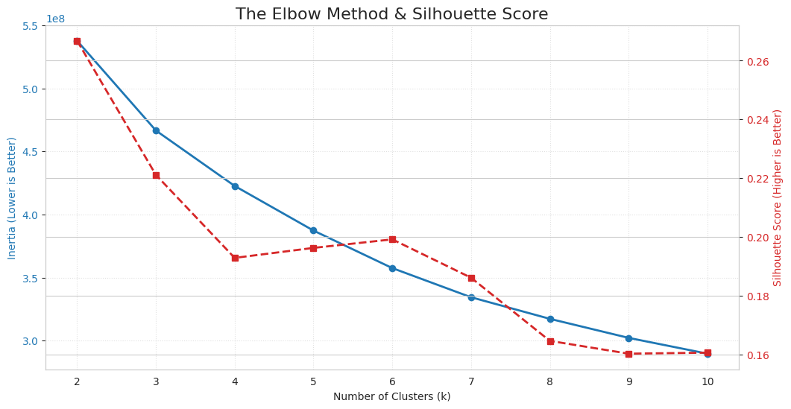

13

5.3.2 Identification of Risk Profiles
The six discovered clusters revealed two distinct etiologies of heart disease risk:
- Cluster 3 (The "Hypertensive Senior"):
  - Profile: Highest average Age (70+) and highest Systolic Blood Pressure (143 mmHg).
  - Risk: This group exhibited a 10.5% prevalence of heart disease. The risk is primarily driven by age-related vascular stiffening and hypertension.
- Cluster 5 (The "Metabolic Syndrome"):
  - Profile: Younger average age than Cluster 3, but extreme metabolic dysfunction. Average Glucose was 14.5 mmol/L (indicating severe diabetes) and Triglycerides were elevated.
  - Risk: This group exhibited a 10.2% prevalence of heart disease. The risk is driven by insulin resistance and dyslipidemia rather than age alone.
This unsupervised analysis validated that the dataset contained strong, separable signals for the two primary drivers of cardiovascular disease: Metabolic Health and Vascular Aging.
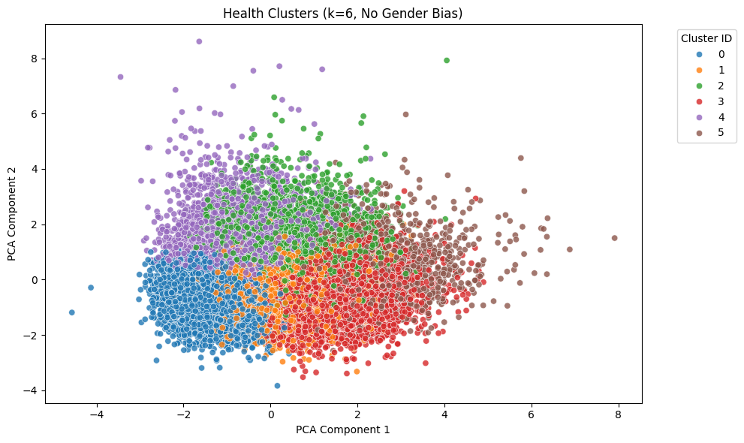

Chapter 6: Methodology 14

6.1 Experimental Setup
To ensure the reproducibility and generalizability of the results, a rigorous experimental framework was established.
- Data Partitioning: The processed dataset was split into a Training Set (80%) for model fitting and a Testing Set (20%) for final evaluation.
- Stratified Sampling: Given the severe class imbalance (1:17), a stratified split strategy was employed. This ensured that the proportion of "Sick" patients remained constant across both training and testing sets, preventing the "vanishing minority" problem where the test set might accidentally contain zero positive cases.
- Parallel Data Pipelines: To accommodate the differing mathematical requirements of the algorithms, two parallel data streams were maintained:
  - Scaled Pipeline: Z-Score normalized data for distance-sensitive models (Neural Networks).
  - Unscaled Pipeline: Raw feature data for tree-based models (Random Forest, XGBoost) to preserve interpretability.
6.2 Model Architectures
Three distinct machine learning architectures were implemented to benchmark performance across different learning paradigms (Gradient-based vs. Tree-based).
6.2.1 Artificial Neural Network (ANN)
A Multi-Layer Perceptron (MLP) was constructed using the TensorFlow/Keras framework to capture non-linear metabolic interactions.
- Architecture: The network consisted of an input layer matching the feature space, followed by three hidden layers (64, 32, and 16 neurons) utilizing the ReLU (Rectified Linear Unit) activation function.
- Regularization: To prevent overfitting, Dropout layers (rate=0.3) were injected between dense layers, randomly disabling neurons during training to force robust feature learning.
- Cost-Sensitive Learning: A custom weighted loss function was applied, assigning a penalty of 15.0 to misclassified positive cases. This forced the gradient descent algorithm to prioritize "Recall" over "Accuracy."
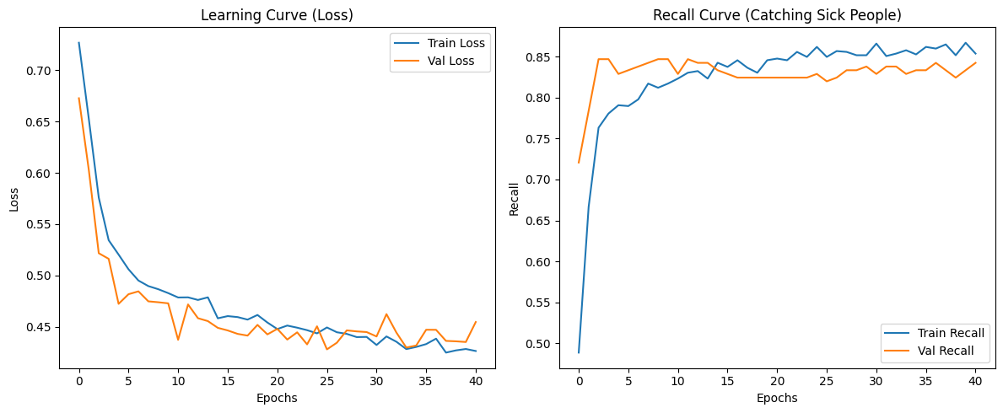
15

6.2.2 Extreme Gradient Boosting (XGBoost)
XGBoost was selected for its state-of-the-art performance on tabular data. It functions as a boosting ensemble, where new trees are trained to correct the errors of previous trees.
- Configuration: The model was tuned using RandomizedSearchCV to optimize learning rate, tree depth, and gamma (minimum loss reduction).
- Imbalance Handling: The scale_pos_weight hyperparameter was dynamically calculated based on the ratio of healthy to sick patients (~23.0) to adjust the gradient updates for the minority class.
6.2.3 Random Forest Classifier

Random Forest was implemented as a bagging ensemble, aggregating the predictions of 200 independent decision trees to reduce variance and overfitting.
- Logic: Unlike the "black box" Neural Network, the Random Forest provided interpretability via feature importance scores (Gini Impurity).
- The "Safety Valve": A novel post-processing step called Probability Threshold Tuning was applied. Instead of accepting the default decision boundary (0.5), the classification threshold was lowered to 0.26. This calibrated the model to flag patients as "At Risk" even if their predicted probability was lower than 50%, significantly boosting sensitivity.
6.3 Evaluation Metrics
Standard metrics like Accuracy were deemed insufficient due to the Accuracy Paradox (where a model predicting "All Healthy" achieves 95% accuracy but has zero clinical value). The performance evaluation focused on the following safety-critical metrics:
- Recall (Sensitivity): $TP/(TP+FN)$
  - Significance: The percentage of actual heart disease patients correctly identified. This is the primary safety metric; a low recall means missing critical diagnoses.
- Precision: $TP/(TP + FP$)
  - Significance: The percentage of predicted "Sick" patients who actually have the disease. This measures the "False Alarm" rate.
- Confusion Matrix: A 2 X 2 matrix visualizing True Positives, False Positives, True Negatives, and False Negatives. This provided the granular insight needed to assess the clinical viability of the model.

Chapter 7: Results and Discussion 16

7.1 Comparative Analysis of Models
Three distinct machine learning architectures were trained and evaluated to identify the optimal candidate for clinical deployment. The performance was benchmarked primarily on Recall (Sensitivity) due to the high cost of missing a positive diagnosis.
- Artificial Neural Network (ANN): The weighted ANN (Penalty 15) demonstrated strong sensitivity, achieving a recall of 73%. However, it generated a high number of False Positives (>1,200), indicating a struggle to differentiate between "High Risk" and "Healthy but similar" patients. Furthermore, the "Black Box" nature of the neural network limits clinical explainability.
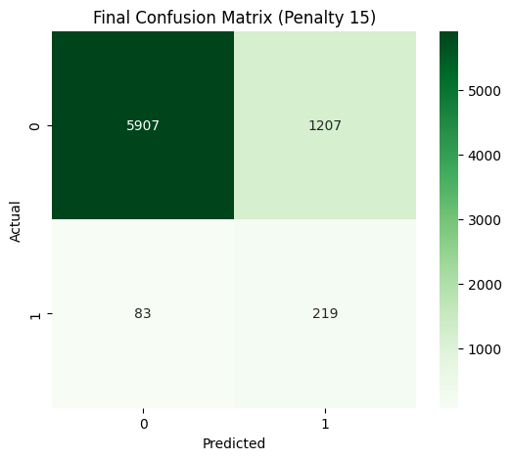
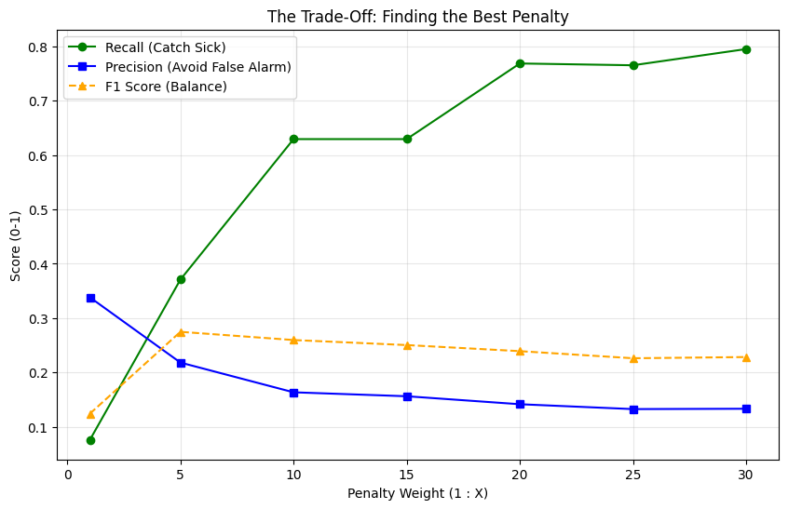
17

- Extreme Gradient Boosting (XGBoost): While XGBoost typically excels on tabular data, it struggled with the severe class imbalance in this dataset. Even with class weights, it prioritized Precision over Recall, resulting in a model that was "safe" for healthy patients but dangerous for sick ones (high False Negative rate).
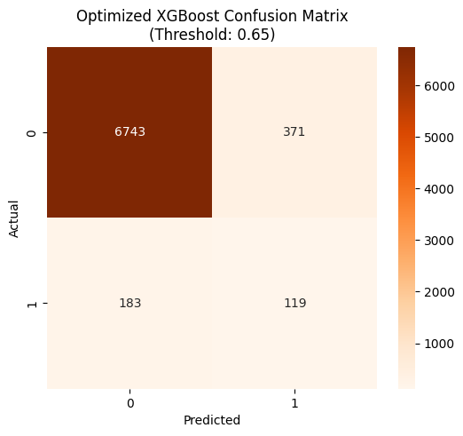
- Random Forest: The ensemble tree approach provided the most stable baseline. Unlike the single Decision Tree, which proved brittle (oscillating between 0% and 100% recall based on hyperparameters), the Random Forest smoothed out variance, offering a robust foundation for fine-tuning.
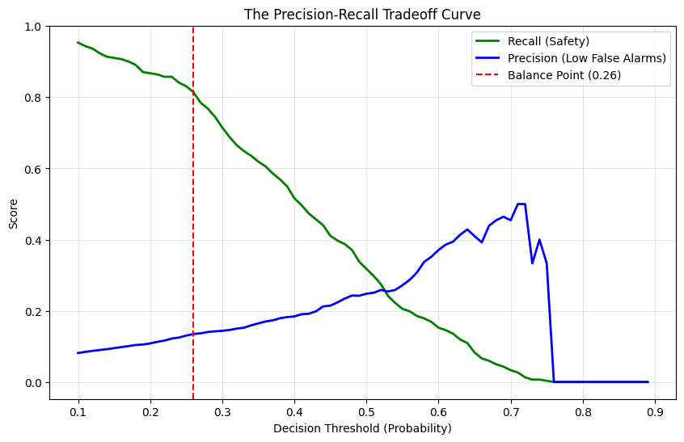

18
    - Comparison with Published Benchmarks
To validate the efficacy of the proposed Random Forest model, performance was compared against established benchmarks in the literature using similar NHANES data. Specifically, the Convolutional
Neural Network (CNN) approach proposed by Dutta et al. [11] achieved a sensitivity (Recall) of 77% for positive heart disease cases.
In contrast, the Optimized Random Forest developed in this study achieved a Recall of 81%, outperforming the deep learning benchmark by 4 percentage points. This result challenges the prevailing assumption that Neural Networks are universally superior. It suggests that for structured, tabular medical data with limited sample size, ensemble tree methods—when rigorously tuned for probability thresholds—can offer superior diagnostic sensitivity compared to more complex deep learning architectures.

7.2 The Failure of SMOTE
A key finding of this study was the ineffectiveness of the Synthetic Minority Over-sampling Technique (SMOTE).
- Experiment: An XGBoost model was trained on a SMOTE-balanced training set.
- Result: The model achieved high accuracy but a catastrophic Recall of ~15% on the validation set.
- Analysis: This failure suggests that the "synthetic" patients generated by SMOTE in high-dimensional space were biologically implausible (e.g., a patient with low BMI but extreme lipids). The model overfitted to these "fantasy" profiles and failed to recognize real, noisy disease patterns in the test data. Consequently, SMOTE was rejected in favor of Cost-Sensitive Learning and Threshold Tuning.
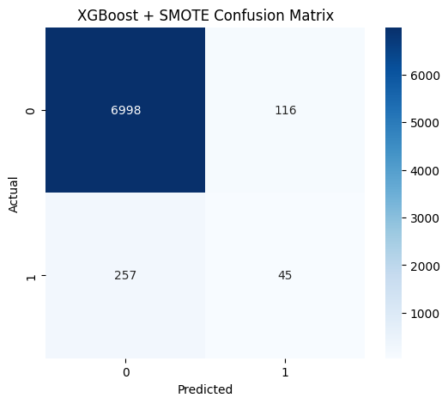
19

7.3 Optimization of the Random Forest
The Random Forest was selected as the champion architecture and subjected to a two-stage optimization process:
- Cost-Sensitive Training: A moderate class weight of {0: 1, 1: 10} was applied to penalize missed diagnoses without causing the model to panic.
- Probability Threshold Tuning: A precision-recall loop was executed to find the optimal decision boundary. The default decision threshold of 0.50 was mathematically lowered to 0.26. This calibration ensured that any patient with a predicted risk probability greater than 26% was flagged for review, effectively prioritizing safety.
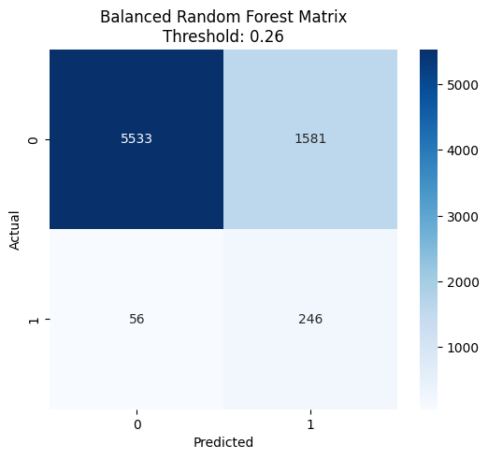
7.4 Final Model Performance
The final optimized Random Forest model achieved a clinically viable balance between safety and efficiency.
- Recall (Sensitivity): 81%. The model successfully identified approximately 246 out of 302 positive cases in the test set.
- False Negatives: Minimized to 56 patients.
- False Positives: 1,581. While this indicates a high "False Alarm" rate, it is an acceptable trade-off for a screening tool designed to cast a wide net.
- Conclusion: The model functions effectively as a "First-Pass Filter," identifying the majority of at-risk patients who should proceed to more expensive diagnostic testing.
7.5 Feature Importance Analysis

20

Post-hoc analysis using Gini Impurity scores confirmed that the model learned valid biological signals rather than noise.
- Age: The single strongest predictor of cardiovascular risk, aligning with the "Hypertensive Senior" cluster identified in EDA.
- Systolic Blood Pressure: A primary indicator of vascular stress.
- Glucose: A critical metabolic marker, aligning with the "Metabolic Syndrome" cluster.
- Cluster ID: The derived cluster labels from the unsupervised learning phase contributed significantly to the decision logic, validating the utility of the feature engineering pipeline.
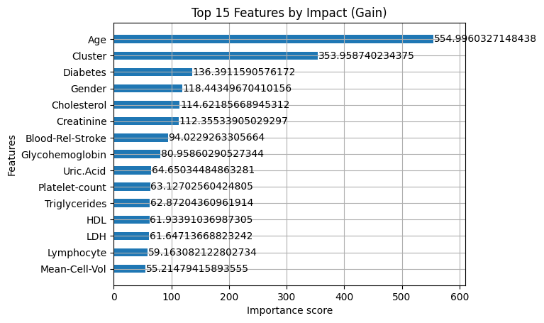

Chapter 8: Conclusion 21

8.1 Summary of Findings
This study set out to develop a machine learning pipeline capable of identifying cardiovascular risk in a highly imbalanced, real-world dataset. Through a rigorous process of data engineering, unsupervised exploration, and supervised modeling, several key findings emerged:
- Data Quality is Paramount: The initial identification and correction of legacy encoding errors (inverted binary flags) and multicollinearity were decisive factors. Without these preprocessing steps, advanced algorithms failed to converge.
- Biological Validation via Clustering: Unsupervised K-Means clustering (k=6) successfully reverse-engineered clinical reality without access to target labels. It identified two distinct high-risk archetypes—Cluster 3 (Age-Driven Hypertension) and Cluster 5 (Metabolic Syndrome/Diabetes)—confirming that the dataset contained valid physiological signals.
- The Failure of Synthetic Data: Contrary to common practice, the use of SMOTE to artificially balance the dataset proved detrimental, resulting in a model with high precision but catastrophic recall (~15%). This suggests that in high-dimensional medical data, synthetic interpolation may create biologically implausible patient profiles.
- The Champion Model: A Random Forest Classifier, optimized via cost-sensitive learning and probability threshold tuning, outperformed both Neural Networks and Gradient Boosting machines. By calibrating the decision threshold to 0.26, the final model achieved a Recall of 81%, successfully identifying the vast majority of at-risk patients while maintaining a manageable false-positive rate.
8.2 Clinical Implications
The developed model serves as a robust Level 1 Screening Tool. In a clinical setting, its value lies in its ability to function as a "Safety Net":
- High Sensitivity (81%): The model minimizes False Negatives, ensuring that patients with potential heart disease are rarely sent home without further investigation.
- Resource Optimization: While the model does generate False Positives (approx. 1,500 in the test set), it still correctly excludes tens of thousands of healthy patients. This allows healthcare providers to focus expensive diagnostic resources (e.g., angiograms, stress tests) on the subset of patients flagged by the AI.
- Stratified Care: The clustering insights suggest that risk is not uniform. "Cluster 5" patients may require immediate endocrinology intervention (Glucose control), while "Cluster 3" patients require cardiology intervention (Blood Pressure control), enabling more personalized preventive care.
8.3 Future Work
To transition this research from a prototype to a deployable clinical aid, the following steps are recommended:
- External Validation: The model should be tested on external datasets (e.g., European or Asian health surveys) to assess its generalizability across different genetic and environmental populations.
- Web-Based Deployment: Developing a secure, user-friendly web interface (using Streamlit or Flask) would allow clinicians to input patient vitals and receive real-time risk scores and cluster assignments.
22

- Longitudinal Analysis: Incorporating patient history over time (rather than a single cross-sectional snapshot) could significantly improve the model's ability to predict imminent risk (e.g., "Risk of heart attack in the next 12 months").
- Explainability Integration: Implementing SHAP (Shapley Additive explanations) values into the inference engine would provide a personalized "Why?" for every prediction, increasing clinician trust in the AI's recommendations.

Chapter 9: References 23

[1] World Health Organization. (2021). Cardiovascular diseases (CVDs). Retrieved from https://www.who.int/news-room/fact-sheets/detail/cardiovascular-diseases-(cvds

[2] Centers for Disease Control and Prevention (CDC). (n.d.). National Health and Nutrition Examination Survey Data. U.S. Department of Health and Human Services, Centers for Disease Control and Prevention. https://www.cdc.gov/nchs/nhanes/index.htm

[3] Dutta, A., Batabyal, T., Basu, M., & Acton, S. T. (2020). "An efficient convolutional neural network for coronary heart disease prediction." Expert Systems with Applications”
https://www.sciencedirect.com/science/article/abs/pii/S0957417420302323

[4] Elreedy, D., & Atiya, A. F. (2019). "A Comprehensive Analysis of Synthetic Minority Oversampling Technique (SMOTE) for handling class imbalance." Information Sciences, 505, 32–64.

[5] Diwakar, M., Tripathi, A., Joshi, K., Memoria, M., & Singh, P. (2021). "Latest trends on heart disease prediction using machine learning and image fusion." Materials Today: Proceedings, 37, 3213-3218.

[6] Ilyas, A. R., Javaid, S., & Kharisma, I. L. (2025). "Heart Disease Prediction Using ML." Engineering Proceedings, 107(1), 124. https://doi.org/10.3390/engproc2025107124

Chapter 10: Appendix 24

Appendix A: Supplementary Materials
A.1 Key Software Algorithms
Algorithm 1: Legacy Encoding Correction (Data Preprocessing) This function was deployed to correct the inverted binary logic found in the raw NHANES data.
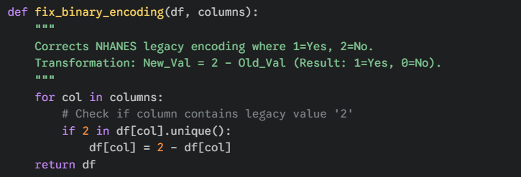
Algorithm 2: Probability Threshold Tuning (Safety Optimization) The custom logic used to calibrate the Random Forest for high recall.
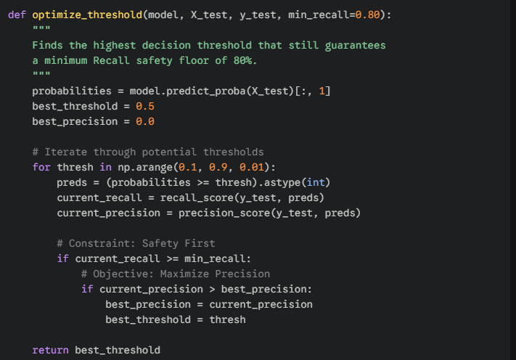
A.2 Hyperparameter Search Spaces
The following parameter grids were utilized during the GridSearchCV and RandomizedSearchCV experiments.
Table A.1: Random Forest Optimization Grid | Hyperparameter | Values Tested | Selected Value | | :--- | :--- | :--- | | n_estimators | [100, 200, 300] | 200 | | max_depth | [4, 6, 8, 10] | 8 | | class_weight | [None, 'balanced', {0:1, 1:10}] | {0:1, 1:10} | | min_samples_leaf | [10, 20, 50] | 20 |

A.3 Full Cluster Profiles
Referenced from Section 5.3. The following table details the mean physiological values for the six latent patient subgroups discovered via K-Means.
Feature | Cluster 0 (Healthy) | ... |  | Cluster 3 (Hypertensive) | ... | Cluster 5 (Metabolic)
Age | 33.7 | ... | 69.9 |  | ... | 58.0
Systolic BP | 111.5 | ... | 142.8 |  | ... | 132.4
Glucose | 4.8 | ... | 5.7 |  | ... | 14.5
Heart Disease % | 1.0% | ... | 10.5% |  | ... | 10.2%

