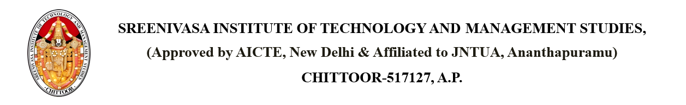

Dated: 2025-04-17

From

PRINCIPAL,

SITAMS COLLEGE

To

Malathi

4-12, Madhu Complex, Peddapalli, Andhra Pradesh – 505172

**SUBJECT**: - **FEE PAYMENT PENDING - Karishma (Roll Number: 22751A0518)**

Dear Malathi,

We hope this letter finds you well. We are writing to kindly remind you that the fees are unpaid for your child, Karishma. As of 2025-04-17, the outstanding amount is 56000.

Please find the fees details as mentioned:

|  |  |  |  |
| --- | --- | --- | --- |
| **YEAR** | **PAYABLE** | **PAID** | **PENDING** |
| 1st Year | 106000 | 106000 | 0 |
| 2nd Year | 106000 | 50000 | 56000 |
| 3rd Year | 106000 | 106000 | 0 |

We kindly request that you settle the outstanding balance by 2025-04-26. If you have already made the payment, please disregard this notice.

If you have any questions or require assistance with the process, please feel free to contact us.

Thank you for your attention to this matter, and we look forward to your cooperation.

Sincerely,  
PRINCIPAL  
SITAMS COLLEGE