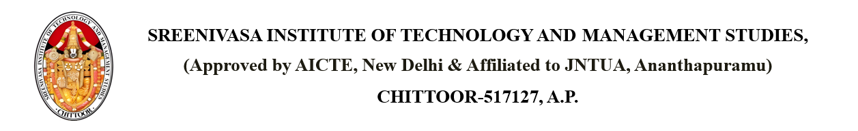

Dated: April 17, 2025

From

PRINCIPAL,

SITAMS COLLEGE

To

Sumati

401, Annamayya Complex, Tirupati, Andhra Pradesh – 517501

**SUBJECT: ACADEMIC MISCONDUCT NOTICE FOR Aishwarya – Roll No: 22751A0507**

Dear Sumati,

This is to inform you that your child, Aishwarya, Roll No: 22751A0507, has been involved in academic misconduct, specifically because of Using unauthorized materials / devices during assessments.

We request you to accompany Aishwarya to school on 2025-05-03 for a meeting to discuss the matter further.

Thank you for your cooperation.

Copy to: - PRINCIPAL

HOD

Parents

Individual