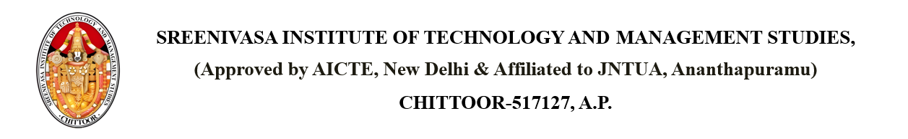

Dated: 17 April 2025

From

PRINCIPAL,

SITAMS COLLEGE

**SUBJECT: Achievements / Highlights**

Dear Students,  
  
We are proud to share the recent achievements of our students in various events and competitions:  
  
• Ms Bhagya Sree won Gold Medal in AI Hackathon  
• Mr Suraj Kumar won Silver Medal in Gymnastics at District Level  
  
Let’s congratulate them for their efforts and excellence!  
  
Keep up the great work, everyone!

Copy to: - PRINCIPAL

All Departments HODs  
Dean Office  
R&D  
Students