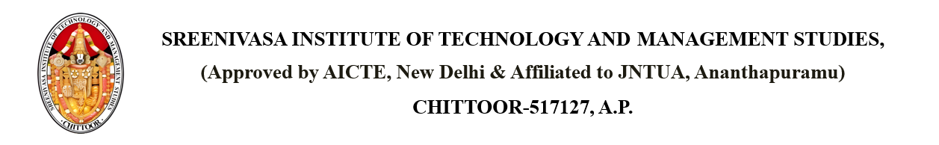

Dated: 17 April 2025

**CIRCULAR**

Sub: - Conduct Departmental faculty meeting

Here by informed to all the faculty to attend the departmental meeting in Principal cabin at 17 April 2025 09:00 AM without fail to discuss the following agenda

1. Class work and Time table
2. Additional responsibilities
3. Activities for current year
4. Faculty Performance report
5. Student code of conduct
6. Any other items

PRINCIPAL