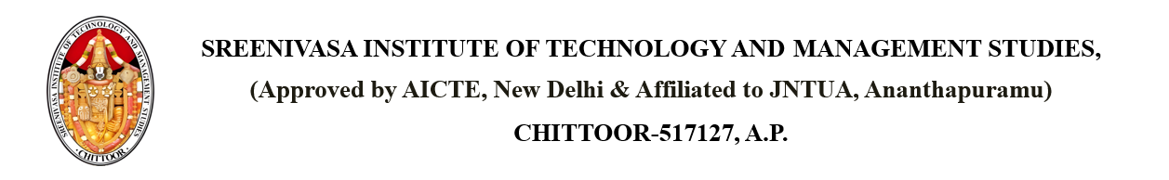

Dated: April 17, 2025

From

PRINCIPAL,

SITAMS COLLEGE

**SUBJECT: Medical Check-up Camps**

Dear Students,  
  
We are pleased to inform you that a General Health CheckUp Health Check-up Camp has been scheduled on 26th April 2025 09:00 AM at the Health Center.  
  
This initiative is aimed at promoting student wellness and early detection of health issues. All students are encouraged to take advantage of this opportunity and get themselves examined by certified medical professionals.  
  
Please make sure to carry your ID card and report at the venue on time.  
  
Stay healthy and take care.

Copy to: - PRINCIPAL

All HODs  
Health Center  
Students