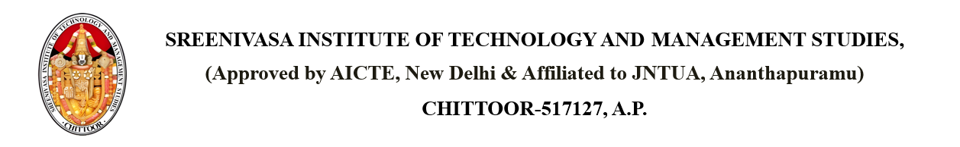

Dated: April 17, 2025

From

PRINCIPAL,

SITAMS COLLEGE

To

Indrajeet

42, Sri Chaitanya Nagar, Eluru, Andhra Pradesh – 534006

**SUBJECT**: - **PROBATION NOTICE FOR Rajan (Roll Number: 22751A0575)**

Dear Indrajeet,

We are writing to inform you that your child, Rajan, has been placed on probation due to Repeated misconduct after a warning. This probationary period will last until 2025-04-25, during which time your child must demonstrate improvement. Failure to meet the required standards may result in further disciplinary action. We encourage you to support your child in addressing these concerns.

Copy to: - PRINCIPAL

HOD

Parents

Individual