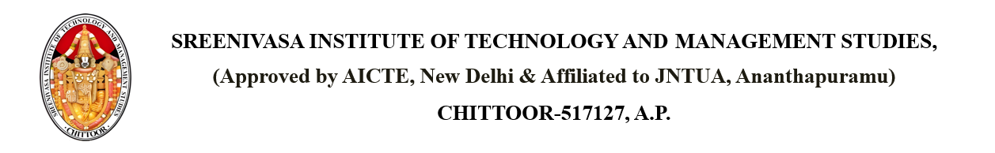

Dated: April 17, 2025

**CIRCULAR**

It is informed to all the students, teaching & non-teaching staff members that 2025-04-18 – Friday is declared as holiday on account of Good Friday.

Copy to: - PRINCIPAL

Dean Academics

Dean R&D

All HODs

Computer Centre

Library

Maintenance I/C

Transport I/C

Canteen