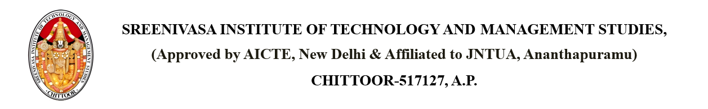

Dated: April 17, 2025

From

PLACEMENT CELL,

SITAMS COLLEGE

**SUBJECT: PLACEMENT DRIVE BY Accenture Solutions Pvt. Ltd. ON 02nd May 2025 09:00 AM AT COLLEGE PLACEMENT CELL**

Dear Students,

We are pleased to inform you that Accenture Solutions Pvt. Ltd. will be conducting a campus placement drive at our college on 02nd May 2025 09:00 AM. The drive will take place in the Placement Cell, and all eligible candidates are encouraged to participate.

This is a valuable opportunity to kick-start your career with a leading global company known for innovation and professional growth. Further details regarding eligibility criteria, required documents, and schedule will be shared shortly.

Please ensure your resumes are updated and be prepared for the recruitment process.

Copy to: - PLACEMENT CELL

HOD

R&D

Individual