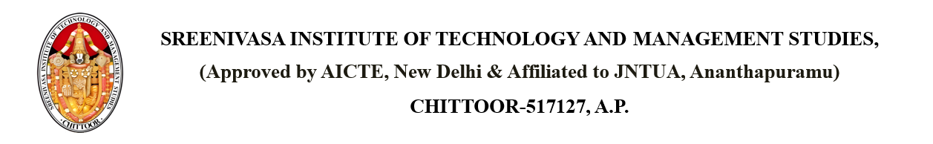

Dated: April 17, 2025

From

PRINCIPAL,

SITAMS COLLEGE

To

Janaki

40, Indiranagar, Rajahmundry, Andhra Pradesh – 533201

**SUBJECT**: - **WARNING NOTICE FOR Aryan (Roll Number: 22751A0566)**

Dear Janaki,

We are writing to inform you of your child, Aryan, who has recently been involved in a violation of SITAMS's college code of conduct. Despite previous discussions regarding their behavior on 2025-04-18, their actions, including Disruptive behavior in class, continue to be a concern. This letter serves as a formal warning that further misconduct may result in suspension from the College. We encourage you to discuss this matter with your child and help guide them in adhering to our college’s values.

Copy to: - PRINCIPAL

HOD

Parents

Individual