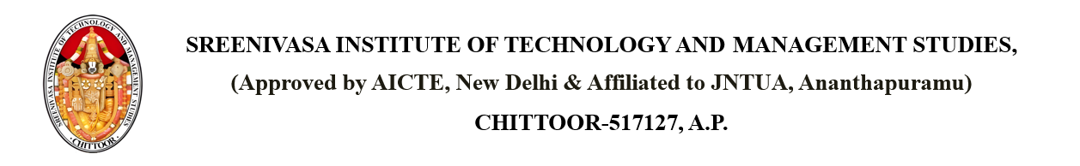

Dated: {CURRENT_DATE}

**CIRCULAR**

It is informed to all the students that on the eve of {FESTIVAL},the following programmes are conducting on {DATE} by {FACULTY},{POST},{BRANCH}

|  |  |  |
| --- | --- | --- |
| **S.No** | **Event name** | **Time** |
| 1 | {EVENT} | {TIME} |

Copy to: - PRINCIPAL

Dean Academics

Dean R&D

All HODs

Read in all Classes

Notice Board