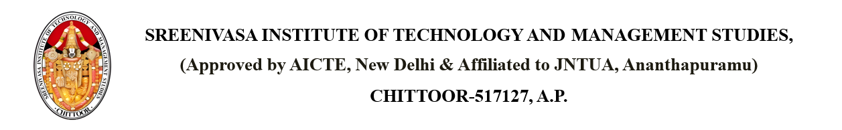

Dated: {CURRENT_DATE}

From

PRINCIPAL,

SITAMS COLLEGE

**SUBJECT: NSS EVENT ON {EVENT_DATE} AT {PLACE}**

Dear Students,

We are excited to announce an NSS (National Service Scheme) event on {EVENT_DATE} at {PLACE}.The event promotes community service, leadership, and social responsibility among students. All students are encouraged to participate and will receive a certificate of appreciation. Your involvement will add great value to the event. Please register with the NSS Coordinator by {DEADLINE}.

Copy to: - PRINCIPAL

HOD

R&D

Individual