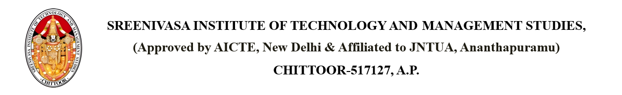

Dated: {CURRENT_DATE}

From

PRINCIPAL,

SITAMS COLLEGE

**SUBJECT: CHANGE OF ACADEMIC REGULATION FROM {OLD_REGULATION} TO {NEW_REGULATION}**

Respected members,

We would like to inform you that our college has officially updated the academic regulation from {OLD_REGULATION} to {NEW_REGULATION}, effective from {EFFECTIVE_DATE}.This change has been made to align with updated curriculum standards and academic policies. All newly admitted students will follow the {NEW_REGULATION} regulation. Detailed information about the changes will be shared through the college website and notice boards. For any queries, students are advised to contact the academic coordinator.

Copy to the Individual PRINCIPAL

Copy to DEAN OF ACADEMICS

Copy to FACULTY

Copy to R&D

Copy to HOD