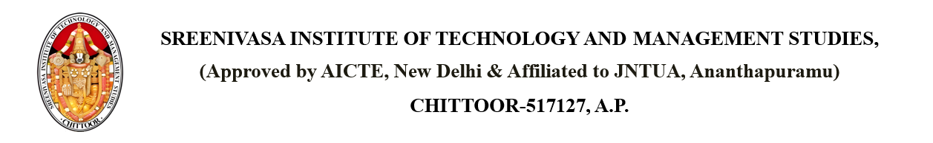

Dated: {CURRENT_DATE}

From

PRINCIPAL,

SITAMS COLLEGE

**SUBJECT: INTIMATION OF UPDATED COLLEGE RULES AND REGULATIONS**

Respected members,

This is to inform all students and staff that our college has updated its rules and regulations, effective from {EFFECTIVE_DATE}.The changes have been made to ensure a better academic environment and discipline within the campus. All are requested to go through the updated rules, which will be displayed on the college notice board and website. Strict adherence to the new rules is expected from everyone. For any clarifications, please contact the administrative office.

Copy to the Individual PRINCIPAL

Copy to DEAN of ACADEMICS

Copy to R&D

Copy to HOD