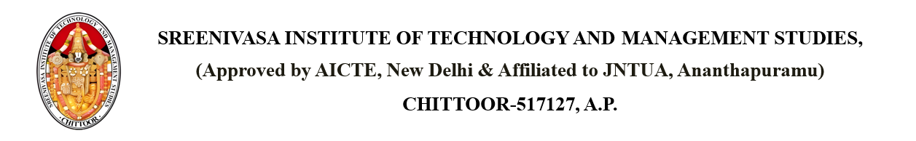

Dated: {CURRENT_DATE}

From

PRINCIPAL,

SITAMS COLLEGE

**SUBJECT: INTIMATION OF STAFF UPDATES IN THE COLLEGE**

Respected members,

We are pleased to inform you that staff updates have been made in our college as part of enhancing academic and administrative efficiency. New faculty members have joined various departments, and some internal role changes have also been implemented. These updates aim to improve the overall learning experience and support services for students. The updated staff list will be available on the college notice board and website. For any queries related to department changes, please contact the respective HODs.

Copy to the Individual PRINCIPAL

Copy to DEAN of ACADEMICS

Copy to R&D

Copy to HOD