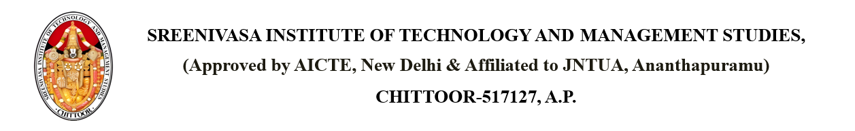

Dated: {CURRENT_DATE}

**CIRCULAR**

It is informed to the girl students of B. Tech & PG that the {SPORT} will be conducted from {STARTDATE} to {ENDDATE} at {PLACE}

|  |  |  |
| --- | --- | --- |
| **Serial no.** | **Date** | **Branch** |
| {SR} | {DATE} | {BRANCH} |

Copy to: - PRINCIPAL

HODs: ECE, EEE, CSE, AI, AIML, DS, MBA & MCA circulate among Department sports coordinator and students