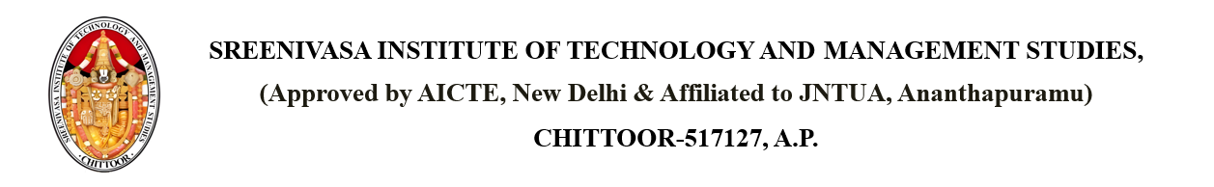

Dated: {CURRENT_DATE}

**CIRCULAR**

It is informed to all the students, teaching & non-teaching staff members that {DATE} – {DAY_OF_WEEK} is declared as {IS_HOLIDAY} on account of {REASON}.

Copy to: - PRINCIPAL

Dean Academics

Dean R&D

All HODs

Computer Centre

Library

Maintenance I/C

Transport I/C

Canteen