VISHWAS n NEllIKOPPA
1BM24CS35
3K

3.
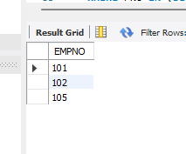
4.
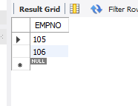
5.
