Java

database orace or mysql

jsp(front end)(little) servlets

Spring boot

jsp jakarta server pages

servlets java programming class

MVC artictecture

JDBC API (java database connectivity api for sql query)

Spring

Spring core -> DEpendancy injection

-> inversion of control

-> beans and beans scope

->spring configration(xml, withour xml(java),anotaion)

Spring MVC

Request params

Request params

Path variable

Spring rest

->json data binding

->spring rest controller

-> retrive pojos(java objects)

-> using path variable for

-> rest endpoints

-> exception handling

-> configuration

-> pagination

-> sorting

hibernate (ORM) better version (spring data jpa/spring data rest)

crud operations

eager vs lazy lading

hibernate maping

Spring AOP

beforeadvice type

pointcut expressions

pointcut decalrqation

oredering aspects

join points

advice type\

Project

train reswernavation(using jsp and servelts) than added spring core spring mvc and spring rest than hibernate

pick one than improve

Spring security (imp)

authentication and authorization

oauth 2.0

jwt tocken

cors

csrf

user roles

junit and mockito

spring boot

makes developemetn faster

spring boot devtools

spring boot actuator

redis with spring boot

kafka with spring boot

spring cloud and microservice

_________________________________________________________________________________________

basic java

adbvancesd - multithreading exception handling file handling db connectivity

fisrt db as rdbms sql(java database connectivity)

servlet(old not used in industry)

hibernate (includes jpa)

security (spring security)

web app using spring-depedalcy injection

microservice(not expertice just uper uper se)

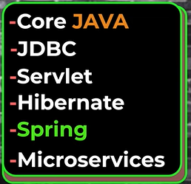

Builde tools - maven and gradel (more maven)

Pipeline build jenkins(optional)

Docker