To conncet sql with java in code

This are steps

 //driverload

            //connection establoish

            //statemetn create

            //execute query

            //connection close

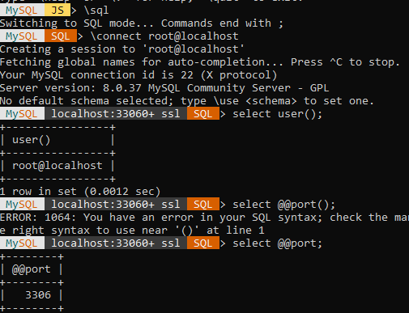

Anything before @localhost is username =-> root is username

In vishuinter/java/projects/jdbc_tutorial/src/mypackage/student.java

//to see how to get username and port see above page

For better practice cerate class student and write all this In method in stdent withour psvm.

Than in main create object of this class and call method

package mypackage;

import java.sql.Connection;

import java.sql.DriverManager;

import java.sql.Statement;

public class Main {

    public static void main(String[] args) {

        try{

            String url = "jdbc:mysql://localhost:3306/";

            String username ="root";

            String psssword = "Admin@root1";

            //step1+2: driverload + connection establish

            Connection conn = DriverManager.getConnection(url,username,psssword);

            // step3: statementcreate

            Statement stm = conn.createStatement();

            System.out.println("connection succefull");

            //step 4:execute query

            String query = "query your here";

            stm.execute(query);

            System.out.println("query run succesfully");

            //step 5:connection close

            conn.close();

        }catch(Exception e){

            e.printStackTrace();

        }

    }

    }

}

In real code we qill have query in query.java

From above code

            String query = "create database db";

stm.execute(query); //sometime even database create it still give false

            //it gives false even database created

            //throw execption if already db exists

//stateetn and query

String query = "insert into student (sid,sname,semail) values(?,?,?))"; //bcz outside " " than inside ' '

        PreparedStatement pstm = conn.prepareStatement(query);

        pstm.setInt(1,2);

        pstm.setString(2,"vishu2");

        pstm.setString(3, "hello@gmail");