**Weekly Report Of CSE623**

**15 March**

**GROUP Cluster 555**

| Vishv Boda | AU2240182 |
| --- | --- |
| Moin Vinchhi | AU2240183 |
| Ritu Patel | AU2240177 |
| Sarthak Siddhpura | AU2240041 |
| Vrunda Patel | AU2240239 |

# Task Done in This Week:

* Loaded and processed vehicle trajectory data of abnormal and normal classes. Selected significant features frameNo, left, top, w, and h to track object movement. Assigned labels 0 for abnormal and 1 for normal behavior. Computed center coordinates center_x, center_y for each trajectory. Red for abnormal behavior and green for normal behavior.

**10**

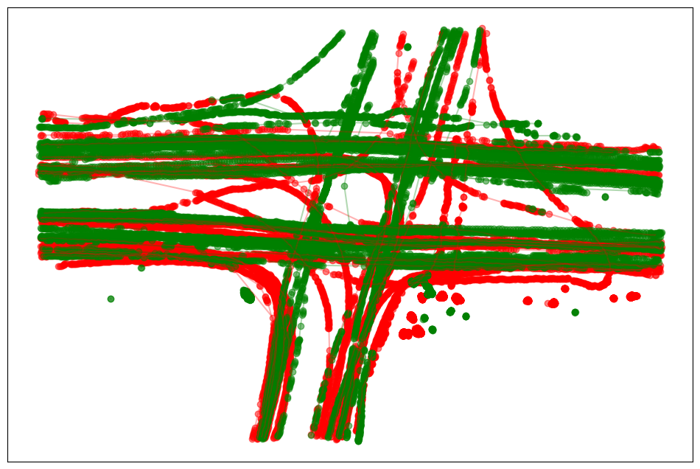

**11**

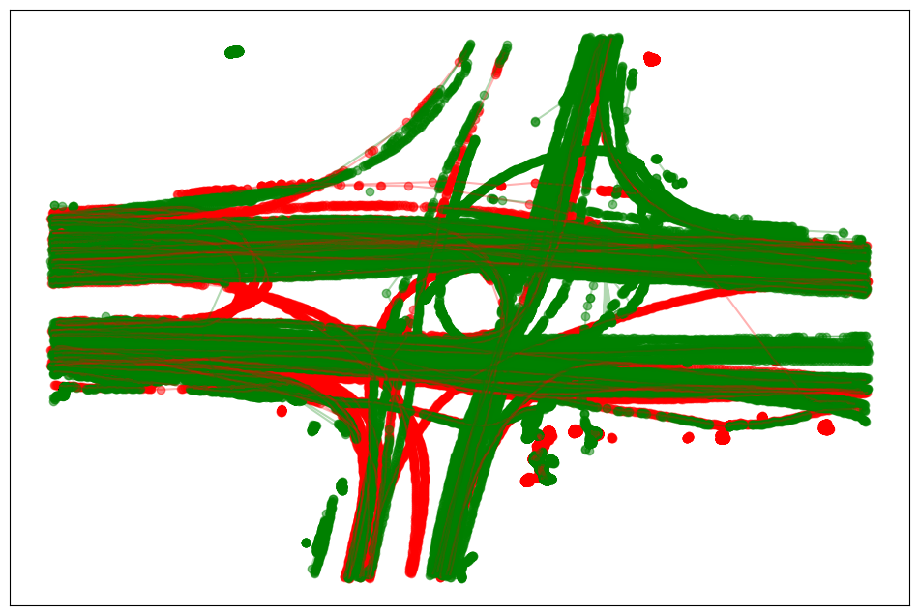

**12**

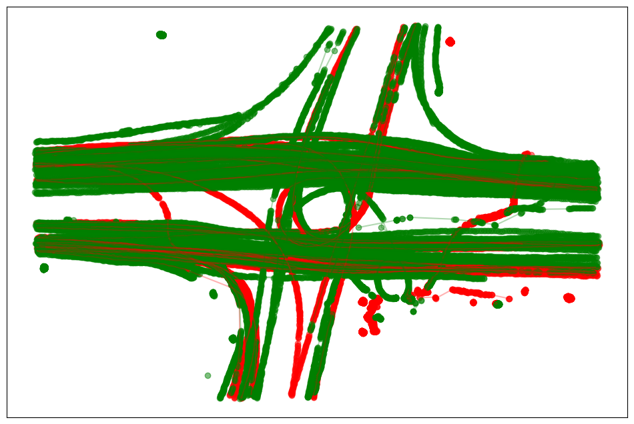

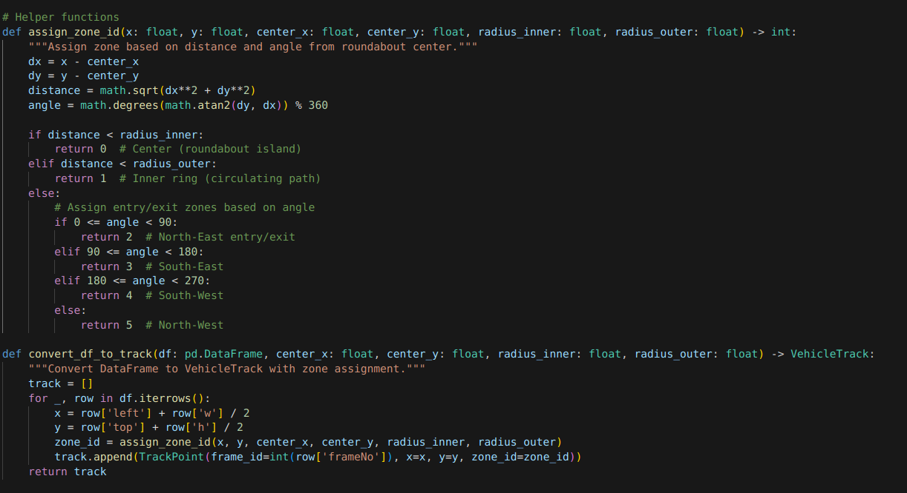

We created a TrackPoint class to contain each point's location and zone and a VehicleTrack to contain a vehicle's complete trajectory. With the **assign_zone_id** function, points were grouped into zones according to their distance and angle from the center of the roundabout. Zones were the center (Zone 0), the inner ring (Zone 1), and four zones (Zones 2-5).

The **convert_df_to_track** function transformed raw trajectory data into VehicleTrack objects via the computation of bounding box centers and zones.

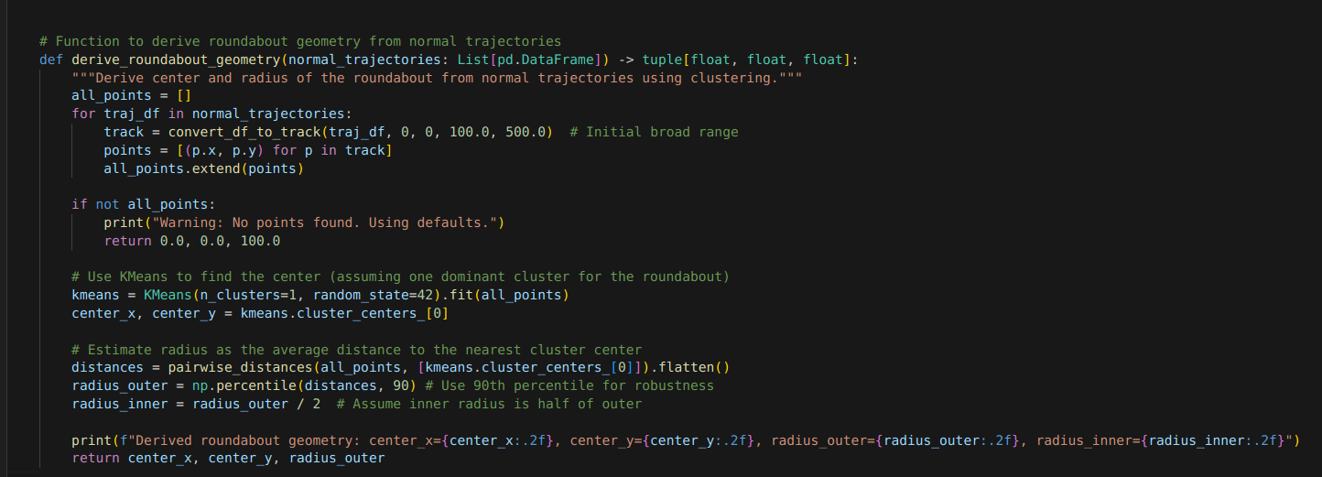

To obtain the roundabout's geometry, we applied KMeans clustering to regular trajectories to fit the center and radius best. We took the outer radius as the 90th percentile of point-to-center distances and the inner radius as half of it.

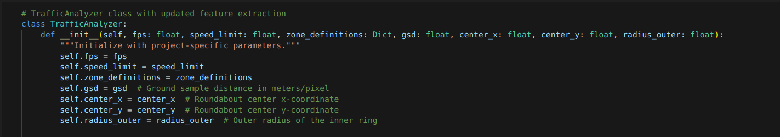

The TrafficAnalyzer class processes vehicle trajectories in a roundabout. It takes parameters such as frame rate (fps), speed limit, zone definitions, ground sample distance (gsd), and roundabout geometry. It calculates some of the most important features as follows:

* **Speed:** Speed between any two consecutive points.
* **Turn Angles:** Angles between three consecutive points to identify sharp turns.
* **Zone Sequence:** Vehicle moves through the following zones.
* **Trip Duration:** Total trip duration.
* **Sharp Turns:** Number of turns within some angle threshold.
* **Zone Transitions:** How many times the vehicle enters zones.
* **Direction Variance:** Turn angle variability.
* **Circular Adherence:** Any movement of the vehicle away from the circular path of the roundabout.

The class manages edge cases and offers metrics for the analysis of traffic behavior, anomaly detection and driver performance measurement.

**Point-Biserial Correlation**

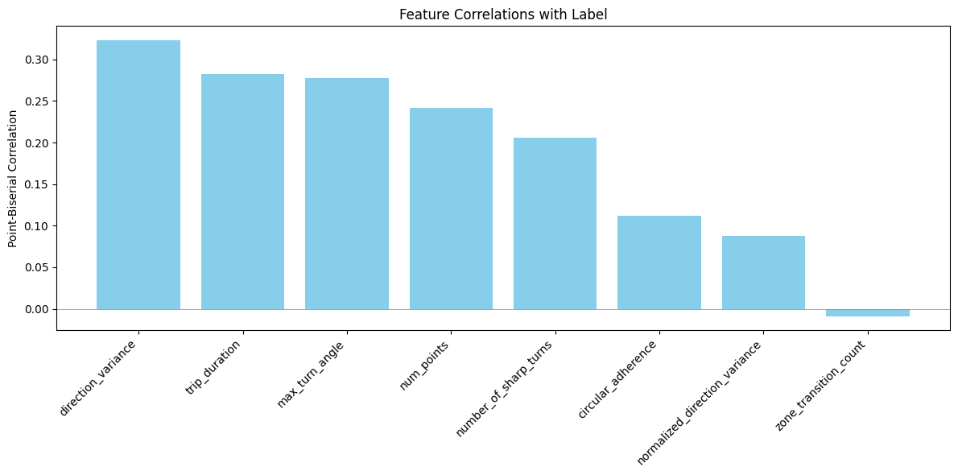

The chart illustrates which factors are most associated with abnormal driving. Direction variance, maximum turn angle and duration of the trip are the most associated features signifying erratic movement, longer trips and sharp turns are most associated with risky driving. Sharp turns and number of points also have some contribution towards abnormal behavior. zone transition count has minimal association signifying it has no contribution towards risky driving.

# Tasks Planned for Next Week:

Next week, we will focus on unsupervised classification using DBSCAN to cluster roundabout trajectories and detect outliers. We’ll also explore the Time-C algorithm for time-series clustering to identify temporal patterns in trajectories.