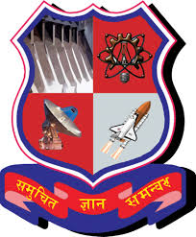

**CUSTOMER RELATIONSHIP MANAGEMENT SYSTEM (CRMS)**

**PROJECT ID:** GIH091

**PROJECT NAME:** CUSTOMER RELATIONSHIP MANAGEMENT SYSTEM (CRMS)

**MEMBERS NAME:** Sharma Bhumi Bhupendra

Sardar Ravina Sudhakarbhai

Rawat Muskan Pramod

Dalwadi Riddhi Upendrakumar

Goraniya Sakshi Khimabhai