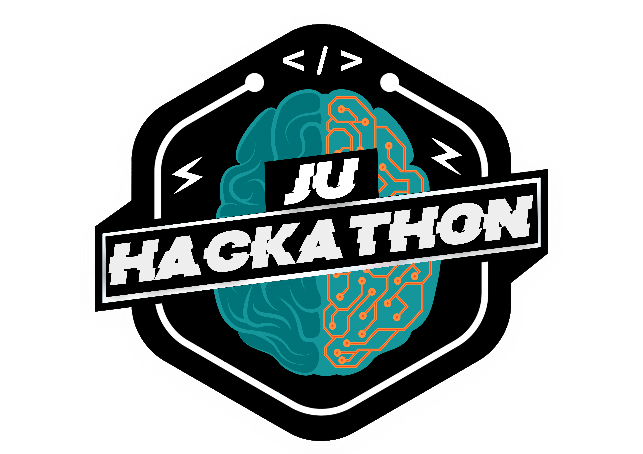


Idea submission form

Title
(Enter your idea title name here)
SMART ALERT AND POST DISASTER SYSTEM

Categories —

Governance ☐
Public Digitalization ☐
Education ☐
Malware and Fraud Analysis ☐
Disaster Management ☒
Environmental Sustainability ☐
Renewable Energy ☐
Cyber Security ☐
Healthcare ☐
Agriculture and Ruler Development ☐

Others

Member List —

S.NO. | Name | Gender | College | Course | Department | DOB | T-shirt size
1 | Sharma Bhumi Bhupendra | Female | Government Polytechnic for Girls, Ahmedabad | Information Technology | Information Technology | 11/1/2000 | M
2 | Thakkar Zinal HiteshKumar | Female | Government Polytechnic for Girls, Ahmedabad | Information Technology | Information Technology | 7/23/2000 | M
3 | Sardar Ravina SudhakarBhai | Female | Government Polytechnic for Girls, Ahmedabad | Information Technology | Information Technology | 8/23/2001 | XXL
4 |  | Choose an item. |  |  |  | Click or tap to enter a date. | Choose an item.

Team name —
Hack ‘O’ holics

E-mail Id —
(Enter the email for group communication)
sharmabhumi2000@gmail.com

Mobile number —
(Enter the Mobile number for group communication)
+91- 9898660970

Abstract —
(**Max of 100 words which describe your idea and gives an overview about the product that you have vision to develop.)

SAPDS is a web portal designed to manage disaster from its prevention to its recovery on a single platform. We will use the portal to notify the officers of national, zonal, state/district level about the disaster, through E-Mail/SMS. User can raise an incident of the disaster which will be verified by CMT. The rescue team will upload the details of the people to whom they have rescued similarly, the family will also upload the details of the people to whom they have lost, and then our portal will make rescued people meet with their family members.

Other links —
(**ex- GitHub links, flowchart, diagrams etc.)

https://drive.google.com/drive/folders/1CfnyyvAv-V4PTJ2QH0b0jYreigzA8-en?usp=sharing

Description (*Required) —
(**A further description of the idea which can include various other aspects like implementation, proof of concept, etc. Max 250 words)
s
Existing System Survey
There is no system that allows informing about disaster via E-mail and SMS. User cannot raise an incident or cannot able to track the disaster digitally. There is no such system that represents the Graphical Representation of disaster also no such a system exists that meets the rescued and lost people. In the previous system, there is no such tie-up between government and Companies for funds.
Outcomes from our System
We will notify the officers of national, zonal, state/district level about the disaster through E-mail/SMS. User can raise an incident of the disaster which will be verified by CMT that whether it is real/fake. He/ She can able to the track disaster digitally and can also view Graphical Representation of the disaster-affected area. In our system, the rescue team will upload the details of people to whom they have rescued similarly, the family will also upload the details of the people to whom they have lost, and then our portal will make rescued people meet with their family members. In our system, there is a tie-up for fund between government and companies. For Example - We have purchase pen drive worth Rs 500.66 Rs from amazon then the Amazon will take 500 Rs and the remaining 66 paise will be stored for disaster. User can view the Disaster Center on Google Maps and can able to view and write blogs, first-aid tips, and disaster checklist, etc.

** After filling up all the details, kindly save the document and upload it in the Hackerearth portal.

