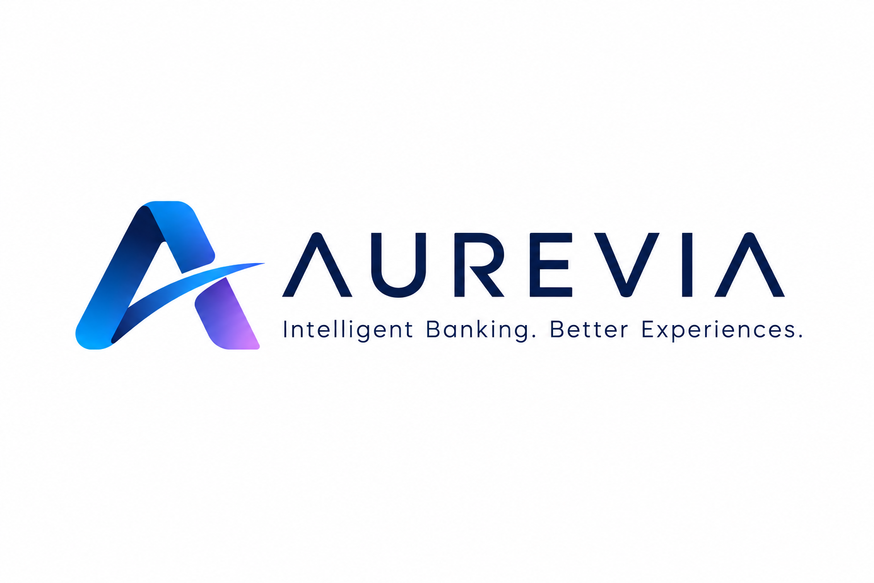
AI-Enabled Smart Onboarding Platform
A Proposal for Aurevia

1. Executive Summary
Aurevia's onboarding process is slow. Legacy systems, manual document checks, and multiple compliance handoffs create delays. This matters commercially: 70% of customers say onboarding shapes whether they stay with a bank. Aurevia risks losing new customers before they experience the brand.
We propose a Smart Onboarding Platform. It works alongside Aurevia's existing core banking system, so nothing needs to be ripped out and replaced. An API and middleware layer connects AI tools to Aurevia's CRM, KYC and compliance systems. AI reads documents, verifies identity, and flags risk. People stay in control of exceptions and high-risk cases.
We recommend a phased rollout, starting with a small, controlled pilot. Aurevia's current onboarding channel stays live throughout as a safety net. The goal is simple: automate the routine, escalate the important, and never compromise compliance or trust.

2. Problem & Analysis
Aurevia's onboarding challenge is not old technology alone. It is fragmentation. Three bottlenecks stand out because they combine high customer friction with strong automation potential.
- Fragmented systems: banking, CRM, KYC and compliance platforms don't talk to each other, so staff re-key the same data more than once.
- Manual document checks: employees spend hours on repetitive verification, and customers get asked for the same documents twice.
- Sequential compliance steps: low-risk applications wait behind high-risk ones in the same queue, even though they need far less scrutiny.
Customers expect speed. Regulators demand rigor. Aurevia needs both — KYC and AML checks are non-negotiable. The real challenge is precision: remove unnecessary manual work, but keep every necessary control. An orchestration layer, not a system replacement, is the right answer.
This matters for Aurevia specifically. Every day a new applicant waits on paperwork is a day a competitor bank can win that customer instead. Fixing the friction, not just the technology, is what protects Aurevia's growth.

3. Proposed Solution
We recommend an AI-enabled Smart Onboarding Platform that runs alongside Aurevia's legacy core. The flow is straightforward: customer, then AI processing, then KYC/AML and risk checks, then risk-based routing, then the API/middleware layer, then Aurevia's existing systems.
Document & customer processing. A mobile-first interface guides customers with conversational AI. OCR and NLP tools read documents, catch errors, and pre-fill forms, cutting repeat requests.
Identity & compliance. Digital identity checks verify customers automatically. AI flags anything unusual and routes it for human review, so nothing risky slips through unchecked.
Risk-based routing. Low-risk applications move straight through. Medium-risk cases get extra verification. High-risk or unclear cases go to a compliance officer. This puts Aurevia's people where their judgment matters most.
Legacy integration. An orchestration layer connects the new AI tools to Aurevia's banking, CRM and compliance systems through APIs. Aurevia's core stays the system of record — nothing is replaced.
We chose this approach over building a brand-new core system because it is faster to deploy, lower risk, and keeps Aurevia's existing compliance investments intact.

4. Implementation
Three risks matter most: integration, compliance, and staff adoption. A phased plan manages all three.
Phase 1 – Validate & Lead (Months 1–3). Set up governance, data-sharing rules and security controls. Connect the platform to Aurevia's systems and run a controlled pilot with a small group of staff and customers. Train senior managers first, since they set the rules everyone else follows.
Phase 2 – Frontline Adoption (Months 4–6). Roll out to customer-facing staff. Use journey analytics to spot friction points and fix them quickly.
Phase 3 – Scale & Embed (Month 7 onward). Expand fully once the pilot proves it works, measured against customer satisfaction, compliance accuracy and system reliability.
Throughout, Aurevia's original onboarding channel stays available. If something breaks, customers still have a way through.
Key pilot risks — data quality, integration failures, false positives and staff resistance — are managed through validation checks, fallback procedures, threshold tuning and role-based training. Any AI or vendor tool is assessed against security, privacy, explainability, regulatory fit, integration ease, reliability and cost before it is added.

5. Success Metrics
Aurevia should track results across three areas before rolling this out further.
Area | Metric | Why It Matters
Customer Experience | Onboarding time, drop-off rate | Faster, smoother sign-ups
Compliance & Risk | Verification accuracy, fraud detection | Stronger, safer decisions
Operations & Adoption | Manual workload, staff training completion | Lower cost, lasting change
We recommend measuring a pilot baseline first, then comparing results against the cost of running the platform. This proves value before Aurevia commits to a full rollout.

6. Use of AI in This Proposal
We used Claude and ChatGPT throughout this project as research and drafting assistants, not decision-makers.
AI helped us structure the problem quickly, compare onboarding technologies such as OCR, conversational AI and predictive analytics, and tighten our writing.
But every recommendation went through human judgment. We checked AI suggestions against real banking constraints: regulatory rules, integration cost, and what Aurevia's customers would actually experience. Where AI suggested something impractical or vague, we changed it.
For example, AI drafted a first-pass list of onboarding technologies. We narrowed it down, rejecting options that were impressive on paper but too costly or too hard to integrate for Aurevia's real systems. That filtering step was ours, not the AI's.
AI was our co-pilot. It moved us faster. It did not fly the plane.

7. Conclusion & Next Steps
Aurevia doesn't need to rebuild its core banking system to fix onboarding. A Smart Onboarding Platform offers a practical, low-disruption path — one that speeds things up without weakening KYC or AML controls.
Next steps: secure leadership approval, confirm data-sharing agreements, set pilot baselines, and launch Phase 1.
Test → Measure → Learn → Improve → Scale
Done right, this gives Aurevia faster onboarding, happier customers, and stronger compliance — all at once.

