NAAN MUDHALAVAN - DIGITAL MARKETING

ASSIGNMENTS

|  |  |
| --- | --- |
| NAME | VISHVAMAHARAJA P |
| NM-ID | 1017F30241CA114BAA2453BAE95CBF8B |

BRAND NAME: SWAGZ

FACEBOOK PAGE:

<https://www.facebook.com/profile.php?id=61550270776366&mibextid=ZbWKwL/>

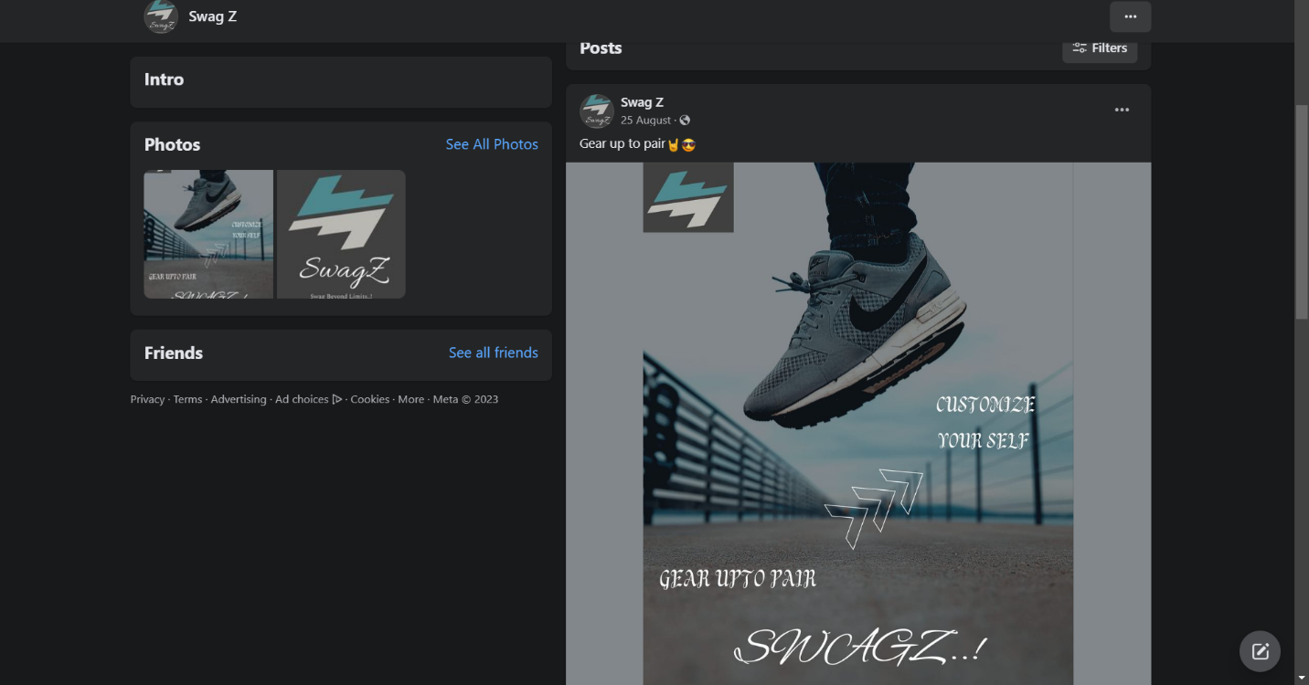

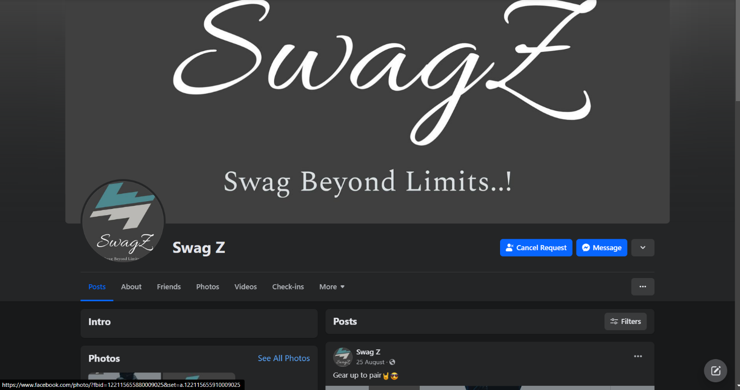

BLOGGER WEBSITE:

<https://qazsdg.blogspot.com/2023/08/stepping-up-your-style-game-with-swagz.html/>

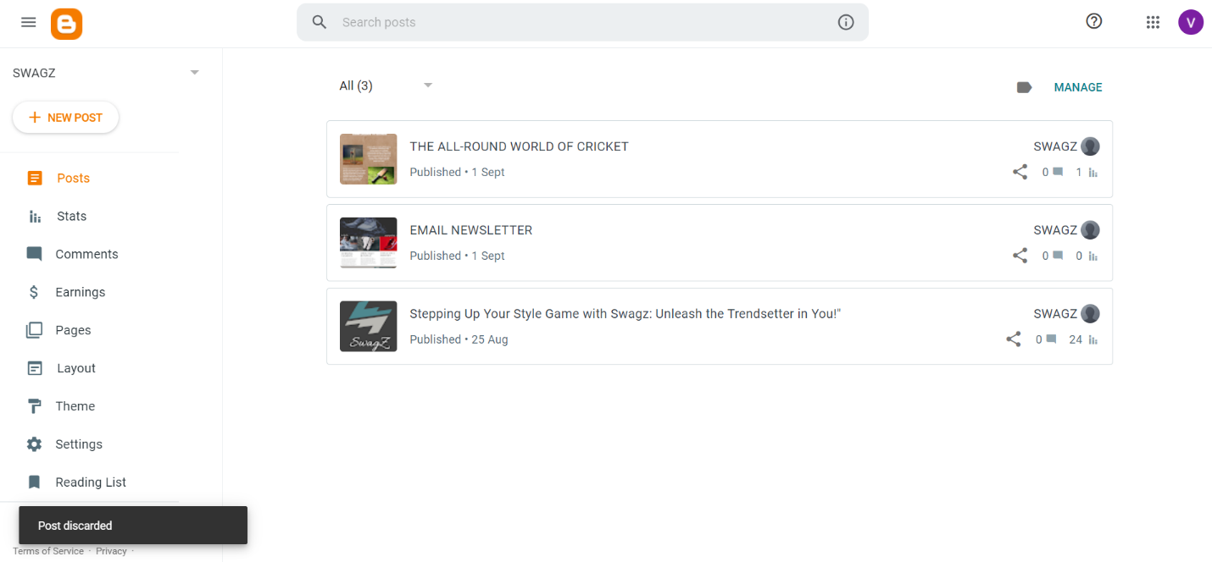

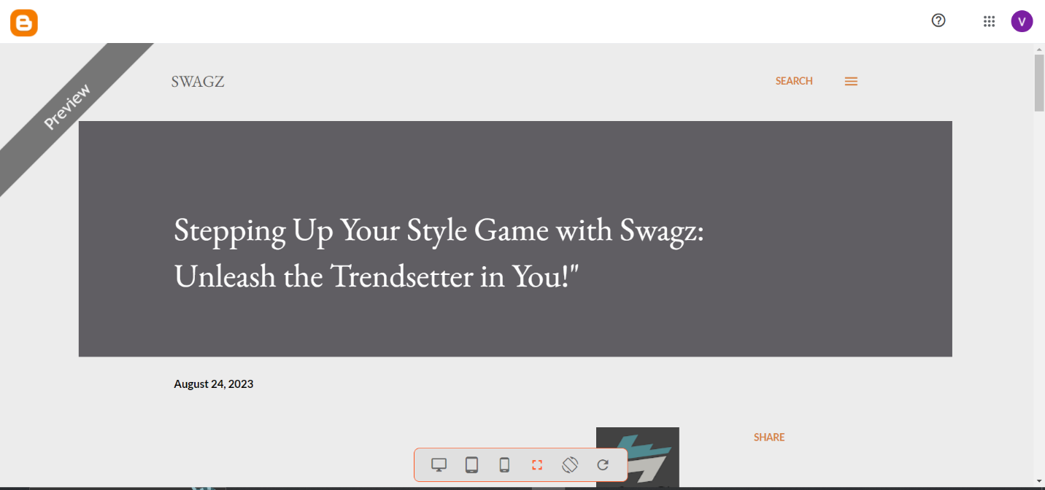

INFOGRAPHIC POST:

<https://qazsdg.blogspot.com/2023/09/the-all-round-world-of-cricket.html/>

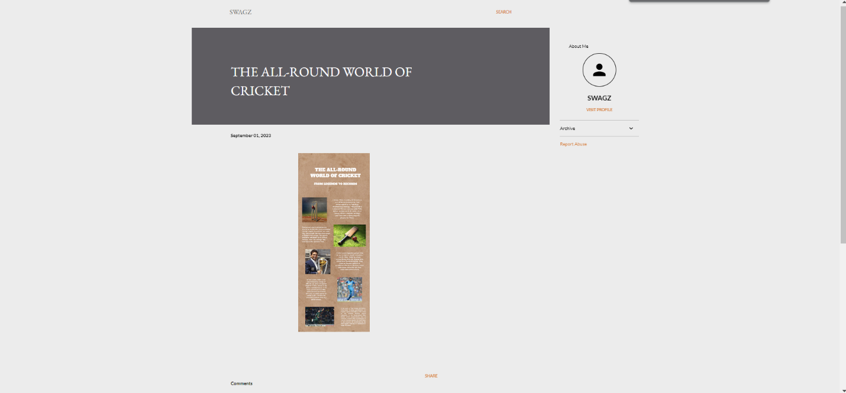

EMAIL NEWSLETTER:

<https://qazsdg.blogspot.com/2023/09/email-newsletter.html/>

