|  |  |  |
| --- | --- | --- |
| AI_Phase_1 | September 30  2023 | |
|  | | NM :Project |

**PHASE 1**

**Problem Definition and Design Thinking**

# PREDICTING HOUSE PRICES USING MACHINE LEARNING

Problem Definition :

* **The problem is to predict house prices using machine learning techniques.**
* **The objective is to develop a model that accurately predicts the prices of houses based on a set of features such as location, square footage, number of bedrooms and bathrooms, and other relevant factors.**
* **This project involves data preprocessing, feature engineering, model selection, training, and evaluation.**

Over View :

* **Data Collection**
* **Gather historical house price data**
* **Collect features like square footage, bedrooms, location, etc.**
* **Data Preprocessing**
* **Handle missing data**
* **Fill missing values**
* **Encode categorical variables**
* **Convert categorical data to numerical**
* **Split data into training and testing sets**
* **Choose a Model**
* **Select Linear Regression**
* **Train the Model**
* **Use training data to train the Linear Regression model**
* **Model Evaluation**
* **Use testing data to evaluate model performance**
* **Calculate MAE, MSE, RMSE, etc…**
* **Visualize results (scatter plots, etc…**
* **Make Predictions**
* **Use the trained model to predict house prices**

# Design Thinking :

* **Data Collection :**
* **Gather historical house price data from reliable sources.**
* **Collect relevant features such as square footage, bedrooms, bathrooms, location, and sale prices.**
* **Data Preprocessing:**
* **Handle missing data by filling in missing values (e.g. with mean or median).**
* **Encode categorical variables, converting them into numerical format (e.g., one-hot encoding).**
* **Split the dataset into training (70-80%) and testing (20-30%) sets for model evaluation.**
* **Choose Model:**
* **Select a regression model suitable for predicting house prices (e.g., Linear Regression).**
* **Train Model:**
* **Utilize the training data to train the selected model.**
* **The model learns relationships between features and target prices.**
* **Model Evaluation:**
* **Assess the model's performance using testing data.**
* **Calculate evaluation metrics like Mean Absolute Error (MAE), Mean Squared Error (MSE), and Root Mean Squared Error (RMSE).**
* **Make Predictions:**
* **Apply the trained model to make predictions on new, unseen data or real-world scenarios.**
* **Monitoring and Maintenance (for production use):**
* **Continuously monitor the model's performance and retrain it with fresh data as needed to ensure accuracy.**

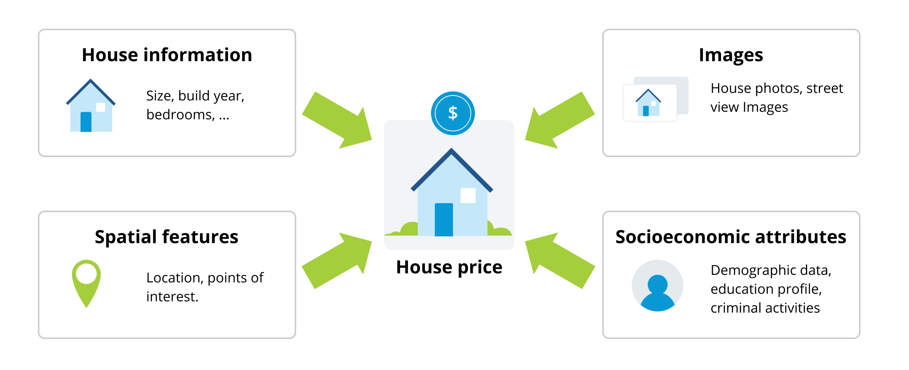

THANK YOU !!!