ZaminWale - Real Estate Platform Documentation

Overview

Seller -> Posts property -> Admin -> Reviews & Approves -> Property goes live -> Buyer -> Searches & views listings -> Contacts Seller -> Offline transaction

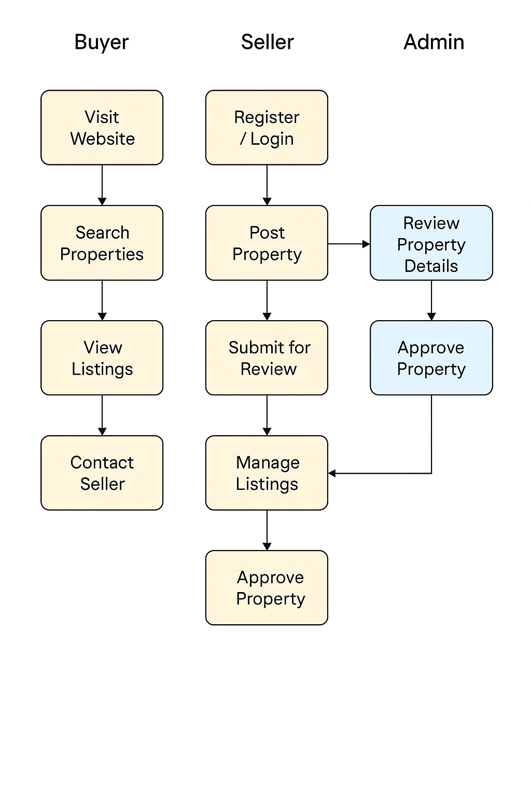
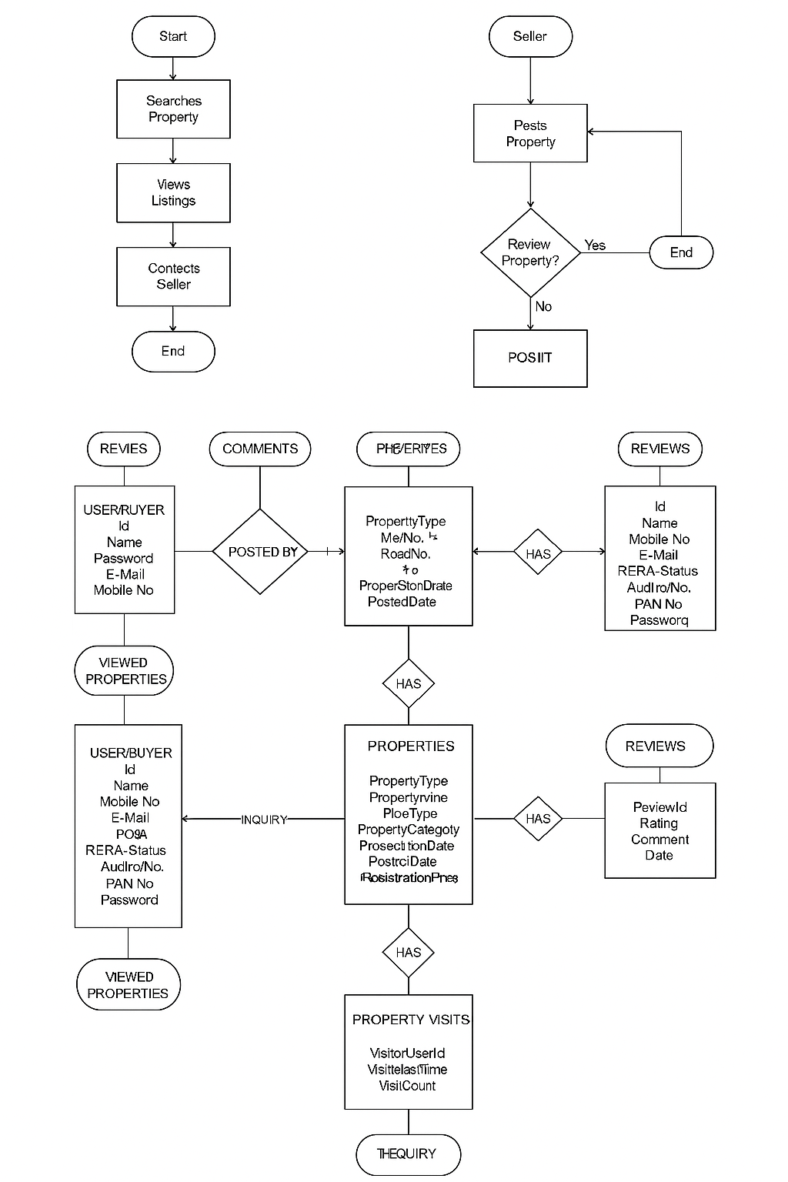

Objectives
- - Create a scalable and responsive real estate portal
- - Enable property search, listing, and inquiry features
- - Provide admin control for managing users and properties

Features
- - Homepage with featured and recommended properties
- - Advanced property search filters (location, type, budget)
- - Google Maps integration for property location
- - Property listing grid and detailed view
- - Enquiry/contact form on each property
- - Blog/news section
- - Post Your Property form
- - User authentication (login/signup)
- - Admin dashboard for managing content

Data (from ZaminWale)
- - Property categories: Residential, Commercial, Bungalow/Villa
- - Locations: Panvel, Thane, Navi Mumbai, Uran, Mumbai ,Khalapur ,Dronagiri, Ranjanpada, Chirle, Vindhane, Chowk Panvel

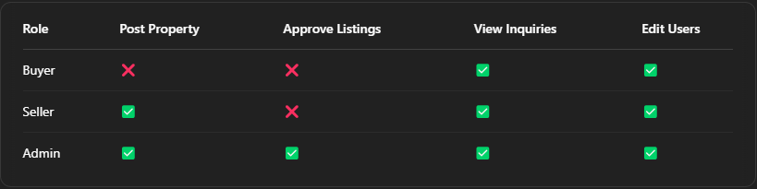

Admin Panel Features
- - View, approve, or delete property listings
- - Manage users and property types
- - Settings (Change Password , etc)

Seller Panel Features

1. Dashboard Overview
- Summary of all posted properties (active, pending, sold)
- View listing-wise performance (total views, CTR)
- Track inquiries per property

2. Property Management
- Add new property with full details (type, location, budget, etc.)
- Upload images/videos and documents (e.g., 7/12 extract, NA title)
- Edit or delete existing listings
- Set property status: Active, Pending Approval, Sold, Expired

3. Inquiry Management
- View all buyer inquiries

4. Profile & Settings
- Update seller details (name, email, phone, etc.)
- Upload KYC documents for verification
- Change account password

Seller Flow

1. Register / Login:
- Seller (individual or agent) signs up/logs in.
- KYC Authentication / Mobile OTP Verification
2. Post Property:
- Click on “Post Property” button.
- Fills form:
3. Submit for Review:
- Listing goes to admin panel.
- Shown as “Pending” until approved.
4. Approval & Publishing:
- Once approved by admin, property goes live.
- Seller receives notification on Dashboard.
5. Manage Listings:
- Sellers can:
  - Edit details
  - View analytics (views, inquiries)

Buyer Flow

- Visit Website:
  - Sees property types: Buy, Rent, Commercial, Projects, etc.
- Search Properties:
  - User enters location, budget, property type (flat, villa, plot), BHK, etc.
- View Listings:
  - Each listing shows photos, price, area (sq.ft), location, features.
  - Can apply filters and sort results.
- Check Property Details:
  - Click on a listing to see:
    - Full description
    - Map location
    - Amenities
    - Seller contact info
    - Similar properties
- Contact Seller/Broker:
  - require Authentication for contact.
  - Options to call, WhatsApp .
- Schedule Visit / Book Property:
  - Offline process starts (site visits, discussions).
  - Buyer negotiates and finalizes with seller/builder.

Master Data :
User/Buyer : Id, Name, Password, Gender ,E-Mail, Mobile No, Commented ID, Reviews ID, Viewed Properties ID , Reported Properties ID , Inquiry Properties ID ,IsActivated , Isverified, ProfileImage , DateOfSignup
Seller : Id , Name , Mobile No, Gender, E-Mail, RERA Status, AdharNo , PAN No , Password , SellerType (Agent/Builder/Owner) , KYCVerified (Yes/No)
Property Details :
- PropertyID
- PropertyName
- PostedBy (SellerID or Agent)
- PostType (Rent/Sale)
- PropertyType (Residential / Commercial / Bungalow / Villa / Plot / Flat / Apartment)
- Location:
  - PlotNo
  - RoadNo
  - Area
  - City
  - State
  - Pincode
  - Landmark
- Price:
  - ExpectedPrice
  - BasePricePerSqft
- AreaInSqft:
  - CarpetArea
  - BuiltUpArea
  - SuperBuiltUpArea
- ConstructionDetails:
  - PropertyAge
  - ConstructionStatus (Under Construction / Ready to Move)
  - Furnishing (Unfurnished, Semi-furnished, Fully-furnished)
  - FloorNo
  - TotalFloors
- RoomsCount:
  - Bedrooms
  - Bathrooms
  - Balconies
  - Halls
- RERAStatus (Verified / Not Verified)
- RegistrationNumber
- PropertyStatus (Approved / Rejected / Pending)
- PossessionDate
- PostedDate
- Images
- VideoURL (optional)
- Facing (East, West, North, South)
- PropertyCategory (Primary / Resale)
- Amenities (Swimming pool, Lift, Gym, etc.)
- GoogleMapEmbedLink
- AvailabilityStatus (Available / Booked / Sold)
- BoostedListing (Yes/No - For paid/premium listings)

Property Reviews
- ReviewID
- UserID
- PropertyID
- Rating (1-5)
- Comment
- Date
Property Visit/Views
- PropertyID
- VisitorUserID
- VisitDateTime
- VisitCount (Aggregate)
- InquiryCount

