# Brainstorm

**TIP**

Add customizable tags to sticky notes to make it easier to find, browse, organize, and categorize important ideas as themes within your mural.

**TIP**

You can select a sticky note and hit the pencil [switch to sketch] icon to start drawing!

**TIP**

Participants can use their cursors to point at where sticky notes should go on the grid. The facilitator can confirm the spot by using the laser pointer holding the **H key** on the keyboard.

## Before you collaborate

#### A little bit of preparation goes a long way with this session. Here’s what you need to do to get going.

##### 10 minutes

**1**

## Define your problem statement

#### What problem are you trying to solve? Frame your problem as a How Might We statement. This will be the focus of your brainstorm.

##### 5 minutes

**2**

## Brainstorm

#### Write down any ideas that come to mind that address your problem statement.

##### 10 minutes

**3**

## Group ideas

#### Take turns sharing your ideas while clustering similar or related notes as you go. Once all sticky notes have been grouped, give each cluster a sentence-like label. If a cluster is bigger than six sticky notes, try and see if you and break it up into smaller sub-groups.

##### 20 minutes

**4**

Predictive maintenance and occupancy monitoring system can also be implemented

Energy Efficiency management and water conservation management can also be implemented

Digital signage and wayfinding system is also can be implemented

We can use Sensors and Solar panels and Touchless Features.

## Prioritize

#### Your team should all be on the same page about what's important moving forward. Place your ideas on this grid to determine which ideas are important and which are feasible.

**20 minutes**

Energy Efficiency management and water conservation management can also be implemented

## After you collaborate

You can export the mural as an image or pdf to share with members of your company who might find it helpful.

**Quick add-ons**

# & idea prioritization

**PROBLEM**

**People got fear for going to a public restroom’s because of un-hygienic places**

Use this template in your own brainstorming sessions so your team can unleash their imagination and start shaping concepts even if you're not sitting in the same room.

###### Team gathering

Define who should participate in the session and send an invite. Share relevant information or pre-work ahead.

###### Set the goal

Think about the problem you'll be focusing on solving in the brainstorming session.

###### Learn how to use the facilitation tools

Use the Facilitation Superpowers to run a happy and

###### Vishvam

using sensor and solar panel

###### Kishore

we control the temperature inside the restrooms

###### Mohanaa Krishnan

we use water conservation system

###### Rishi kannan

we control the street lights based upon our weather condition

###### Share the mural

**Share a view link** to the mural with stakeholders to keep them in the loop about the outcomes of the session.

We can use Sensors and Solar panels and Touchless Features.

###### Export the mural

Export a copy of the mural as a PNG or PDF to attach to emails, include in slides, or save in your drive.

**10 minutes** to prepare

**1 hour** to collaborate

**2-8 people** recommended

productive session.

[**Open article**](https://support.mural.co/en/articles/2113740-facilitation-superpowers)

**Key rules of brainstorming**

To run an smooth and productive session

###### Naveen

using sensor to change the light control

###### Tamil selvan

We can introduce a hand-sensing drier

**Person 7**

**Person 8**

### Keep moving forward

###### Strategy blueprint

Define the components of a new idea or strategy.

###### [Open the template](https://app.mural.co/template/e95f612a-f72a-4772-bc48-545aaa04e0c9/984865a6-0a96-4472-a48d-47639307b3ca)

**Customer experience journey map**

Stay in topic. Defer judgment.

Encourage wild ideas. Listen to others.

### Importance

If each of these

Understand customer needs, motivations, and obstacles for an experience.

###### [Open the template](https://app.mural.co/template/b7114010-3a67-4d63-a51d-6f2cedc9633f/c1b465ab-57af-4624-8faf-ebb312edc0eb)

Go for volume. If possible, be visual.

tasks could get

done without any difficulty or cost, which would have the most positive impact?

We can implement Feedback system in our SPR’s

We can implement Feedback System in our SPR’s

###### Strengths, weaknesses, opportunities & threats

Identify strengths, weaknesses, opportunities, and threats (SWOT) to develop a plan.

|  |  |
| --- | --- |
|  |  |
|  |  |

###### [Open the template](https://app.mural.co/template/6a062671-89ee-4b76-9409-2603d8b098be/ca270343-1d54-4952-9d8c-fbc303ffd0f2)

[**Share template feedback**](https://muralco.typeform.com/to/CiqaHVat?typeform-source=app.mural.co)

[**Share template feedback**](https://muralco.typeform.com/to/CiqaHVat?typeform-source=app.mural.co)

### Feasibility

Regardless of their importance, which tasks are more feasible than others? (Cost, time, effort, complexity, etc.)

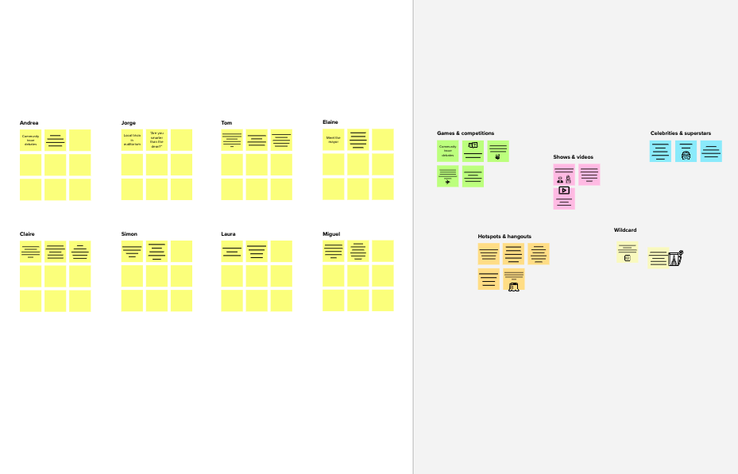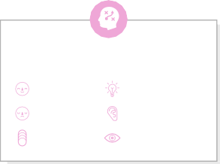

**Template**

**Need some inspiration?**

See a finished version of this template to kickstart your work.

[**Open example**](https://app.mural.co/template/e5a93b7b-49f2-48c9-afd7-a635d860eba6/93f1b98d-b2d2-4695-8e85-7e9c0d2fd9b9)