E-Commerce Website (BOAT - Clone)

Human Computer Interface - MINI PROJECT REPORT

Submitted by

VISHVAM PARIHAR (24MCI10010)

in partial fulfillment for the award of the degree of
MASTER OF COMPUTER APPLICATIONS

IN

COMPUTER APPLICATIONS



Chandigarh University, India.

April, 2026



CERTIFICATE OF ACCEPTANCE

Certified that this project report “E-Commerce Website (BOAT - Clone)” is the bonafide work of “Vishvam Parihar” who carried out the project work under my/our supervision.
This project work is hereby accepted by the Department of Computer Applications, University Institute of Computing, Chandigarh University, India, in partial fulfillment of the requirements for the award of Degree in Master of Computer Application.

SIGNATURE
Dr. Javed Alam
(Associate Professor)
SUPERVISOR

ACKNOWLEDGEMENT

We would like to express my heartfelt gratitude to all those who assisted us in preparing and completing our Major Project report titled “E-Commerce Website (BOAT - Clone)”.I extend my sincere appreciation and thanks to Dr. Javed Alam for inspiring, cooperating, and encouraging us to pursue my work.
With his valuable suggestions and guidance, I was able to complete my work in a short time frame at this institution.
I also convey our respect and gratitude to Dr. Amandeep Kaur, (HOD) University Institute of Computing, and Chandigarh University, as well as all the faculty members, for their valuable suggestions and guidance towards completing the report.
Furthermore, I’m grateful to all our academic mentors who provided direct or indirect assistance in successfully completing our major project report.
Last but not least, I’m immensely grateful to our parents, who served as a constant source of encouragement and inspiration throughout the completion of this work at Chandigarh University, Mohali.

Vishvam Parihar (24MCI10010)

ABSTRACT

Ensuring seamless public access to digital marketplaces and optimizing the consumer journey remains a significant issue within contemporary digital metropolises. This initiative introduces an integrated front-end framework aimed at facilitating electronic commerce by analyzing user-centric and chronological variables. The study specifically examines how well the interface performs in distinguishing between various product categories based on features like responsiveness and modern UI design.
Among the technologies utilized, the Bootstrap framework stands out due to its strong layout capabilities and ease of understanding by human users. The highly refined design serves as the core of our system, which presents user interfaces through static HTML pages accompanied by CSS styling and JavaScript functionality on top-level components. This instrument offers instantaneous interaction evaluations through the analysis of crucial elements like Navigation, Product Details, and Category Filtering. This system showcases an effective use of artificial intelligence and front-end techniques to improve public access to electronics by increasing consumer surveillance capabilities and possibly assisting retailers in managing inventory efficiently.

Table of Contents

- Introduction
- Objectives
- Scope of Project
- Technologies Used
- System Requirements
- Project Structure
- UI Components Used
- Design Approach
- Implementation Details
- Challenges and Solutions
- Testing
- Results and Output
- Future Enhancements
- Conclusion

1. Introduction
The project is a high-fidelity front-end e-commerce website designed specifically to showcase and sell premium electronic products such as earbuds, headphones, speakers, and smartwatches. It serves as a simulation of a real-world online shopping platform where users can browse products, view specific details, and navigate between various categories efficiently. The primary focus is on delivering a modern User Interface (UI) that emphasizes responsiveness and usability.

2. Objectives
The core goals of this development include:
- Designing a fully responsive e-commerce layout that adapts to various screen sizes.
- Implementing modern UI techniques to create attractive product cards.
- Organizing a vast inventory into multiple, easy-to-navigate categories.
- Creating detailed product-specific pages to provide deep information to the user.
- Enhancing the overall User Experience (UX) using CSS animations and pre-built Bootstrap components.

3. Scope of Project
Currently, the scope is strictly limited to front-end development. While it includes the complete visual and interactive structure, it does not yet include backend functionalities like user authentication, database storage, or live payment processing. However, the system architecture is designed to allow for seamless backend integration in the future.

4. Technologies Used
- HTML5: Used for the semantic structural foundation of the site, including headers, sections, and layout containers.
- CSS3: Responsible for the visual styling, including the custom layout design, color schemes, typography, and interactive hover animations.
- Bootstrap: This framework is used to implement a responsive grid system, align UI components like navigation bars, and ensure mobile compatibility.
- Font Awesome: Utilized to integrate scalable vector icons for social media links and UI features.
- VS Code: The Integrated Development Environment (IDE) used for writing, debugging, and managing the project code.

5. System Requirements
- Hardware: A standard computer or laptop with a minimum of 4GB RAM is required for smooth development and local hosting.
- Software: A modern web browser like Google Chrome or Microsoft Edge for rendering, and VS Code for source code management.

6. Project Structure
The project is organized into a modular file system:
- index.html: Serves as the primary homepage.
- Category Pages: Dedicated files for Earbuds, Headphones, Speakers, and Smartwatches.
- Product Pages: Individual files (e.g., product1.html) for specific item details.
- CSS Files: Modular stylesheets like first.css and product.css.
- Image Assets: A centralized folder for all product and branding imagery.

7. UI Components Used
The interface is built using several key components to ensure a professional look:
- Fixed Navigation Bar: A header that stays at the top for constant access to links.
- Mega Menu: Dropdown menus that organize categories for quick navigation.
- Interactive Cards: Specialized containers for products that include "Add to Cart" and "Buy Now" buttons.
- Footer Section: A comprehensive bottom section containing company details and social links.

8. Design Approach
The design follows modern UI/UX principles, focusing on a clean and minimal layout. A card-based display is used for products to provide a consistent look, supported by a unified color theme and smooth hover animations. Flexbox and the Bootstrap grid system are the primary tools used to maintain alignment across the site.
9. Implementation Details
The technical execution involved using the Bootstrap grid (row, col) and Flexbox for layout stability. Each product card was meticulously styled with box-shadows for depth, border-radius for rounded edges, and hover effects to increase interactivity. Navigation is handled via internal linking and clickable images.

10. Challenges and Solutions
Challenge | Solution
Image alignment issues | Resolved using the object-fit property and Flexbox containers.
Hover effect overlapping | Fixed by applying overflow: hidden to parent containers.
Header hiding top content | Corrected by adding a margin-top to the main content body.
Icons not appearing | Fixed by correcting the Font Awesome class naming conventions.

11. Testing
To ensure quality, the following testing procedures were performed:
- Link Verification: Checking that all internal and external navigation links function correctly.
- Responsiveness: Testing the layout on multiple screen sizes to ensure it doesn't break.
- Interactive Elements: Verifying that hover effects and buttons trigger the correct visual responses.
- Compatibility: Ensuring the site renders consistently across different web browsers.

12. Results and Output
The project successfully resulted in a fully functional front-end e-commerce platform. Key outputs include a dynamic homepage with a Quick Search section , a Top Smart Watches Collection , and a detailed Product Interface showing prices, ratings, and specifications like battery life and water resistance.

Header Part -
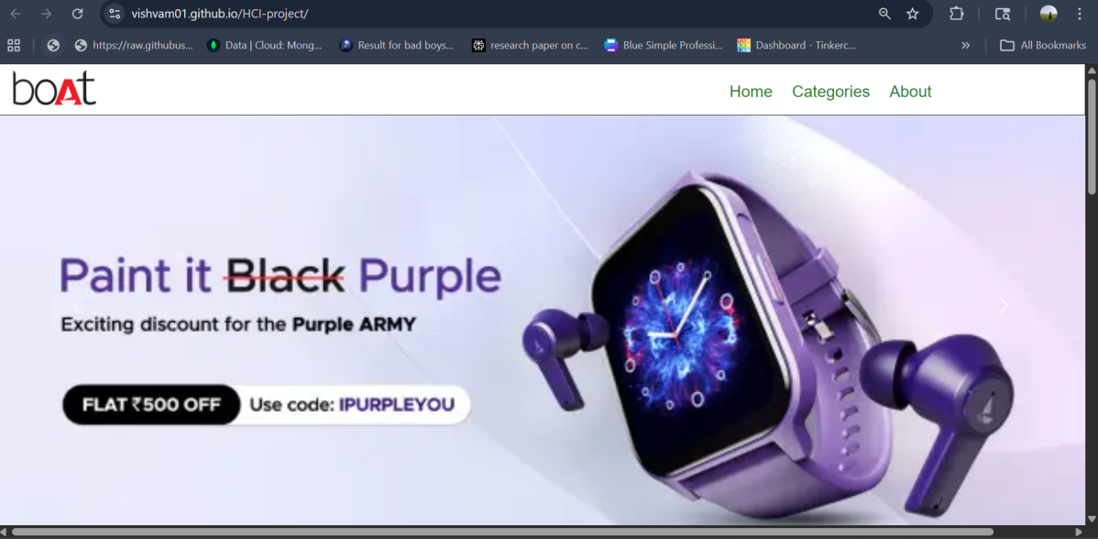
Quick Search Part –
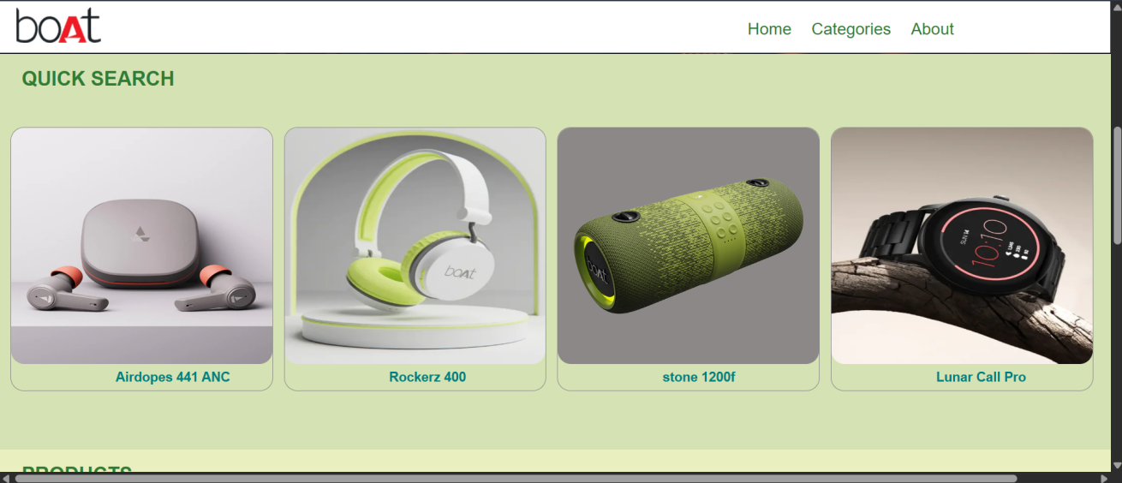

Product part –
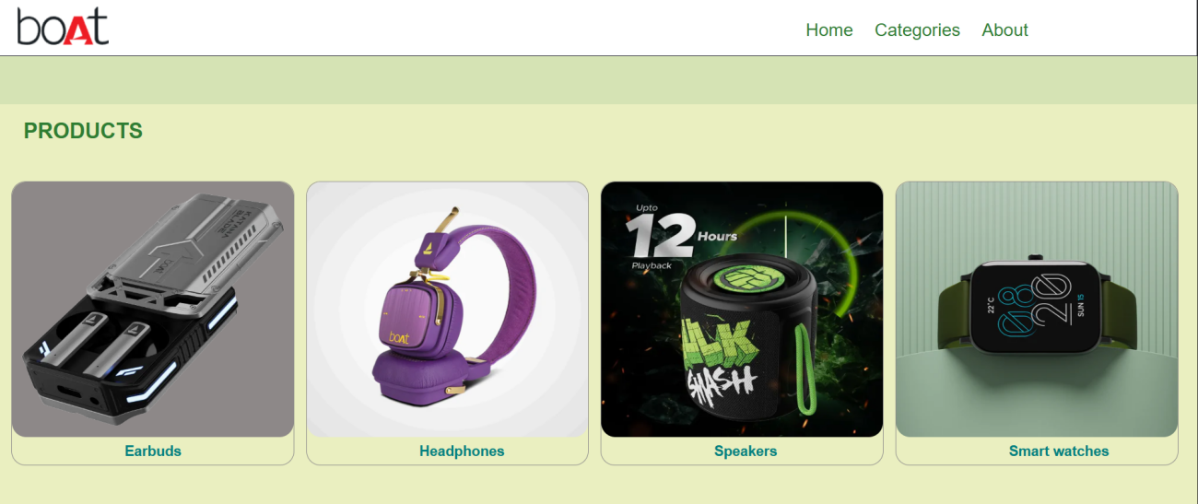

Footer Part -
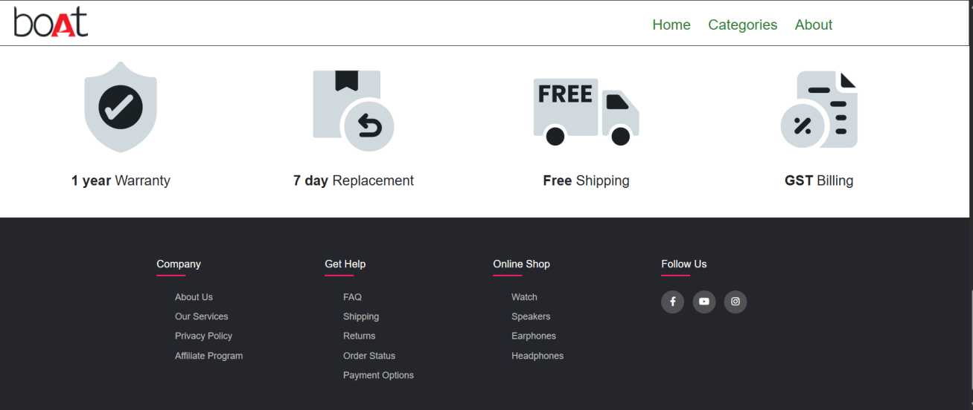

Watch Interface -
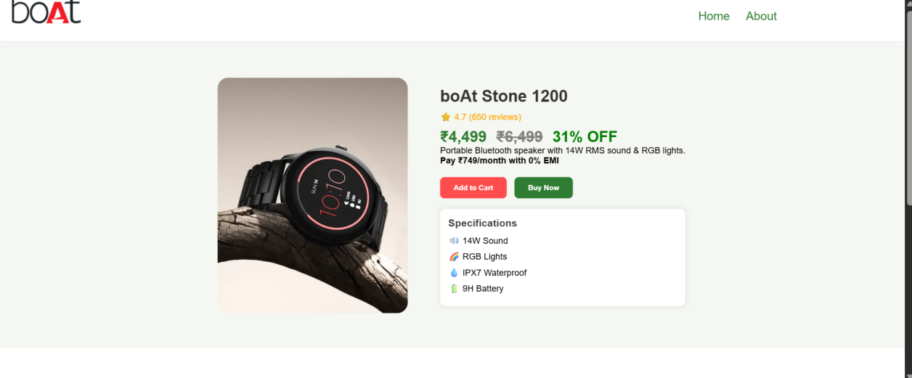
About Part -
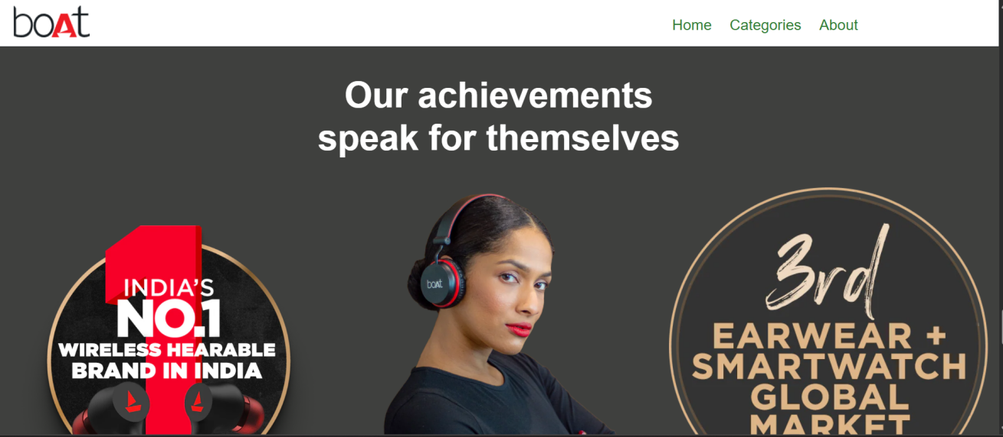

Products part -
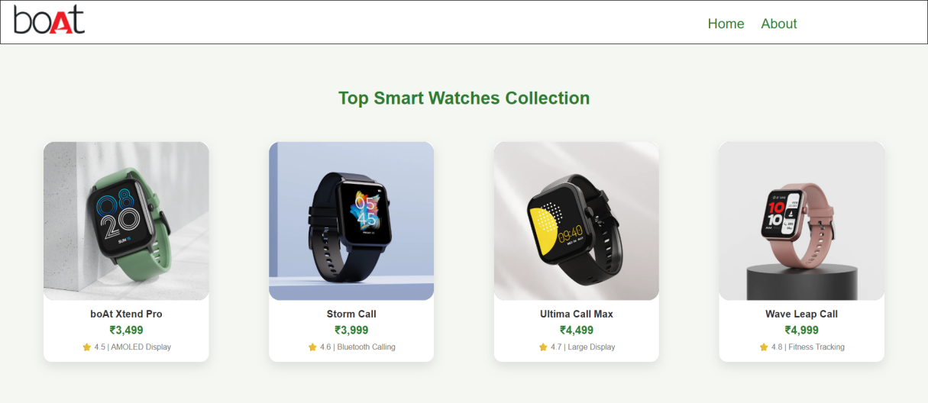
13. Future Enhancements
To evolve the project into a full-scale application, future steps include:
- Adding backend functionality and database storage.
- Developing a functional shopping cart system.
- Implementing user authentication (Login/Signup).
- Integrating a secure payment gateway for real transactions.
14. Conclusion
This project successfully demonstrates the practical application of HTML, CSS, and Bootstrap in a real-world scenario. It has significantly enhanced my skills in UI design and responsive web development, providing a strong foundation for building professional-grade web applications.
Github Link - https://github.com/Vishvam01/HCI-project
