Project Report: Data Analysis **Dashboard**

Student Name: **Vishvam Parihar** UID: **24MCI10010**

Branch: MCA (AIML) Section/Group:24MAM 1-A

Semester: 1st Date: 28/10/2024

Subject Name: Python Programming Subject Code: 24CAH-606

## Title

**Data Analysis Dashboard**

## Aim

To develop a user-friendly data analysis dashboard that allows users to upload datasets, perform statistical analysis, and visualize data through various types of plots, enhancing their understanding of the dataset and pr-omoting data-driven decision-making.

## Objectives

* Dataset Uploading: Implement functionality for users to upload CSV datasets easily.
* Data Preview: Enable users to view a preview of the uploaded dataset for validation.
* Statistical Analysis: Provide basic statistical metrics (mean, median, standard deviation, minimum, maximum) for user-specified columns.
* Data Visualization: Allow users to create various visualizations (line plots, bar plots, histograms) to better understand data patterns and distributions.
* User Interaction: Develop a simple menu-driven interface to facilitate easy navigation and interaction with the dashboard.

## Tasks to be Done

* Setup the Environment: Install necessary libraries (Pandas, Matplotlib, Seaborn).
* Implement Dataset Upload Functionality: Create a function to upload CSV files and load data into a DataFrame.
* Develop Data Preview Functionality: Implement a function to display the first few rows of the DataFrame.
* Statistical Analysis Functions: Create functions to calculate and display statistical metrics for specified columns.
* Visualization Functions: Develop functions to create different types of plots based on user input.
* Menu Interface: Design a simple menu interface that allows users to navigate between functionalities.
* Testing: Test the application with different datasets to ensure functionality and robustness.

## CODE

import pandas as pd

import matplotlib.pyplot as plt

import seaborn as sns

# Global variable to store the dataframe

dataframe = None

def menu():

    while True:

        print("\n1. Upload Dataset\n2. View Dataset\n3. Perform Analysis\n4. Visualize Data\n5. Exit")

        choice = input("Enter your choice: ")

        if choice == '1':

            upload()

        elif choice == '2':

            view()

        elif choice == '3':

            analysis()

        elif choice == '4':

            visualize()

        elif choice == '5':

            break

        else:

            print("Invalid choice.")

def upload():

    global dataframe

    file_path = input("Enter the path to your dataset (CSV file) without quotes: ")

    try:

        dataframe = pd.read_csv(file_path)

        print("Dataset uploaded successfully.")

    except Exception as e:

        print(f"Error: {e}")

def view():

    if dataframe is not None:

        print(dataframe.head())

    else:

        print("No dataset uploaded.")

def analysis():

    if dataframe is not None:

        column = input("Enter the column name for analysis: ")

        if column in dataframe.columns:

            print(f"Mean: {dataframe[column].mean()}")

            print(f"Median: {dataframe[column].median()}")

            print(f"Std Dev: {dataframe[column].std()}")

            print(f"Min: {dataframe[column].min()}")

            print(f"Max: {dataframe[column].max()}")

        else:

            print("Column not found.")

    else:

        print("No dataset uploaded.")

def visualize():

    global dataframe

    if dataframe is not None:

        print("\nChoose a type of plot:")

        print("1. Line Plot")

        print("2. Bar Plot")

        print("3. Histogram")

        plot_choice = input("Enter your choice: ")

        if plot_choice == '1':

            sns.lineplot(data=dataframe)

            plt.title("Line Plot")

            plt.show()

        elif plot_choice == '2':

            sns.barplot(data=dataframe)

            plt.title("Bar Plot")

            plt.show()

        elif plot_choice == '3':

            dataframe.hist()

            plt.title("Histogram")

            plt.show()

        else:

            print("Invalid choice.")

    else:

        print("No dataset uploaded.")

menu()

## Output:

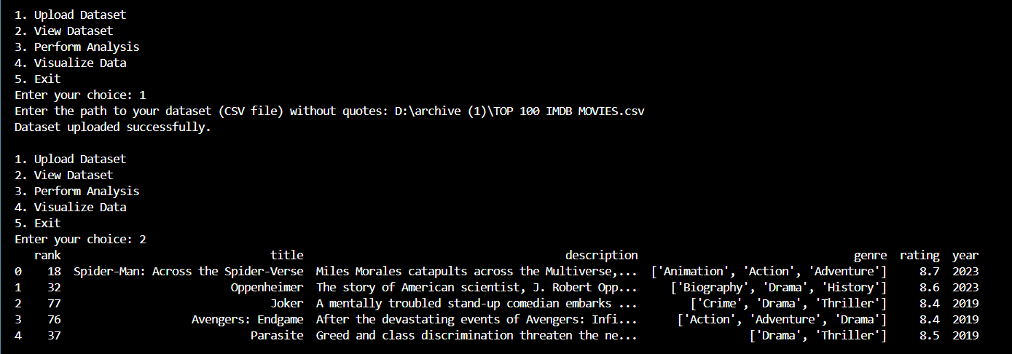

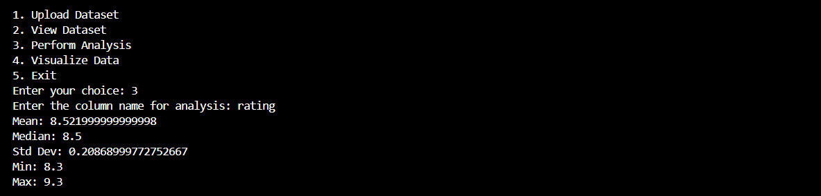

## 

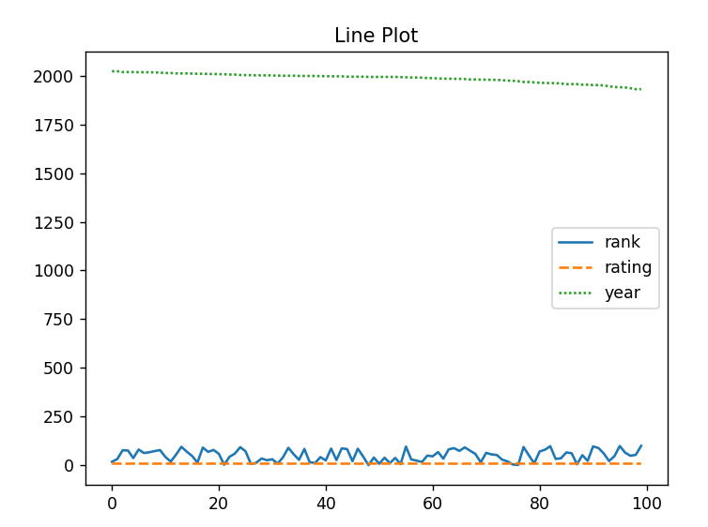 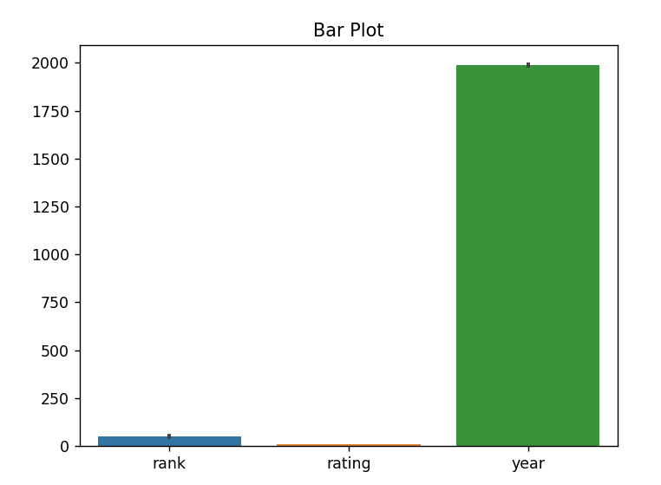 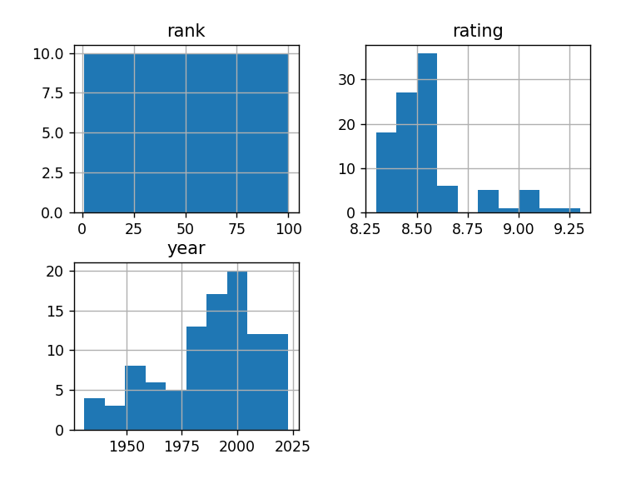

## Learning Outcomes

* Understanding Data Handling: Gain practical experience in data handling and manipulation using Pandas.
* Statistical Analysis Skills: Develop an understanding of basic statistical concepts and how to compute them programmatically.
* Data Visualization Techniques: Learn how to visualize data using Matplotlib and Seaborn to communicate insights effectively.
* Python Programming Proficiency: Enhance Python programming skills, including function creation, user input handling, and control flow structures.
* Project Development Experience: Acquire experience in developing a complete software project, from concept to execution, including debugging and user testing.
* User Interface Design: Understand the principles of designing a user-friendly interface for better user interaction.

## Github Repository