**Online Mobile Shop Management System**

A project submitted to

**UKA TARSADIA UNIVERSITY**

in partial fulfilment of the requirements

for the degree of

**Integrated Masters of Science in Information Technology**

for 5th Semester

2023-24

**Submitted By:**

**Vishvas Lathiya (202106100110127)**

**Rohan Narigara (202106100110137)**

**Guided By:**

**Ms. Jaimini Patel**

**Associate Professor**



**Babu Madhav Institute of Information Technology**

**Uka Tarsadia University**

**Bardoli – 394350**

**December 2023**

**CERTIFICATE**

Date: 09th December, 2023

This is to certify that the project report entitled **“Online Mobile Shop Management System”** has been carried out by **Mr. Vishvas Lathiya (202106100110127), Mr. Rohan Narigara (202106100110137)** under my guidance in partial fulfillment of the requirement for the **Integrated Masters of Science in Information Technology** during the academic year 2023-24.

| **_________________**  **Ms. Jaimini Patel**  **Project Guide** |  | **_________________**  **Dr. Jitendra Nasriwala**  **Programme Coordinator** |
| --- | --- | --- |
| **External Examiner(s)** | | |



**BABU MADHAV INSTITUTE OF**

**INFORMATION TECHNOLOGY**

**Table of Content**

| **Chapters** | **Particulars** | | | **Page no.** |
| --- | --- | --- | --- | --- |
| **1** | **Introduction** | | |  |
| 1.1 | Problem Definition | | 01 |
| 1.2 | Project Objective | | 01 |
| 1.3 | Product Scope | | 02 |
|  | | | | |
| **2** | **Overall Description** | | |  |
| 2.1 | Product Perspective/Environment Description | | 03 |
| 2.1.1 | Hardware Interface/ Hardware Specification | 03 |
| 2.1.2 | Software Interface/ Software Specification | 03 |
|  | | | | |
| **3** | **System Specific Requirements** | | |  |
| 3.1 | Functional Requirement | | 04 |
| 3.2 | Non-functional Requirement | | 06 |
|  | | | | |
| **4** | **UML Diagrams** | | |  |
| 4.1 | Use case Diagram | | 07 |
| 4.2 | Activity Diagram | | 08 |
|  | | | | |
| **5** | **System Design** | | |  |
| 5.1 | Database Design | | 11 |
| 5.1.1 | Database Schema | 11 |
| 5.1.2 | Data Dictionary | 13 |
|  | | | | |
| **6** | **System Implementation** | | |  |
| 6.1 | Screenshots | | 19 |
|  | | | | |
| **7** | **Testing** | | |  |
| 7.1 | Test Cases | | 25 |
|  | | | | |
| **8** | **Future Enhancement** | | | 28 |
|  |  | | |  |
|  | **Conclusion** | | |  |
|  |  | | |  |
|  | **Bibliography** | | |  |

**List of Figures**

| **Figure no.** | **Figure Description** | **Page no.** |
| --- | --- | --- |
| **4.1.1** | **Use Case Diagram for Online Mobile Shop Management System** | 07 |
| **4.2.1** | **Activity Diagram for Registration** | 08 |
| **4.2.2** | **Activity Diagram for Login** | 08 |
| **4.2.3** | **Activity Diagram for Forgot Password** | 09 |
| **4.2.4** | **Activity Diagram for Generate Report** | 09 |
| **4.2.5** | **Activity Diagram for Manage Product** | 10 |

**List of Tables**

| **Table no.** | **Table Description** | **Page no.** |
| --- | --- | --- |
| 5.1.2 | Data Dictionary Tables | 13 |
| 7.1.1 | Test Cases for Registration | 25 |
| 7.1.2 | Test Cases for Login | 26 |
| 7.1.3 | Test Cases for Change Password | 26 |
| 7.1.4 | Test Cases for Forgot Password | 27 |
| 7.1.5 | Test Cases for add City | 27 |

Chapter 1 - Introduction

* 1. Problem Definition:

In today’s world, People are trying to make things easier. Every people are going out to purchase something for their usage. That is time consuming for them. Some People are too busy with their daily rooting and because of that they don’t have time to go out and purchase their necessary Products. It is not possible for everyone to go physically for purchasing something to the Shop. In present trend most of the work is done through Online applications.

In traditional way, everyone has to go to the Shop for Purchasing things that they want. However, in today’s Digital world, everyone switches to the Online Websites for shopping anything. There are so many websites are available for shopping anything Online and All sellers are doing competition to sell their Products to Customers. It is important to make such platform that provide facility to the Owner of Products to make their Products Online. And as a customer, it is easy to buy Products online rather than going to the shops in traffics and spends some hours in it.

* 1. Project Objective:

Online Mobile Shop Management System is E-commerce online shopping website which allow customers to purchase Mobiles Online. This System will help to the Owner of the Shop in many ways like; by providing Security, storing data digitally, saving time for many processes like; counting bill, etc.

Online Mobile Shop Management System will provide the Mobile Phones on online bases. The main objective of the “Online Mobiles Shop Management System” is to make a workflow flexible and to improve the services provided to the Customers. The System will be helpful for Shop Owner as well as Customers in different ways.

* 1. Product Scope:

The “Online Mobile Shop Management System” is limited to India only. The System will not provide tracking facility of the Products. In this System customers will not able to place order with COD for preventing Money Frauds.

Chapter 2 - Overall Description

2.1 Product Perspective/Environment Description

2.1.1 Hardware Interface/ Hardware Specification

* Processor: 11th Gen Intel(R) Core (TM) i5-1135G7 @ 2.40GHz 2.42 GHz
* RAM: 8.00 GB
* System Type: 64-bit operating system, x64-based processor
* Mouse: Logitech – M221 Wireless

2.1.2 Software Interface/ Software Specification

1. Front-End: Visual Studio Code

2. Back-End: SQL Server

1. Front-End: Visual Studio Code

Visual Studio Code is a lightweight but powerful source code editor which runs on your desktop and is available for Windows, macOS and Linux. It comes with built-in support for JavaScript, TypeScript and Node.js and has a rich ecosystem of extensions for other languages and runtimes (such as C++, C#, Java, Python, PHP, Go, .NET).

1. Back-End: SQL Server

SQL (Structured Query Language) used to perform various operations on Database like; Insert, Update, Delete, etc. It is also useful for storing data.

Chapter 3 - System Specific Requirements

3.2 Functional Requirement

* Manage User

| RN | Description | Comment |
| --- | --- | --- |
| FRN 1 | The user shall be able to sign into system.  The details would be asked as name, contact number, email id, password, etc.  By giving details the user will be able to use the internal facilities of system. | login /  registration |
| FRN 2 | Admin shall be able to handle users on the System like; add User, Active/Deactive User. | customer |
| FRN3 | Admin shall be able to update information of Customer when Customer presence is Offline. |  |

* Manage Product

| RN | Description | Comment |
| --- | --- | --- |
| FRN 1 | The admin shall be able to manage Product details like; add Product, update Product details, and delete Product. | product |
| FRN2 | Admin shall be able to allocate product to a specific category(brand). | product |

* Manage Customer

| RN | Description | Comment |
| --- | --- | --- |
| FRN 1 | The admin shall be able to manage customers details when Customer presence is Offline (at Shop) like; Customer Name, Customer Address, Customer Contact Number, Customer Email, etc., Active / Deactive Customer and remove Customer. | customer |
| FRN2 | Customers shall be able to add, update their information after successful registration and login. | customer |

* Manage Order

| RN | Description | Comment |
| --- | --- | --- |
| FRN 1 | The customer shall be able to manage Order of the Product like; place Order, cancel Order, view Order. | order |
| FRN2 | The admin shall be able to view the Order details placed by the Customer. | order |
| FRN3 | Admin shall be able to manage Order if Customer presence is Offline | order |

* Manage Cart

| RN | Description | Comment |
| --- | --- | --- |
| FRN 1 | The customer shall be able to manage their Cart details like; view Cart, add Product to Cart, empty Cart, etc. | cart |
| FRN2 | The admin shall not be able to view the cart details of the Customer. |  |

* Manage Payment

| RN | Description | Comment |
| --- | --- | --- |
| FRN 1 | The customer shall be able to manage Payment Details of the Product like; make Payment, cancel Payment, etc. | payment |
| FRN2 | The admin shall be able to view the Payment Confirmation. |  |

* Report Generate

| RN | Description | Comment |
| --- | --- | --- |
| FRN 1 | The system shall be able to generate Report of the Customer, Category, Products, etc. | report |
| FRN 2 | The admin shall be able to generate the Report. | report |
| FRN 3 | The System will generate bill of the Customer Order. |  |

3.1 Non-Functional Requirement

| RN | Description | Comment |
| --- | --- | --- |
| NFR 1 | User authentication and authorization mechanism would be in place to ensure that only authorized personnel can access sensitive information and perform specific actions. | Security |
| NFR 2 | The system would be compatible with various mobile devices, operating systems and browsers to accommodate a diverse range of users. | Compatibility |
| NFR 3 | The system would be available at any time when user want to access the system to accomplish their tasks. | Availability |
| NFR 4 | The system would be able to recover from failures without data lose. | Reliability |
| NFR 5 | The system’s code and architecture would be well-documented and modular, marketing it easier to update, maintain and enhance in the future. | Maintainability |
| NFR 6 | The System would comply with relevant data protection regulations, safeguarding user and customer data and allowing users to control their data preferences. | Data Privacy |

Chapter 4 - UML Diagram

4.1 Usecase Diagram

4.1.1 Usecase Diagram for ‘Online Mobile Shop Management System’:

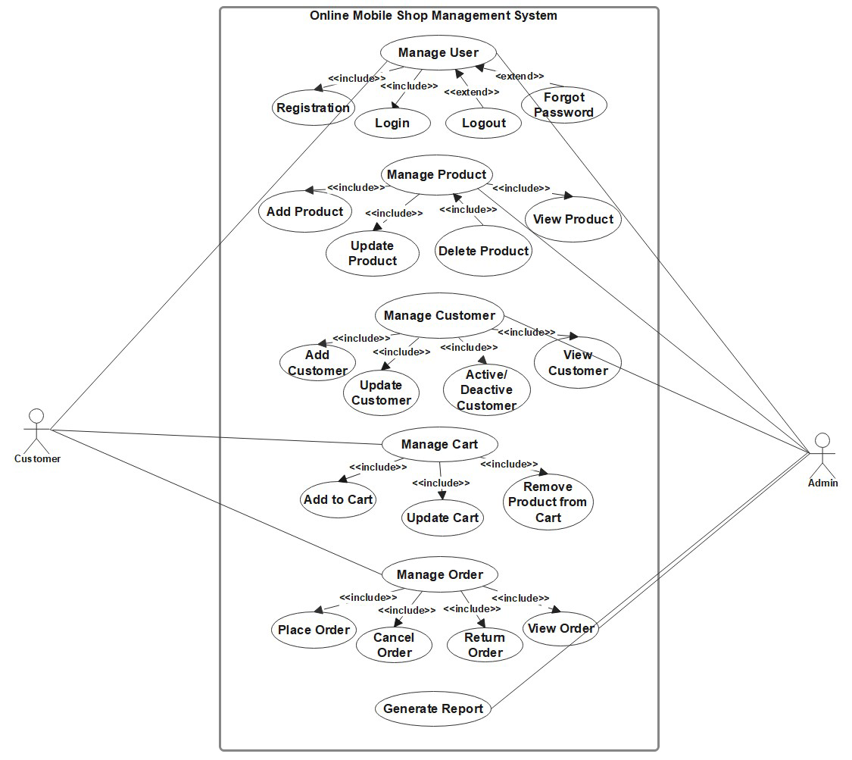

4.2 Activity Diagram:

4.2.1 Activity Diagram for ‘Registration’:

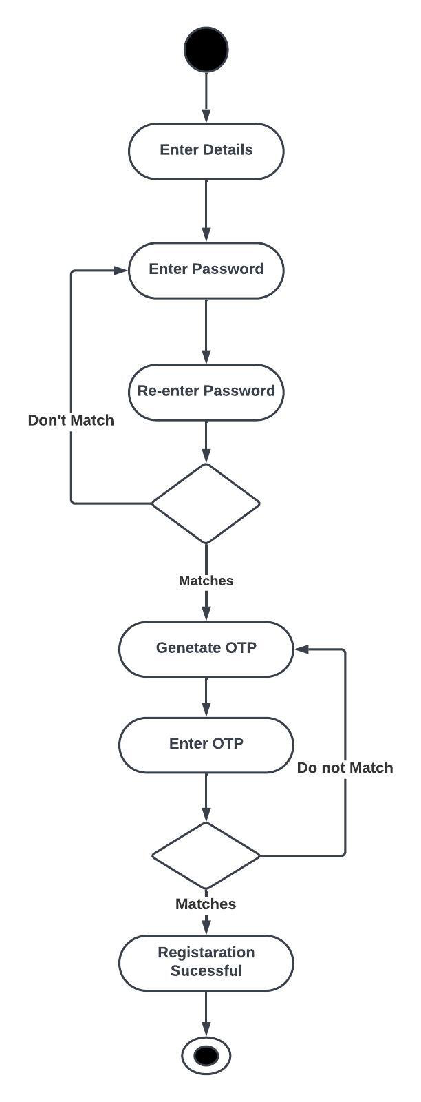

4.2.2 Activity Diagram for ‘Login’:

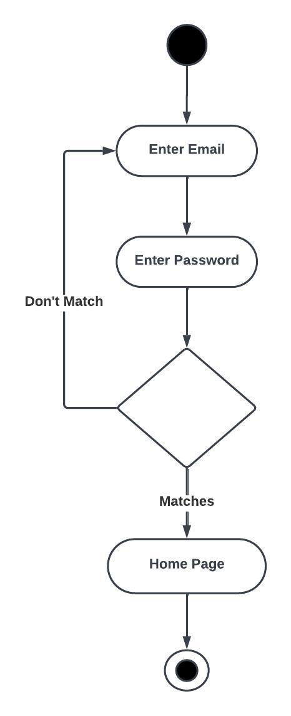

4.2.3 Activity Diagram for ‘Forgot Password’:

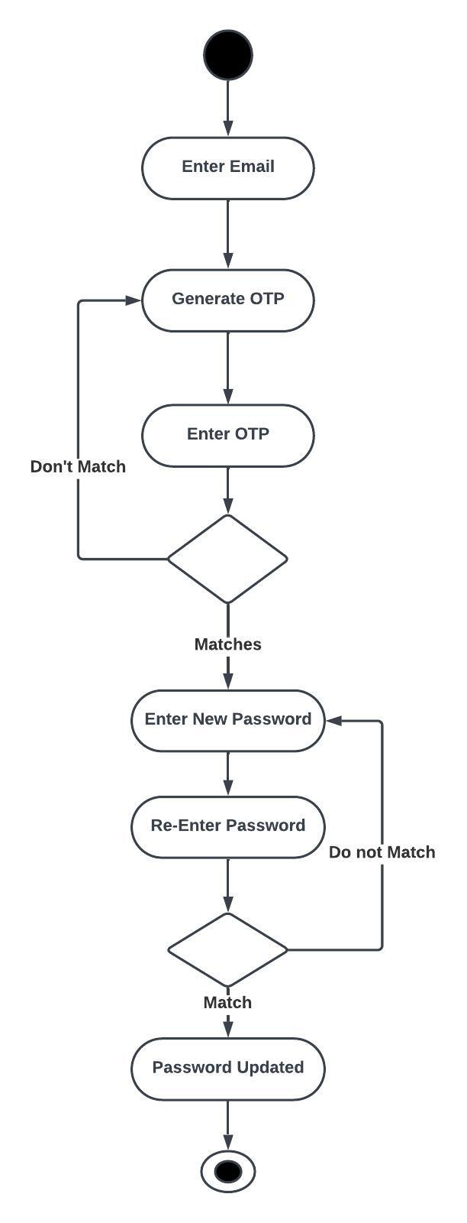

4.2.4 Activity Diagram for ‘Generate Report’:

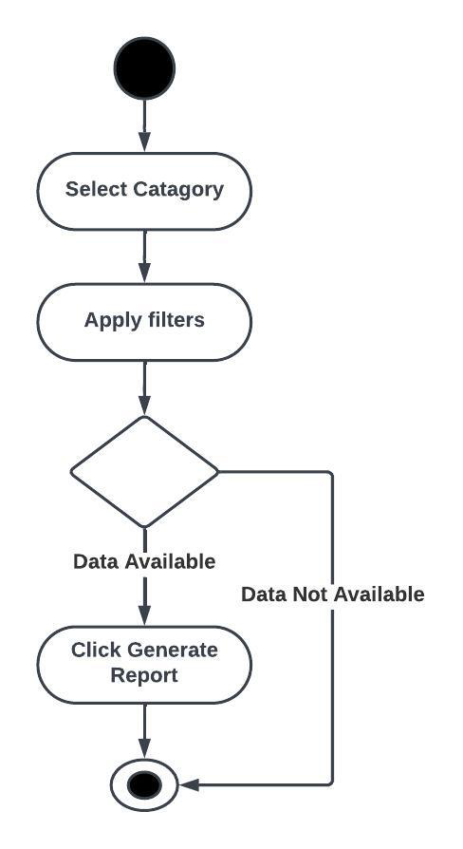

4.2.5 Activity Diagram for ‘Manage Product’:

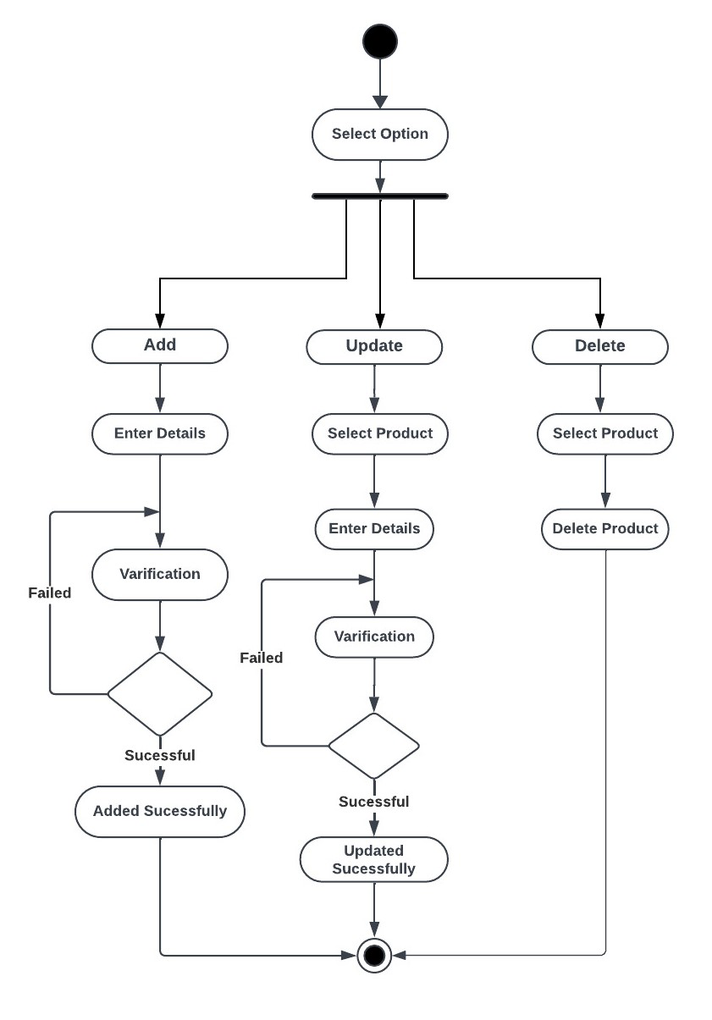

Chapter 5 - System Design

5.1 Database Design

5.1.1 Database Schema

* Manage User
* tblState (id [PK], name)
* FD: id [PK] => name
* tblCity (id [PK], name, sid [FK][tblState])
* FD: id [PK] => name, sid [FK][tblState]
* tblUser (id [PK], name, email, password, contact, gender, cityid, address, role, status)
* FD: id [PK] => name, email, password, contact, gender, cityid [FK][tblCity], address, role, status
* Manage Product
* tblBrand (id [PK], name)
* FD: id [PK] => name
* tblColor (id [PK], name)
* FD: id [PK] => name
* tblProduct (id [PK], name, bid [FK][tblBrand], imageName, status)
* FD: id [PK] => name, bid [FK][tblBrand], imageName, status
* tblStorage (id [PK], storage)
* FD: id [PK] => storage
* tblPorductDetail (id [PK], pid [FK][tblProduct], cid [FK][tblColor], sid [FK][tblStorage], description, price, stock)
* FD: id [PK] => pid [FK][tblProduct], cid [FK][tblColor], sid [FK][tblStorage], description, price, stock
* Manage Cart
* tblCart (id [PK], custId [FK][tblCustomer])
* FD: id [PK] => custId [FK][tblCustomer])
* tblCartProduct (id [PK], cartId [FK][tblCart], prodId [FK][tblProduct], quantity, total)
* FD: id [PK] => cartId [FK][tblCart], prodId [FK][tblProduct], quantity, total
* Manage Order
* tblOrder (id [PK], custId [FK][tblCustomer], orderDate, deliveryAddress, total, deliveryStatus)
* FD: id [PK] => custId [FK][tblCustomer], orderDate, deliveryAddress, total, deliveryStatus
* tblOrderProduct (id [PK], oid [FK][tblOrder], prodId [FK][tblProduct], quantity)
* FD: id [PK] => oid [FK][tblOrder], prodId [FK][tblProduct], quantity

5.1.2 Data Dictionary

* Table Name: tblState

| Sr.  No. | Field  Name | Datatype | Size | Constrain | Description |
| --- | --- | --- | --- | --- | --- |
| 1. | Id | Int | - | Primary Key,  Auto Increment | Identifies the Unique id of State. |
| 2. | Name | Varchar | 20 | Unique, Not Null | Specifies the Name of the State. |

* Table Name: tblCity

| Sr.  No. | Field  Name | Datatype | Size | Constrain | Description |
| --- | --- | --- | --- | --- | --- |
| 1. | Id | Int | - | Primary Key,  Auto Increment | Identifies the Unique id of City. |
| 2. | Name | Varchar | 20 | Unique, Not Null | Specifies the Unique Name of City. |
| 3. | Sid | Integer | - | Foreign Key | Referenced from tblState(sid). |

* Table Name: tblUser

| Sr.  No. | Field  Name | Datatype | Size | Constrain | Description |
| --- | --- | --- | --- | --- | --- |
| 1. | Id | Integer | - | Primary Key,  Auto Increament | Identifies the Unique id of User |
| 2. | Name | Varchar | 50 | Not Null | Specifies the Name of User. |
| 3. | Email | Varchar | 100 | Unique, Not Null | Specifies the Unique Email Address of User. |
| 4. | Password | Varchar | 20 | Not Null | Specifies the Password of User. |
| 5. | Contact | Varchar | 10 | Not Null | Specifies the Contact Number of User. |
| 6. | Gender | Varchar | 6 | Not Null | Specifies the Gender of User. |
| 7. | CityId | Integer | - | Foreign Key | Referenced from tblCity(id). |
| 8. | Address | Varchar | 255 | Not Null | Identifies the Address of the User. |
| 9. | Role | Varchar | 8 | Not Null | Identifies the Role of User. |
| 10 | Status | Integer | 1 | Not Null | Specifies the Status of User. |

* Table Name: tblBrand

| Sr.  No. | Field  Name | Datatype | Size | Constrain | Description |
| --- | --- | --- | --- | --- | --- |
| 1. | Id | Integer | - | Primary Key,  Auto Increment | Identifies the Unique id of Brand. |
| 2. | Name | Varchar | 20 | Unique, Not Null | Specifies the Name of Brand. |

* Table Name: tblColor

| Sr.  No. | Field  Name | Datatype | Size | Constrain | Description |
| --- | --- | --- | --- | --- | --- |
| 1. | Id | Integer | - | Primary Key,  Auto Increment | Identifies the Unique id of Color. |
| 2. | Name | Varchar | 20 | Unique, Not Null | Specifies the Name of Color. |

* Table Name: tblProduct

| Sr.  No. | Field  Name | Datatype | Size | Constrain | Description |
| --- | --- | --- | --- | --- | --- |
| 1. | id | Integer | - | Primary Key,  Auto Increment | Identifies the Unique id of City. |
| 2. | Name | Varchar | 100 | Unique, Not Null | Specifies the Unique Name of Product. |
| 3. | Bid | Integer | - | Foreign Key | Referenced from tblBrand(id). |
| 4. | ImageName | Varchar | 255 | Not Null | Specifies the Name of Photo of Product. |
| 5. | Status | Integer | - | Not Null | Specifies the Status of Product. |

* Table Name: tblStorage

| Sr.  No. | Field  Name | Datatype | Size | Constrain | Description |
| --- | --- | --- | --- | --- | --- |
| 1. | id | Integer | - | Primary Key,  Auto Increment | Identifies the Unique id of Storage. |
| 2. | Storage | Varchar | 20 | Unique, Not Null | Specifies the Size of Storage. |

* Table Name: tblProductDetail

| Sr.  No. | Field  Name | Datatype | Size | Constrain | Description |
| --- | --- | --- | --- | --- | --- |
| 1. | id | Integer | - | Primary Key,  Auto Increment | Identifies the Unique id of Product Detail. |
| 2. | Pid | Integer | - | Foreign Key | Referenced from tblProduct(id). |
| 3. | Cid | Integer | - | Foreign Key | Referenced from tblColor(id). |
| 4. | Sid | Integer | - | Foreign Key | Referenced from tblStorage(id). |
| 5. | Description | Varchar | 255 | Not Null | Specifies the Description of Product. |
| 6. | Price | Integer | - | Not Null | Specifies the Price of the Product. |
| 7. | Stock | Integer | - | Not Null | Specifies the Stock of the Product. |

* Table Name: tblOrder

| Sr.  No. | Field  Name | Datatype | Size | Constrain | Description |
| --- | --- | --- | --- | --- | --- |
| 1. | id | Integer | - | Primary Key,  Auto Increment | Identifies the Unique id of Order. |
| 2. | CustId | Integer | - | Foreign Key | Referenced from tblCustomer(id). |
| 3. | OrderDate | Date | - | Not Null | Specifies the Order Dare. |
| 4. | DeliveryAddress | Varchar | 255 | Not Null | Specifies the Address where Customer wants to Deliver their Order. |
| 5. | Total | Integer | - | Not Null | Specifies the total Payable Amount. |
| 6. | DeliveryStatus | Varchar | 10 | Not Null | Specifies the Delivery Status of Order. |

* Table Name: tblOderProduct

| Sr.  No. | Field  Name | Datatype | Size | Constrain | Description |
| --- | --- | --- | --- | --- | --- |
| 1. | Id | Integer | - | Primary Key,  Auto Increment | Identifies the Unique id for Order Product. |
| 2. | Oid | Integer | - | Foreign Key | Referenced from tblOrder(id). |
| 3. | Pid | Integer | - | Foreign Kry | Referenced from tblProduct(id). |
| 4. | Quantity | Integer | 4 | Not Null | Specifies the Quantity of Product. |

* Table Name: tblCart

| Sr.  No. | Field  Name | Datatype | Size | Constrain | Description |
| --- | --- | --- | --- | --- | --- |
| 1. | Id | Integer | - | Primary Key,  Auto Increment | Identifies the Unique id for Order Product. |
| 2. | CustId | Integer | - | Foreign Key | Referenced from tblCustomer(id). |

* Table Name: tblCartProduct

| Sr.  No. | Field  Name | Datatype | Size | Constrain | Description |
| --- | --- | --- | --- | --- | --- |
| 1. | Id | Integer | - | Primary Key,  Auto Increment | Identifies the Unique id for Cart Product. |
| 2. | CartId | Integer | - | Foreign Key | Referenced from tblCart(id). |
| 3. | Pid | Integer | - | Foreign Key | Referenced from tblProduct(id). |
| 4. | Quantity | Integer | 4 | Not Null | Specifies the Quantity of Product. |
| 5. | Total | Integer | - | Not Null | Specifies the Total Amount to be Paid. |

Chapter 6 - System Implementation

6.1 Screenshots

6.1.1 Screenshot of Login Page

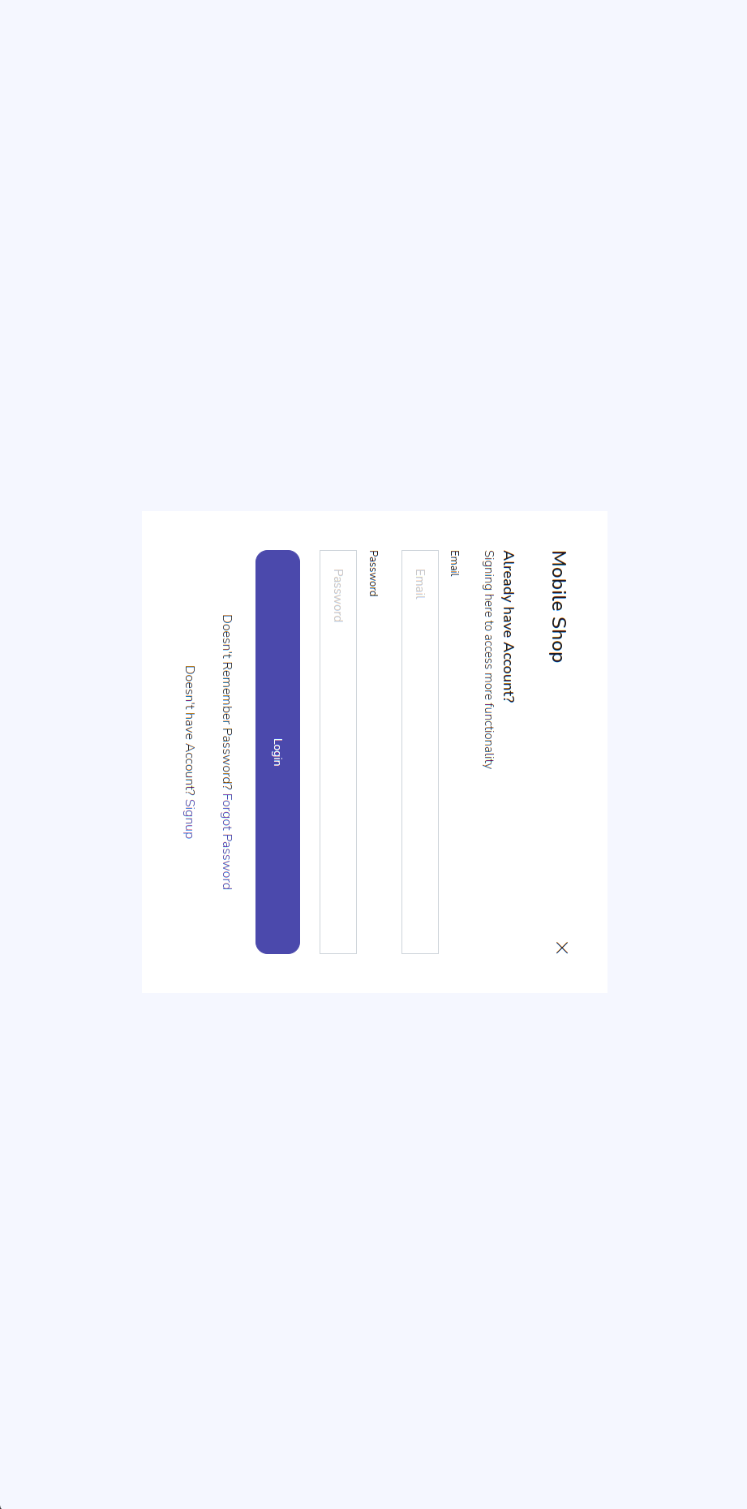

6.1.2 Screenshot of Forgot Password Page

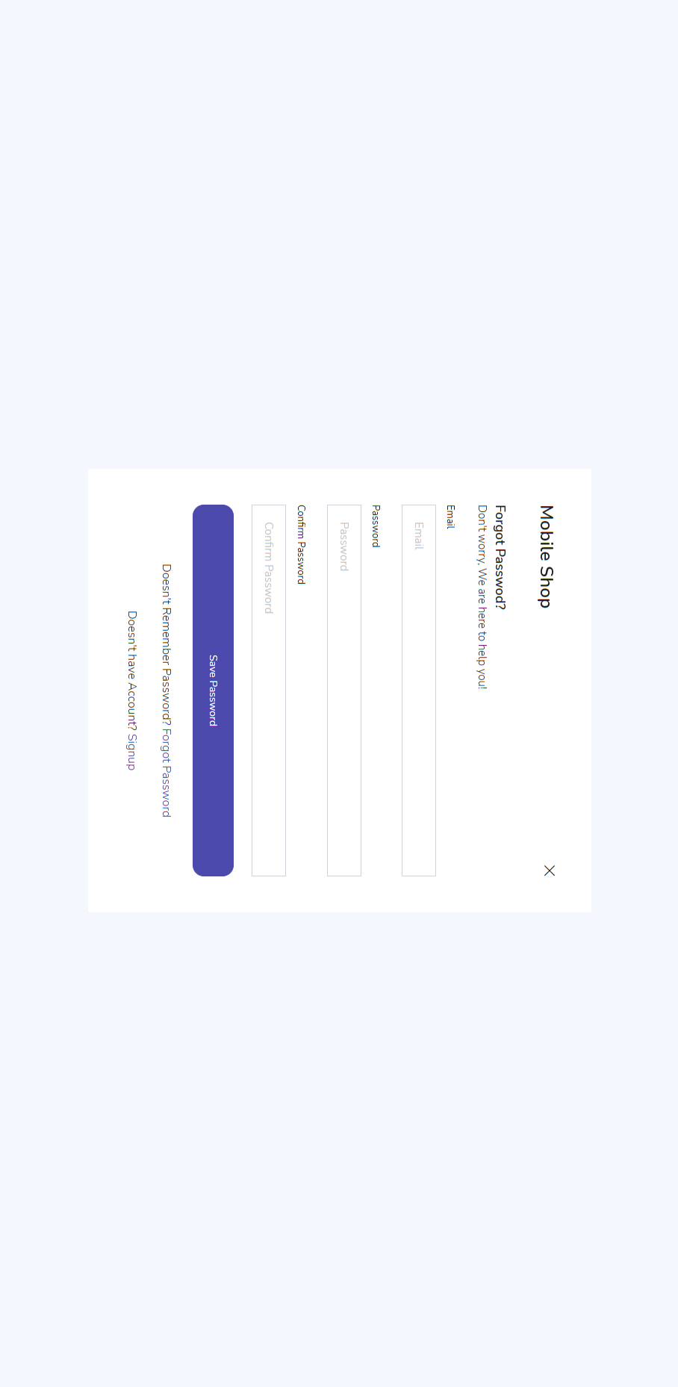

6.1.3 Screenshot of Users Page

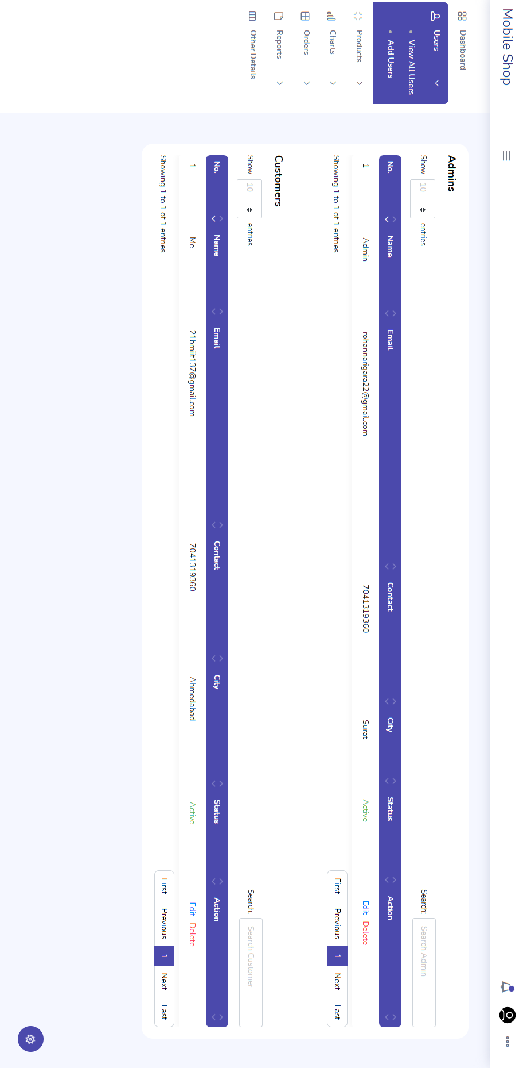

6.1.4 Screenshot of Products Page

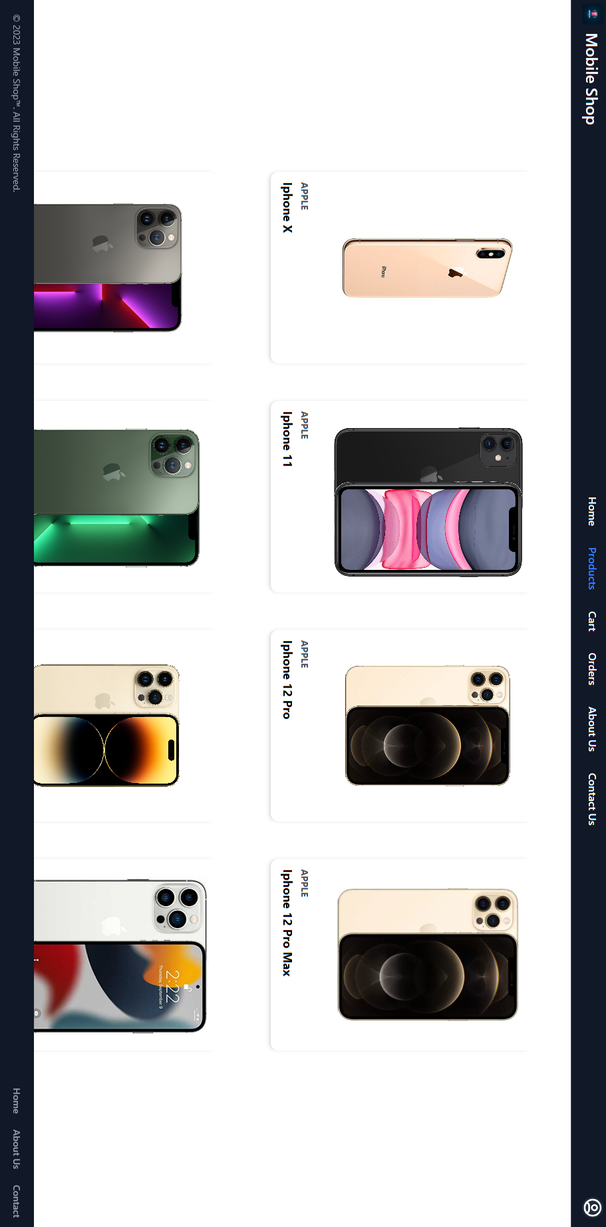

6.1.5 Screenshot of Other Details Page

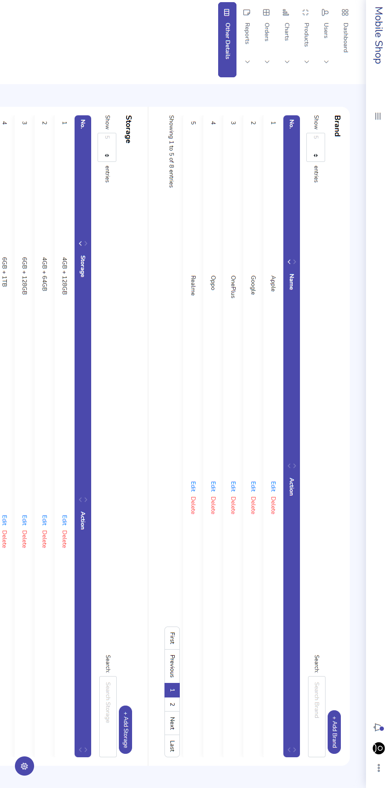

Chapter 7 - Testing

7.1 Test Cases

7.1.1 Test Cases for Registration

| **Sr. No.** | **Input Field** | **Input Value** | **Valid/ Invalid** | **For Valid Value** | **For Invalid Value** |
| --- | --- | --- | --- | --- | --- |
| **1.** | Full Name | Bhavik | Valid | No Message | -- |
| Abcde | Valid | No Message | -- |
| [Empty] | Invalid | -- | Please Enter Your Name! |
| **2.** | Email | admin@gmail.com | Valid | No Message | -- |
| Admin.com | Invalid | -- | Please Enter Valid Email! |
| [Empty] | Invalid | -- | Please Enter Your Email! |
| **3.** | Contact No. | 9725158630 | Valid | No Message | -- |
| [Empty] | Invalid | -- | Please Enter Your Contact Number! |
| Dj2939he83e7he | Invalid | -- | Please Enter Valid Contact Number! |
| 123156 | Invalid | -- | Please Enter Valid Mobile Number |
| **4.** | Gender | Male [Default Selected] | Valid | No Message | -- |
| **5.** | State | State [Selected] | Valid | No Message | -- |
| [Empty] | Invalid | -- | Please Select State |
| **6.** | City | City [Selected] | Valid | No Message | -- |
| [Empty] | Invalid | -- | Please Select City |
| **7.** | Address | 12, street, city | Valid | No Message | -- |
| [Empty] | Invalid | -- | Please Enter Address |
| **8.** | Password | admin | Valid | No Message | -- |
| abc@.com | Valid | No Message | -- |
| [Empty] | Invalid | -- | Please Enter Your Password! |
| **9.** | Confirm Password | admin | Valid | No Message | -- |
| [Empty] | Invalid | -- | Please Enter Your Confirm Password! |
| 123 | Invalid | -- | Password not Matched! |

7.1.2 Test Cases for Login

| **Sr. No.** | **Input Field** | **Input Value** | **Valid/ Invalid** | **For Valid Value** | **For Invalid Value** |
| --- | --- | --- | --- | --- | --- |
| **1.** | Email | admin@gmail.com | Valid | No Message | -- |
| Admin.com | Invalid | -- | Please Enter Valid Email! |
| [Empty] | Invalid | -- | Please Enter Your Email! |
| **2.** | Password | admin | Valid | No Message | -- |
| abc@.com | Valid | No Message | -- |
| [Empty] | Invalid | -- | Please Enter Your Password! |

7.1.3 Test Cases for Change Password

| **Sr. No.** | **Input Field** | **Input Value** | **Valid/ Invalid** | **For Valid Value** | **For Invalid Value** |
| --- | --- | --- | --- | --- | --- |
| **1.** | Email | admin@gmail.com | Valid | No Message | -- |
| Admin.com | Invalid | -- | Please Enter Valid Email! |
| [Empty] | Invalid | -- | Please Enter Your Email! |
| **2.** | Old Password | abcd | Valid | No Message | -- |
| [Empty] | Invalid | -- | Please Enter Old Password |
| **3.** | Password | admin | Valid | No Message | -- |
| abc@.com | Valid | No Message | -- |
| [Empty] | Invalid | -- | Please Enter Your Password! |
| **4.** | Confirm Password | admin | Valid | No Message | -- |
| [Empty] | Invalid | -- | Please Enter Your Confirm Password! |
| 123 | Invalid | -- | Password not Matched! |

7.1.4 Test Cases Forgot Password

| **Sr. No.** | **Input Field** | **Input Value** | **Valid/ Invalid** | **For Valid Value** | **For Invalid Value** |
| --- | --- | --- | --- | --- | --- |
| **1.** | Email | admin@gmail.com | Valid | No Message | -- |
| Admin.com | Invalid | -- | Please Enter Valid Email! |
| [Empty] | Invalid | -- | Please Enter Your Email! |
| **2.** | Password | admin | Valid | No Message | -- |
| abc@.com | Valid | No Message | -- |
| [Empty] | Invalid | -- | Please Enter Your Password! |
| **3.** | Confirm Password | admin | Valid | No Message | -- |
| [Empty] | Invalid | -- | Please Enter Your Confirm Password! |
| 123 | Invalid | -- | Password not Matched! |

7.1.5 Test Cases for add City

| **Sr. No.** | **Input Field** | **Input Value** | **Valid/ Invalid** | **For Valid Value** | **For Invalid Value** |
| --- | --- | --- | --- | --- | --- |
| **1.** | State | State [Selected] | Valid | No Message | -- |
| [Empty] | Invalid | -- | Please Select State |
| **2.** | City | City [Selected] | Valid | No Message | -- |
| [Empty] | Invalid | -- | Please Select City |

Chapter 8 – Future Enhancements

We will improve our User UI for best Graphical User Interface Experience. We will Provide search functionalities to client so that, they can search product based on their Requirements.