**Project Name: Public Grievance and Management Portal**

**Project Member:**

**Anil Kumawat 190843120010**

**Pratik Mergal 190843120035**

**Prasad Shinde 190843120046**

**Swarup Waghmare 190843120073**

**Abstract:**

The government-to-consumer aspect of electronic governance (e-governance) is the most effective use of the World Wide Web. The primary goal of an e-governance site is to make government services online to reduce time and increase productivity.

This project deals with developing an e-governance website for Online Grievance Management. It provides the user with a catalogue of different category of Grievances available for registering in the portal. In order to facilitate online complaining a Register New Complain page is provided to the user. The system is implemented using a 3-tier approach, with a backend database, a middle tier of Spring MVC, and web browser as the front end client.

In order to develop an e- governance website, a number of Technologies must be studied and understood. These include multi-tiered architecture, server and client side scripting techniques, implementation technologies such as Spring MVC, programming language (such as Core Java, Advance Java), relational databases (such as MySQL).

This is a project with the objective to develop a basic website where a consumer is provided with a government application. Where the user will be given the power to know about his complaint status and would be able to review it. Thus, resulting in a better communication and trust between the general public and government body.

**Implementation Technologies:**

1. **Spring Framework:**

Spring Framework is a Java platform that provides comprehensive infrastructure support for developing Java applications. Spring handles the infrastructure so you can focus on your application.

Spring enables you to build applications from “plain old Java objects” (POJOs) and to apply enterprise services non-invasively to POJOs. This capability applies to the Java SE programming model and to full and partial Java EE.

**1.1 Features of Spring Framework:**

**1. Lightweight**

Spring is modular lightweight framework which allows you to selectively use any of its modules on the top of Spring Core.

**2. Inversion of Control (IOC)**

This is another top feature of Spring framework where application dependencies are satisfied by the framework itself. Framework creates the object in runtime and satisfies application dependencies.

**3. Aspect Oriented Programming (AOP)**

Aspect Oriented Programming (AOP) is very popular in programming world and in Spring it is well implemented. Developer can use Aspect Oriented Programming (AOP feature of Spring to develop application in which business logic is separated from system services.

**4. Container**

Spring provides their own container for managing the bean lifecycle.

**5. MVC Framework**

Spring MVC Framework is used for developing MVC based web applications.

**6. Transaction Management**

Spring framework provides generic Transaction Management layer which can be used with or without J2EE(JEE) environment.

**7. JDBC Exception Handling**

Spring provides their own abstraction of JDBC exception which further simplifies the exception handling in program.

**1.2 Advantages of Spring Framework:**

**1. Solving difficulties of Enterprise application development**

Spring is solving the difficulties of development of complex applications, it provides Spring Core, Spring IoC and Spring AOP for integrating various components of business applications.

**2. Support Enterprise application development through POJOs**

Spring supports development of Enterprise application development using the POJO classes which removes the need of importing heavy Enterprise container during development. This makes application testing much easier.

**3. Easy integration other frameworks**

Spring designed to be used with all other frameworks of Java, you can use ORM, Struts, Hibernate and other frameworks of Java together. Spring framework do not impose any restriction on the frameworks to be used together.

**4. Application Testing**

Spring Container can be used to develop and run test cases outside enterprise container which makes testing much easier.

**5. Modularity**

Spring framework is modular framework and it comes with many modules such as Spring MVC, Spring ORM, Spring JDBC, Spring Transactions etc. which can used as per application requirement in modular fashion.

**6. Spring Transaction Management**

Spring Transaction Management interface is very flexible it can configure to use local transactions in small application which can be scaled to JTA for global transactions.

1. **The JDBC Template**

The central class of the Spring JDBC abstraction framework is the **JdbcTemplate** class that includes the most common logic in using the JDBC API to access data, such as handling the creation of connection, statement creation, statement execution, and release of resource. The**Jdbc-Template**class can be found in the **org.springframework.jdbc.core**package.

The **JdbcTemplate** class instances are thread-safe once configured. A single **JdbcTemplate** can be configured and injected into multiple DAOs.

We can use the **JdbcTemplate** to execute the different types of SQL statements. **Data Manipulation Language** (**DML**) is used for inserting, retrieving, updating, and deleting the data in the database such as **SELECT**, **INSERT**, or **UPDATE** statements

**2.1** **MySQL**

MySQL, the most popular Open Source SQL database management system, is developed, distributed, and supported by Oracle Corporation.

**Features of MySQL:**

* **MySQL is a database management system.**

A database is a structured collection of data. It may be anything from a simple shopping list to a picture gallery or the vast amounts of information in a corporate network. To add, access, and process data stored in a computer database, you need a database management system such as MySQL Server. Since computers are very good at handling large amounts of data, database management systems play a central role in computing, as standalone utilities, or as parts of other applications.

* **MySQL databases are relational.**

A relational database stores data in separate tables rather than putting all the data in one big storeroom. The database structures are organized into physical files optimized for speed. The logical model, with objects such as databases, tables, views, rows, and columns, offers a flexible programming environment.

* **MySQL software is Open Source.**

Open Source means that it is possible for anyone to use and modify the software. Anybody can download the MySQL software from the Internet and use it without paying anything.

* **The MySQL Database Server is very fast, reliable, scalable, and easy to use.**

MySQL Server was originally developed to handle large databases much faster than existing solutions and has been successfully used in highly demanding production environments for several years. Although under constant development, MySQL Server today offers a rich and useful set of functions. Its connectivity, speed, and security make MySQL Server highly suited for accessing databases on the Internet.

* **MySQL Server works in client/server or embedded systems.**

The MySQL Database Software is a client/server system that consists of a multithreaded SQL server that supports different back ends, several different client programs and libraries, administrative tools, and a wide range of application programming interfaces (APIs).

1. **Hardware and Software Requirements (Minimum):**

**Hardware:**

1. Intel i3 processor 3rd generation or later / AMD Ryzen 200 2nd generation or later

2. 2 GB ddr3 ram.

3. Windows 7 Home edition or later.

4. 200 GB Sata HDD Space

5. Data Connection 200 kbps

**Software:**

1. Eclipse 4.7 Oxygen
2. MySQL 5.7 with Workbench 8.0
3. Google Chrome version 79.0
4. Apache Tomcat Server 8.5
5. Maven Dependencies
6. **ER Diagram:**

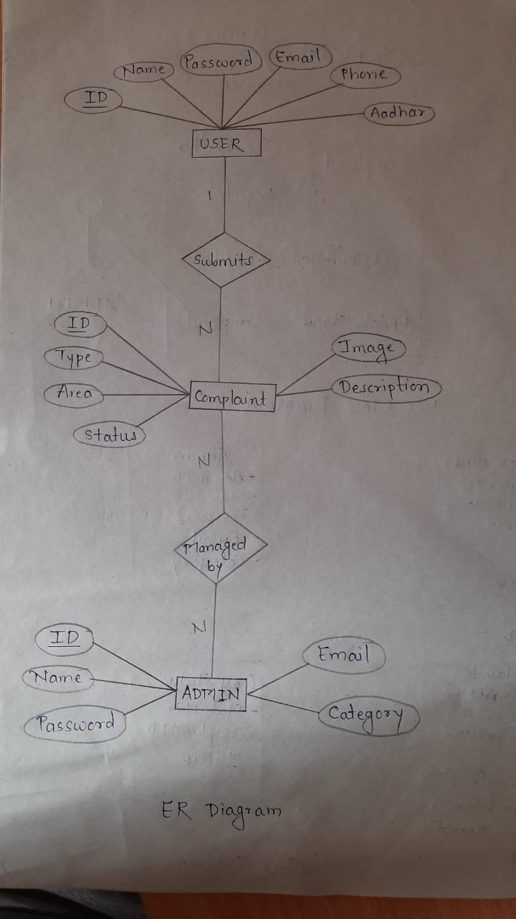

Figure 1: ER Diagram

1. **Table Structures:**
2. **Table name:GovtConsumer**

**Column name Type**

ConsumerId int (11) NO PRI auto_increment

Name varchar(20) YES

Password varchar(20) YES

EmailId varchar(40) YES

ContactNo varchar(20) YES

Suburb varchar(20) YES

City varchar(20) YES

Address_String varchar(20) YES

Pincode varchar(20) YES

1. **Table name:Admin**

**Column name Type**

Admin_Id int (11) NO PRI auto_increment

Admin_Name varchar(50) YES

Admin_Password varchar(10) YES

Admin_Email varchar(30) YES

Complain_Category varchar(50) YES

1. **Table name:Complaint**

**Column name Type**

ComplainId int (11) NO PRI auto_increment

ConsumerId int (11) YES MUL

ConsumerName varchar(40) YES

Complain_Category varchar(100) YES

Complain_Heading varchar(100) YES

Description varchar(200) YES

Image varchar(50) YES

Affected_address varchar(150) YES

1. **Table name:Compstatus**

**Column name Type**

StatusId int (11) NO PRI auto_increment

ComplainId int (11) YES MUL

Status varchar(100) YES

1. **UML Diagrams:**

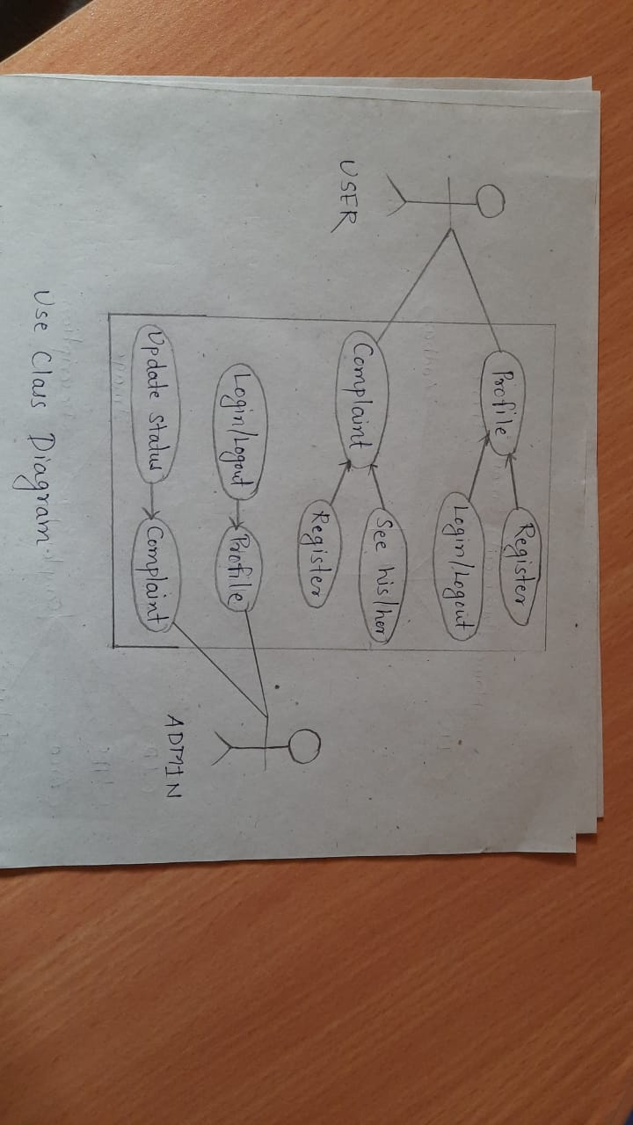

Figure 2: Use Case

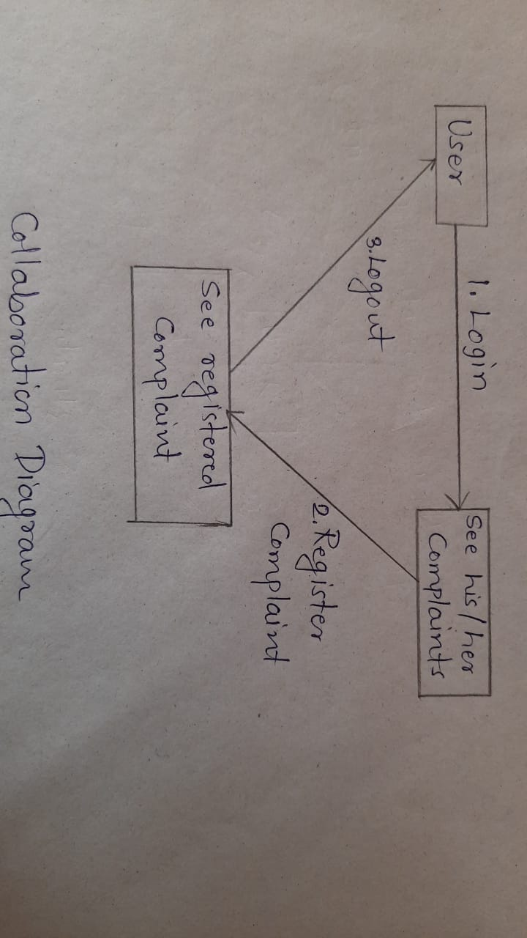

Figure 3: Collaboration Diagram

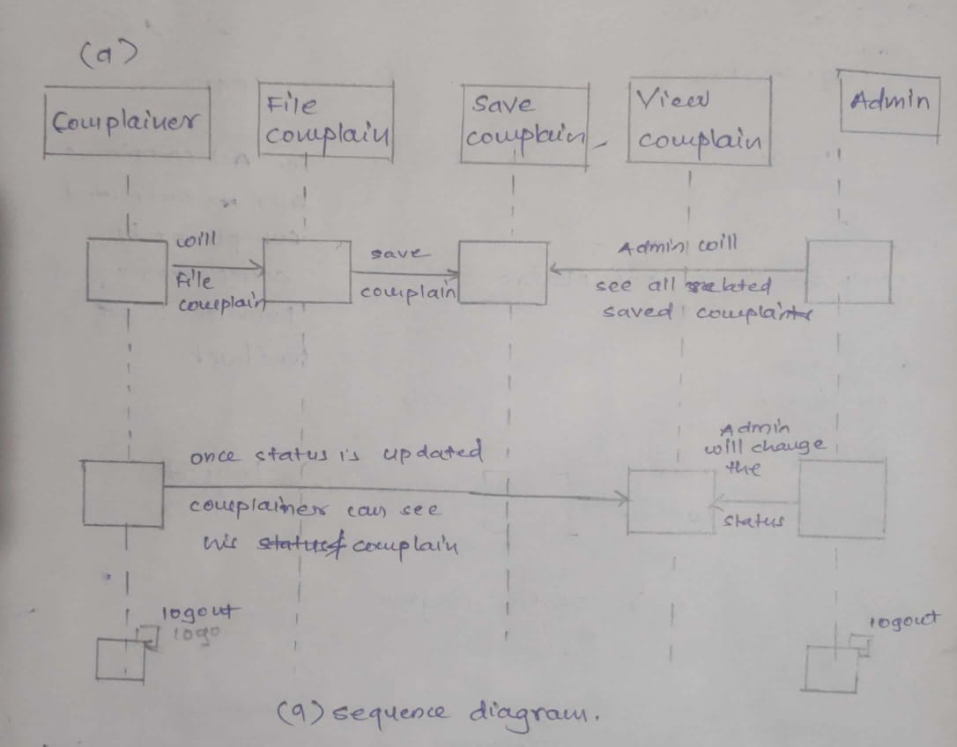

Figure 4: Sequence Diagram

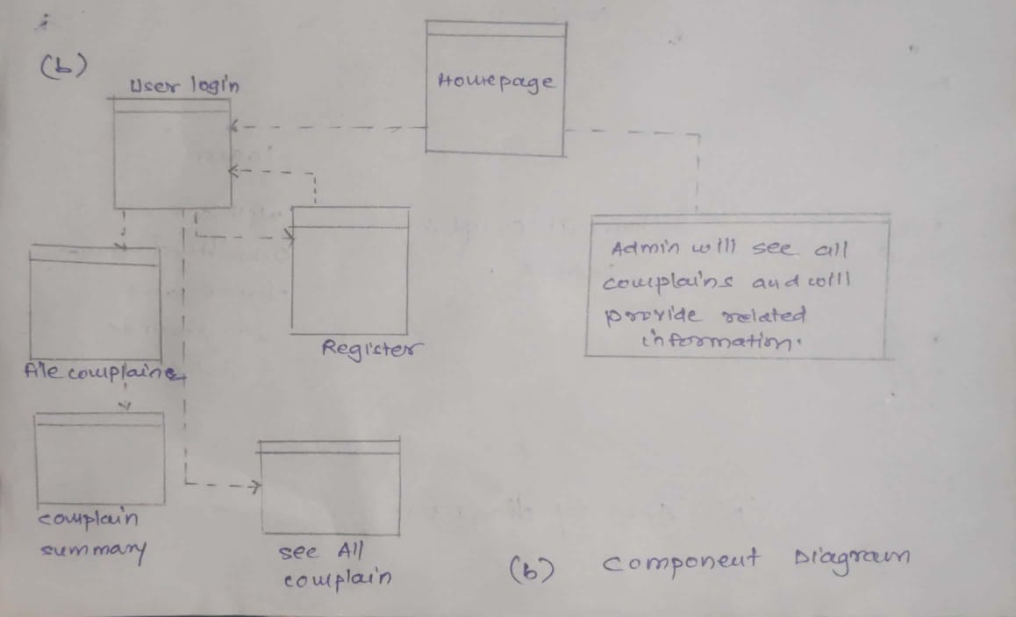

Figure 5: Component Diagram

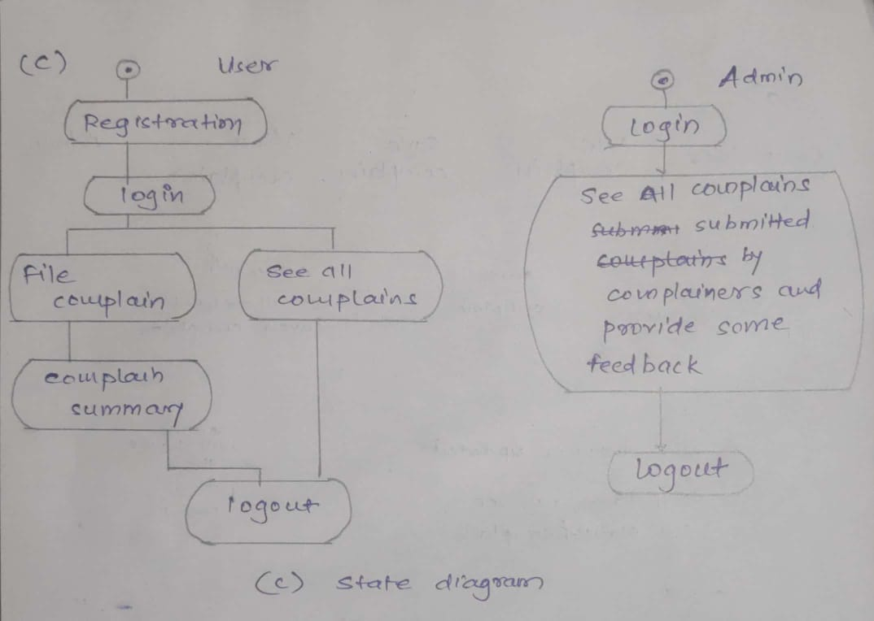

Figure 6: State Diagram

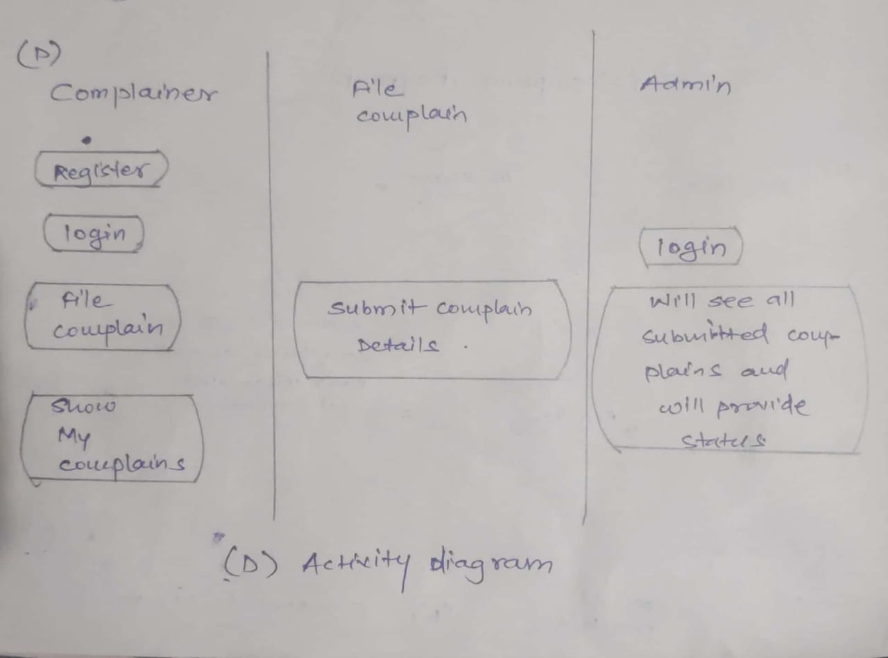

Figure 7: Activity Diagram

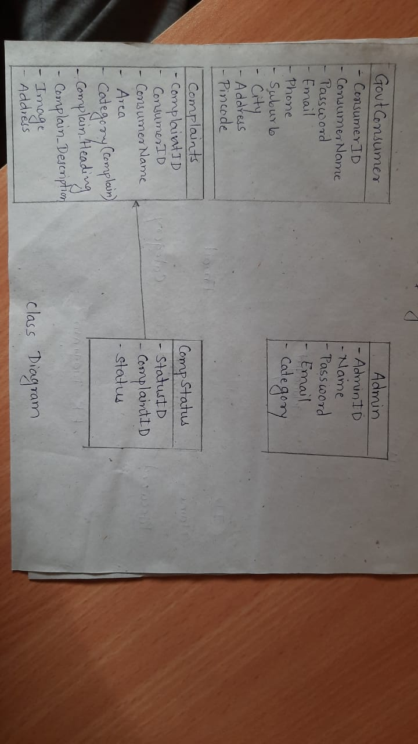

Figure 8: Class Diagram

1. **End to End Flow of Application:**

**User:**

* 1. User will login to the portal or will have to register if he is not a registered user.
  2. After registration User will login and Dashboard page will be displayed to him which will display the previous complains and its status if any.
  3. From that page can User can click on the ‘**file new complain’** button and reach the complaint details form page.
  4. In the complaint details page the User has to pick a category among the **Eight**predefinedcategories and brief about the problem with affected area (address) and image of the object or place.
  5. A ‘**summary report’** will be displayed on the Website showing all the details of the complaint.
  6. User will only be able to see his complaint after the complaint has been ‘**Received’**or either ‘**Resolved’** by the respective admin of the category chosen.

**Admin:**

1. Admin will login as Admin from the ‘**Admin login**’ page and will be able to see his share of Complains filed by the Users of a particular area.
2. Admin can Review the complaint and after understanding it Admin will ‘**Receive’** the complaint.
3. It is the job of Admin to assign appropriate contractor or service person to resolve the matter at the hand as soon as possible to avoid disturbance among the public.
4. After conforming about the completion/resolving of the problem, Admin will check the status of the problem as ‘**Resolved’**and head over to the next complaint if any.
5. Future Scope of Project

**Thank You!**