Here’s a simple, human‑readable manual you can share. It explains **what data is used**, **where it comes from**, **what you must download manually**, and **which commands to run**.

---

**What data we use (and why)**

1) **Yield ground truth (main target)**
- **What**: Final wheat yield (kg/ha) for Gujarat/Mehsana
- **Why**: This is the label we predict
- **Source**: Gujarat APY / data.gov.in
- https://dag.gujarat.gov.in/Home/AreaProductionAndYield
- https://www.data.gov.in/catalog/area-production-and-yield-major-crops-gujarat-state
- **Manual or Auto**: **Manual download** (CSV/PDF)
- **Where to put**: apy
- **Used for**:
- `yield_kg_ha` target
- `yield_quintile` (Q1–Q5) from training years only

---

2) **Weather data (daily)**
- **What**: Rainfall, Tmin, Tmax, humidity, solar radiation
- **Why**: Weather controls growth and stress at each stage
- **Source**: Open‑Meteo Archive API (auto)
- **Manual or Auto**: **Auto**
- **Output file**: `data/interim/weather_daily.csv`
- **Used for**:
- GDD (growing degree days)
- stage‑wise weather aggregates (rain sum, Tmax mean, etc.)

---

3) **Satellite time series (Sentinel‑2)**
- **What**: NDVI, NDRE, EVI + cloud percentage
- **Why**: Crop health trajectory over the season
- **Source**: Google Earth Engine export or local CSV
- **Manual or Auto**: **Manual export / local CSV**
- **Where to put**: satellite
- **Output file**: `data/interim/satellite_observations.csv`
- **Used for**:
- NDVI/NDRE/EVI trajectory features (last/mean/slope by stage)

---

4) **Drone observations (optional but strong)**
- **What**: Canopy cover, weed cover, crop‑only NDVI, canopy temperature
- **Why**: High‑resolution crop state and weed correction
- **Manual or Auto**: **Manual CSV**
- **Where to put**: drone
- **Output file**: `data/interim/drone_observations.csv`
- **Used for**:
- Crop‑only NDVI and weed correction features
- Canopy cover and thermal stress signals

---

5) **Farm visit logs (optional but valuable)**
- **What**: Irrigation, fertilizer dates/doses, pest/disease scores
- **Why**: Management events affect yield
- **Manual or Auto**: **Manual CSV**
- **Where to put**: farm_logs
- **Output file**: `data/interim/farm_logs.csv`

---

6) **Soil data (static)**
- **What**: pH, EC, organic carbon, NPK, texture
- **Why**: Baseline fertility and soil constraints
- **Manual or Auto**: **Manual CSV**
- **Where to put**: soil
- **Output file**: `data/interim/soil.csv`

---

7) **Auxiliary image datasets (optional)**
- **What**: Public wheat images for stage/weed support
- **Why**: Helps build stage detection / weed segmentation support
- **Manual or Auto**: **Manual download**
- **Where to put**: images
- **Output file**: `data/interim/image_metadata.csv`

---

**What you must fill first (required)**
- **Field registry**:
field_registry_template.csv
Must include:
`case_id, lat, lon, sowing_date, harvest_date, yield_kg_ha`

This file defines every “Field × Season” case.

---

**Which scripts to run (in order)**

1) Create/refresh templates
`python src/data/prepare_templates.py`

2) Download weather (auto)
`python src/data/download_weather.py`

3) Load APY yield CSVs (manual files required)
`python src/data/download_apy.py`

4) Ingest satellite CSVs (manual files required)
`python src/data/ingest_satellite.py`

5) Prepare image metadata (optional)
`python src/data/search_or_prepare_image_data.py`
`python src/data/ingest_images.py`

6) Build interim tables (farm logs, drone, soil, cases)
`python src/data/preprocess_all.py`

7) Build stage‑wise final tables
`python src/data/build_stage_table.py`

---

**Final outputs you will get**
- `data/processed/stage_features.csv`
→ one row per **case_id × stage**, with stage‑wise features
- `data/processed/targets.csv`
→ one row per **case_id** with yield + quintile
- data_sources_report.md
- data_quality_report.md
- image_dataset_notes.md

---

**How the data is used (simple explanation)**
- We align **all data by date** from sowing to harvest
- We slice the season into **stages**
- For each stage, we compute features **only up to that stage**
- We predict the **final harvest yield**, not stage yield
- This ensures **no leakage**

---

If you want, tell me which raw data you already have (APY? satellite CSV? field registry?) and I will tailor the exact next step for your current state.
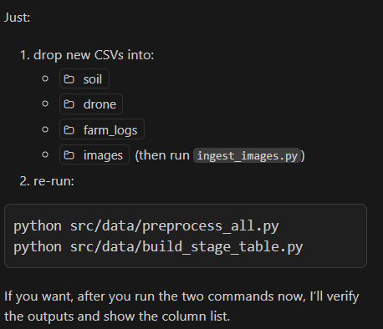

FINAL EVALUATION

