**Q1. Create a sample table in postgres/mysql with following columns (15 Marks) Table Name : cdac_power_bi Column Name - varchar Id- integer Age- integer Dob – date**

***Solution***

powerbi_exam=# create table cdac_power_bi(Name varchar(20),Id int, Age int,Dob date);

CREATE TABLE

powerbi_exam=# select * from cdac_power_bi;

name | id | age | dob

------+----+-----+-----

(0 rows)

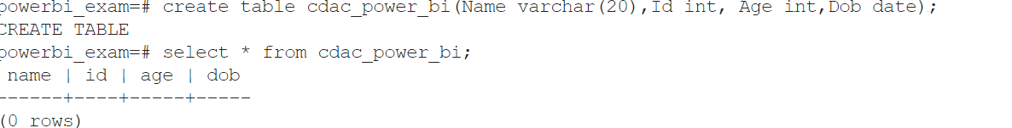

powerbi_exam=# insert into cdac_power_bi(Name, Id, Age, Dob) values('Amar',1,35,'1987-08-12');

INSERT 0 1

powerbi_exam=# select * from cdac_power_bi;

name | id | age | dob

------+----+-----+------------

Amar | 1 | 35 | 1987-08-12

(1 row)

powerbi_exam=# insert into cdac_power_bi(Name, Id, Age, Dob) values('Amit',2,32,'1990-09-11');

INSERT 0 1

powerbi_exam=# insert into cdac_power_bi(Name, Id, Age, Dob) values('Aman',3,36,'1986-06-12');

INSERT 0 1

powerbi_exam=# insert into cdac_power_bi(Name, Id, Age, Dob) values('Ankit',4,40,'1982-01-23');

INSERT 0 1

powerbi_exam=# insert into cdac_power_bi(Name, Id, Age, Dob) values('Arun',5,30,'1992-05-19');

INSERT 0 1

powerbi_exam=# select * from cdac_power_bi;

name | id | age | dob

-------+----+-----+------------

Amar | 1 | 35 | 1987-08-12

Amit | 2 | 32 | 1990-09-11

Aman | 3 | 36 | 1986-06-12

Ankit | 4 | 40 | 1982-01-23

Arun | 5 | 30 | 1992-05-19

(5 rows)

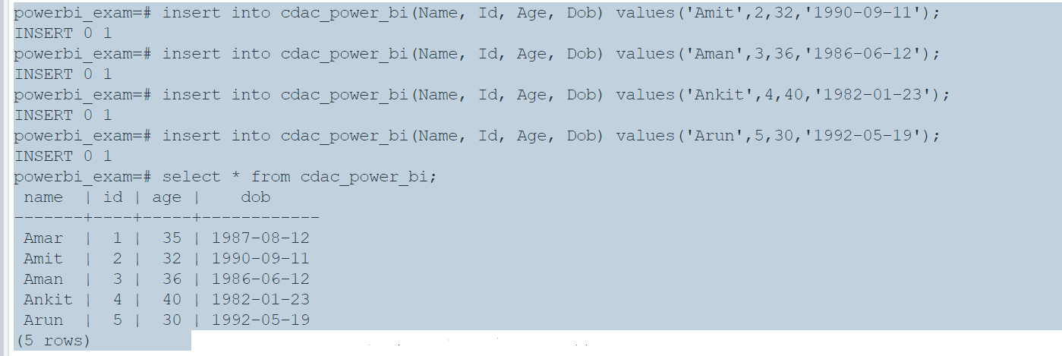

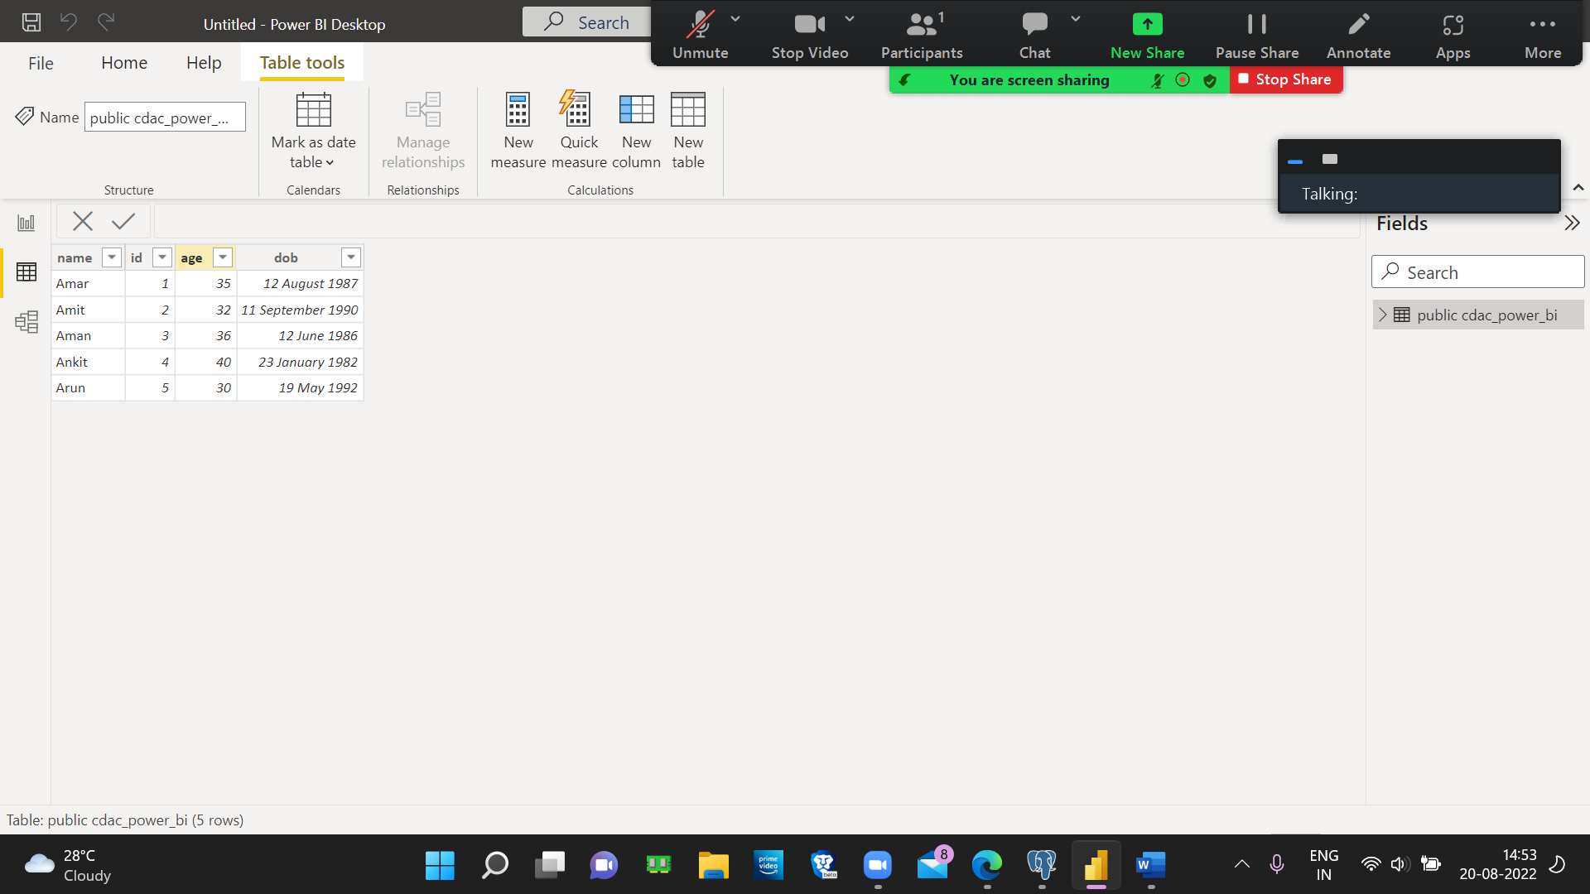

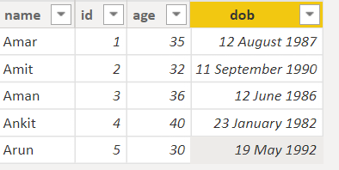

Insert 5 dummy rows into it and then connect to superset and populate

1. Table Chart

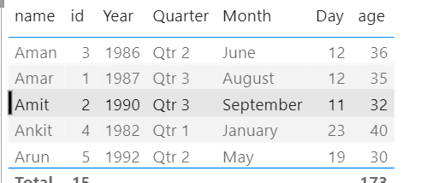

2. Card chart showing max age

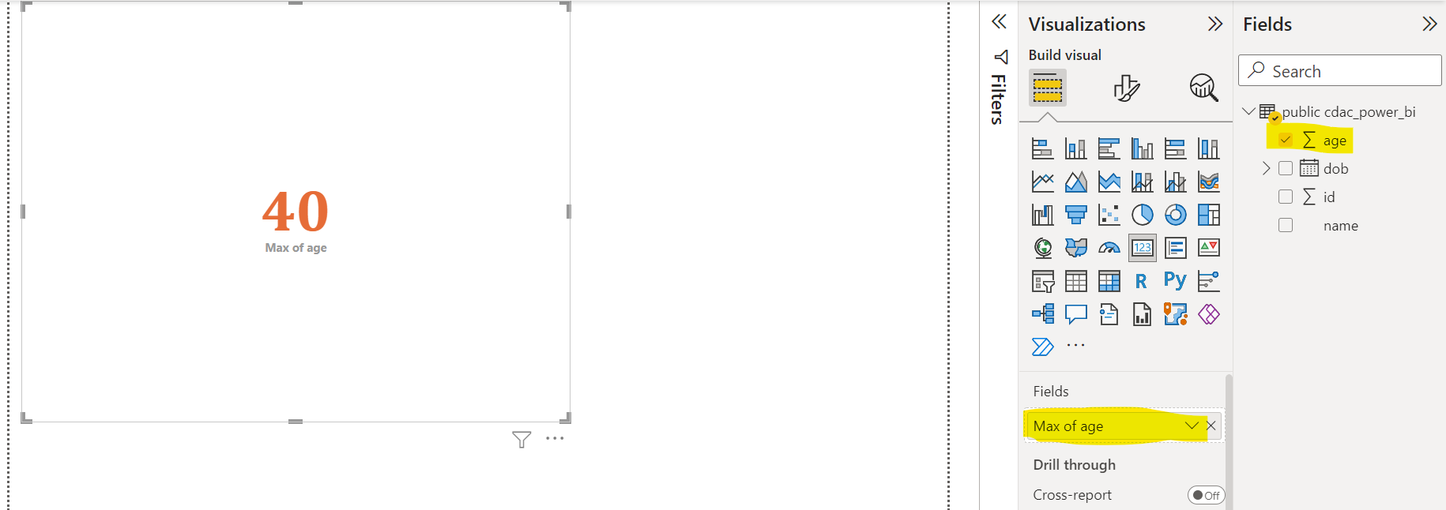

**QUESTION 2**

Q2.On product_table data set do the following (25 Marks)

1. Create table chart with title , vendor,customer name,quantity,price,city

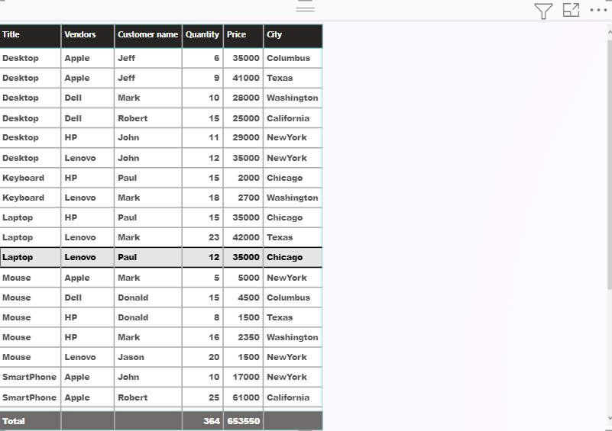

1. Add new calculated column naming total_sales which is derived from quantity * price

total_sales1 = (Product_table[Quantity])*(Product_table[Price])

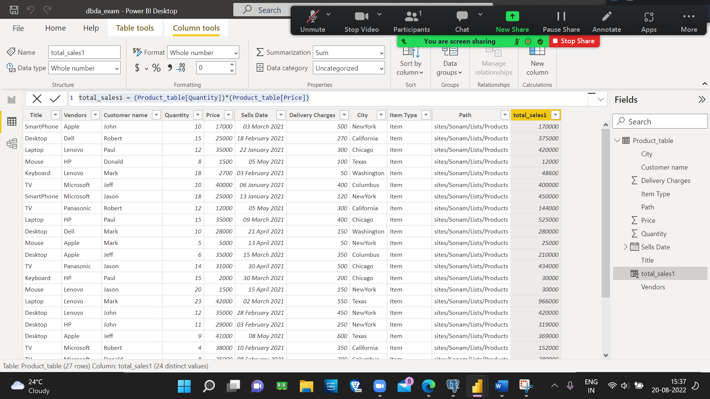

1. Add new measure naming max_price to get max of price column and then display every vendor max price in table chart

Max_price = MAX([Price])

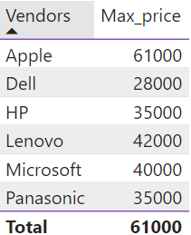

1. Create pie chart showing the value and percentage of quantity by vendors

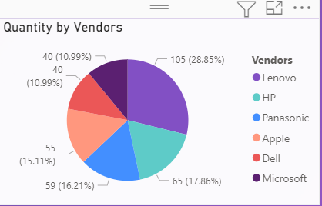

5.Create one more column naming total_sales_2022 which is derived from quantity * price * 1.16

total_sales_2022 = (Product_table[Quantity])*(Product_table[Price])*1.16

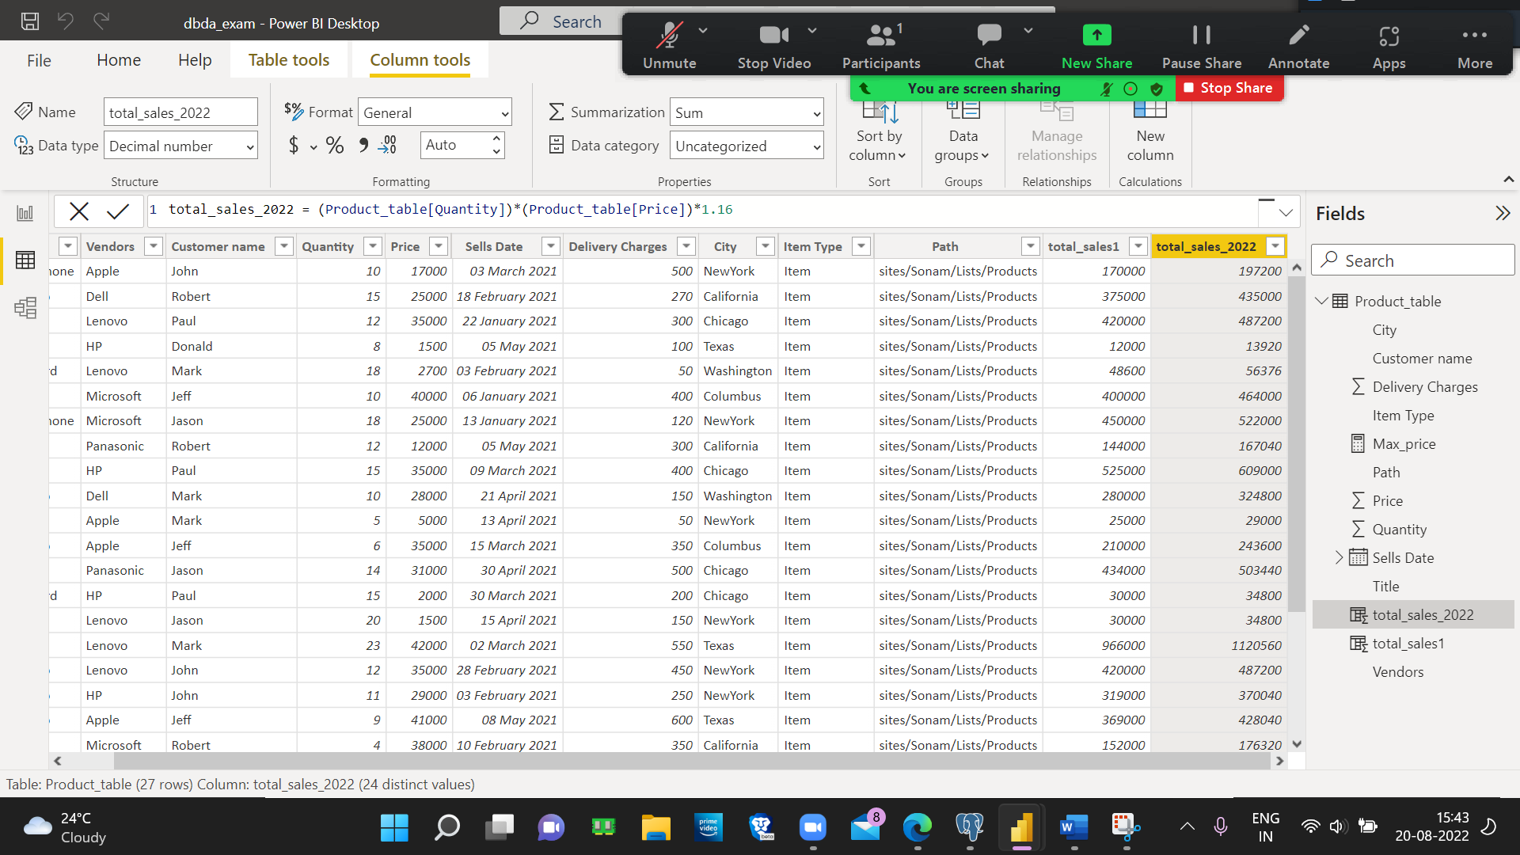

6.Create clustered column chart showing both total_sales and total_sales_2022

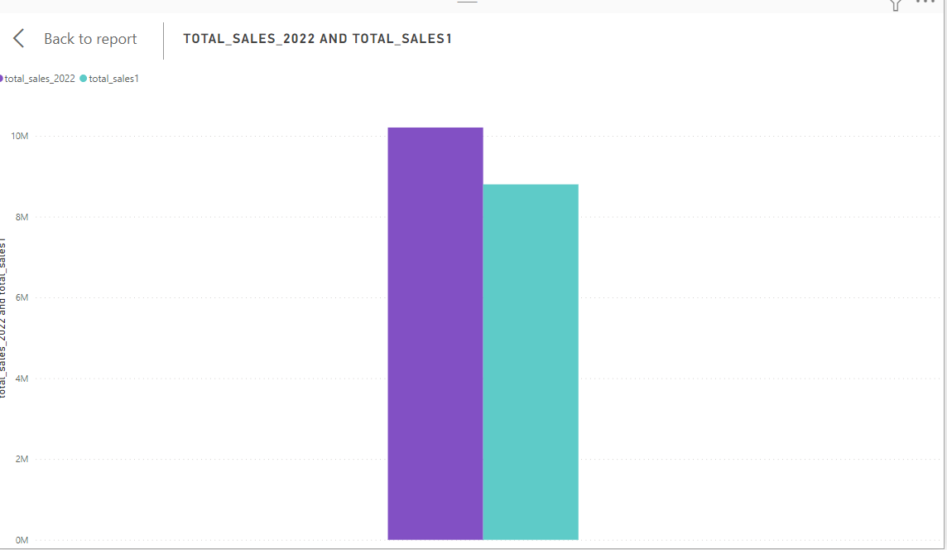

7. Create a slicer chart of price

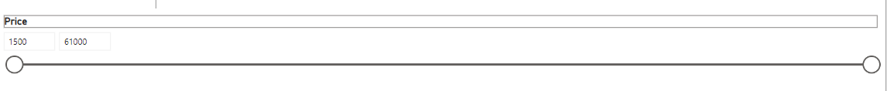

8.Calculate avg sales and show in tile



10.Create gauge chart with ○ value as total_sales ○ Maximum value as max of total_sales_2022 ○ Target Value as average of total_sale

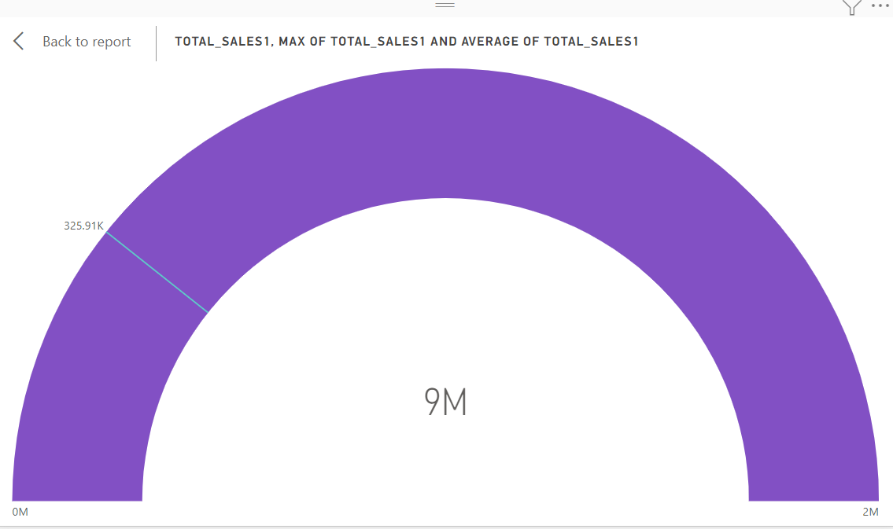

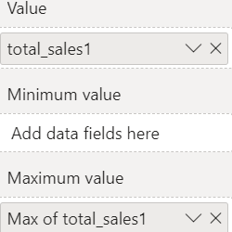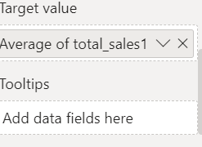

FINAL

