17.03.2026 PLACEMENT TRAINING CLASS LEETCODE PROBLEMS

QUESTION NUMBER : LC 1
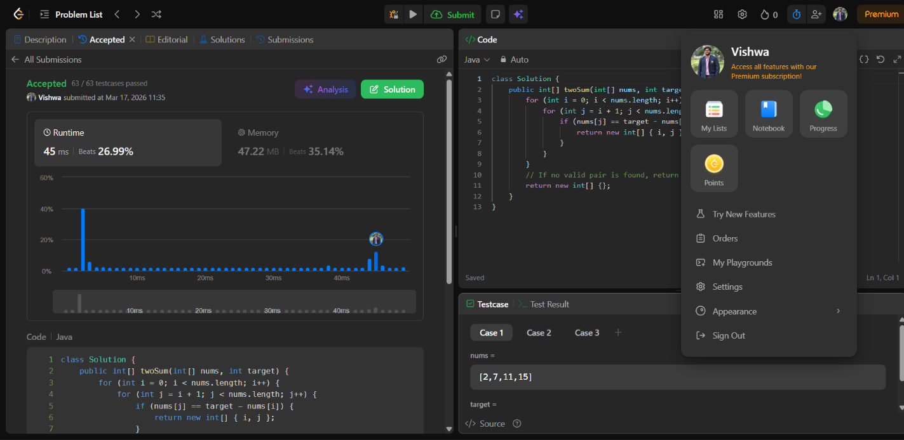

QUESTION NUMBER : LC 121
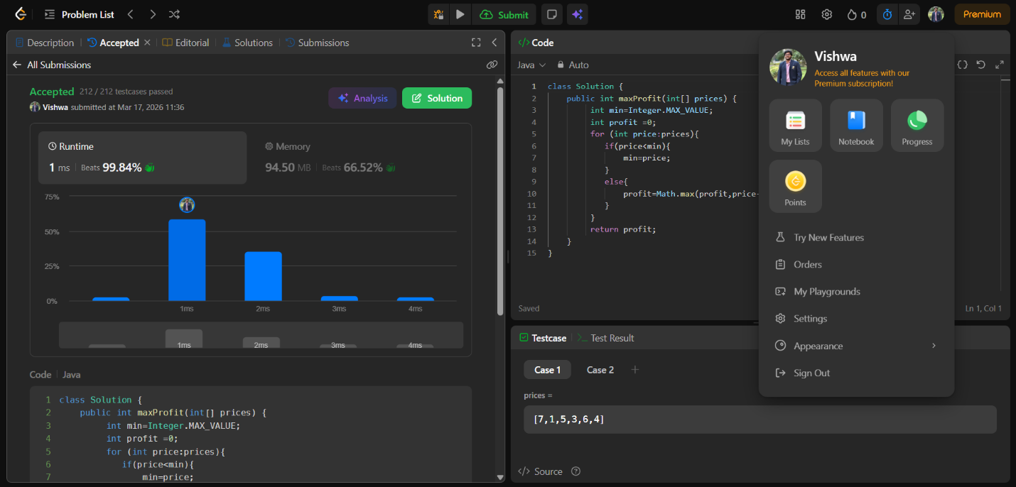

QUESTION NUMBER : LC 217
