**Task-1: SuperAdmin of Django**

1. **Task Description**

Implemented a feature in Django Admin (SuperAdmin) panel to export model data into a .csv file directly from the interface. Added a custom “Export as CSV” option in the Actions dropdown, allowing administrators to easily download and analyze database records offline using tools like Microsoft Excel or Google Sheets.

1. **Task Output Screenshot**

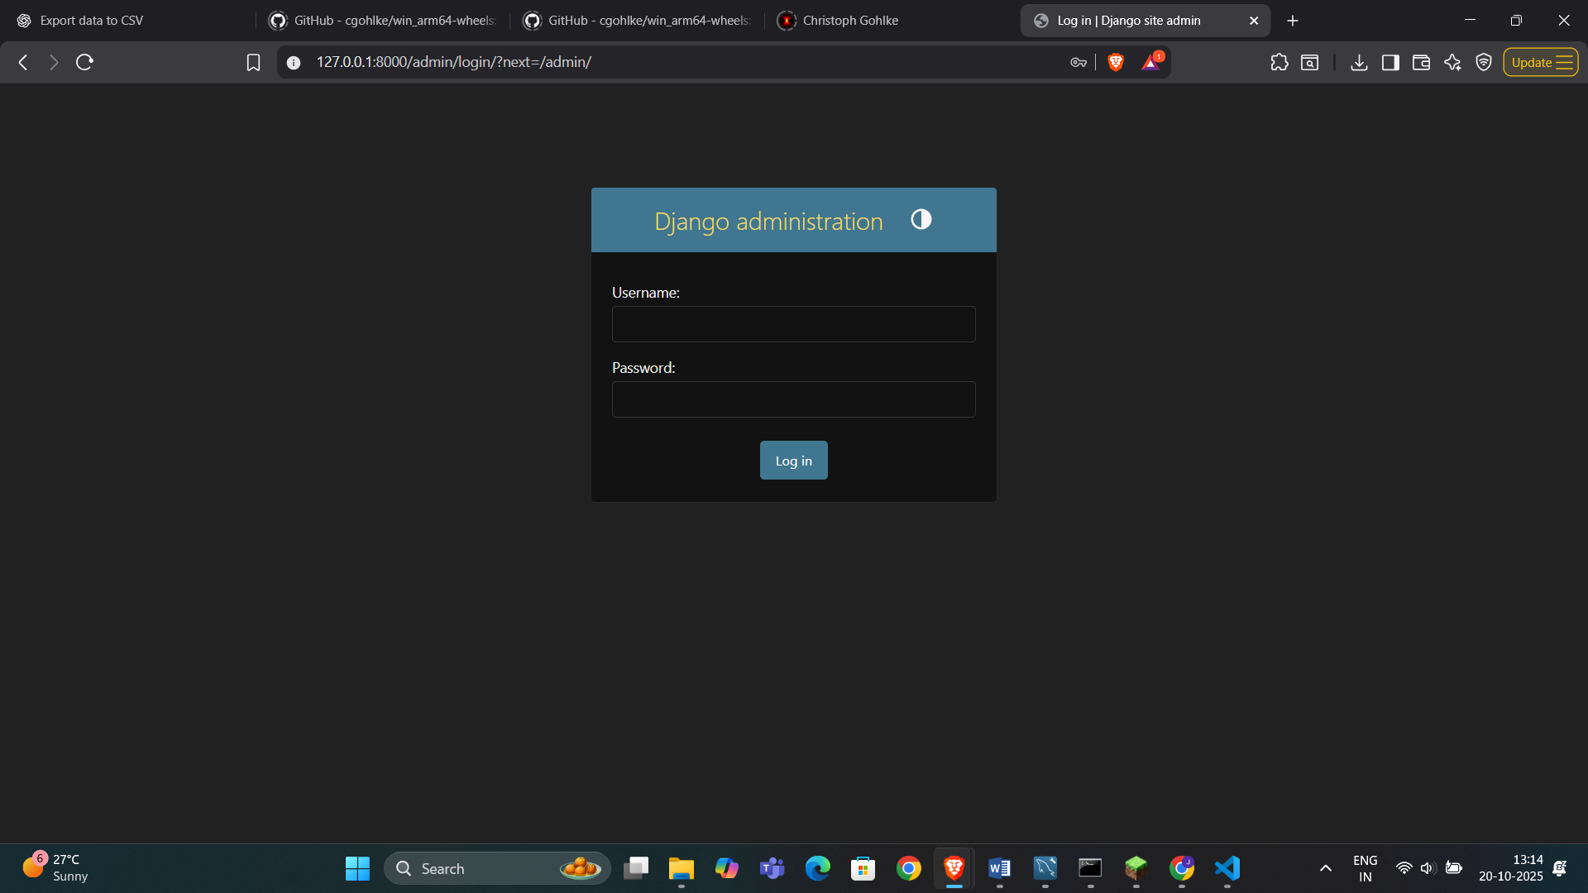

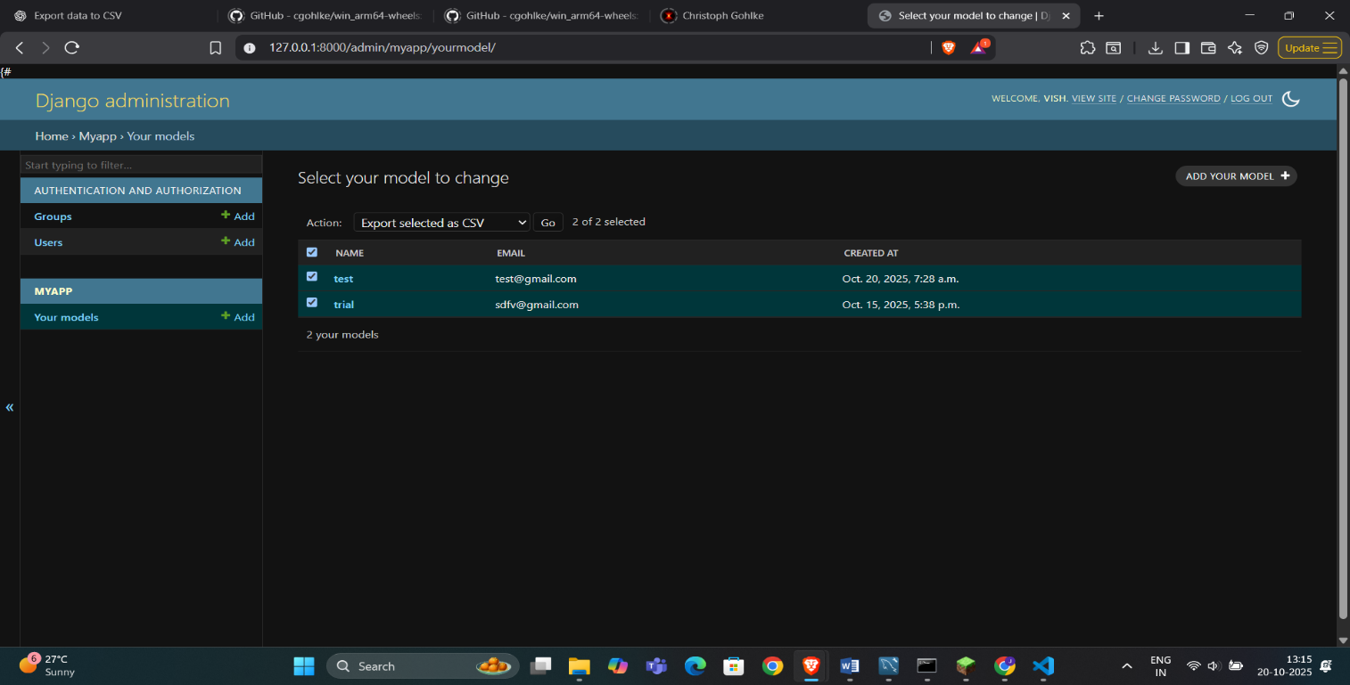

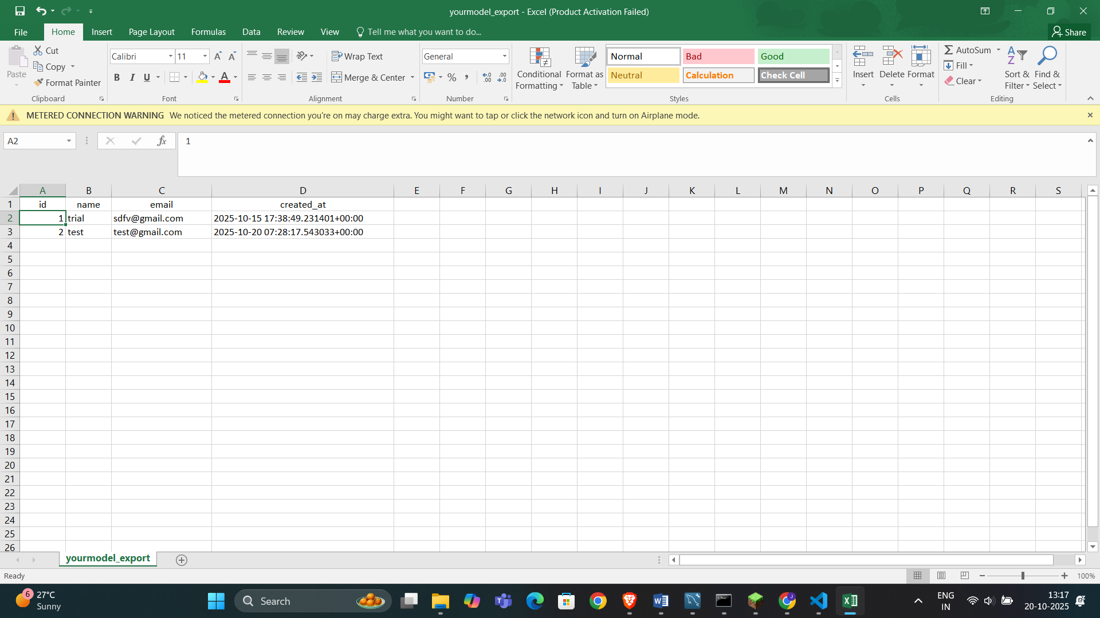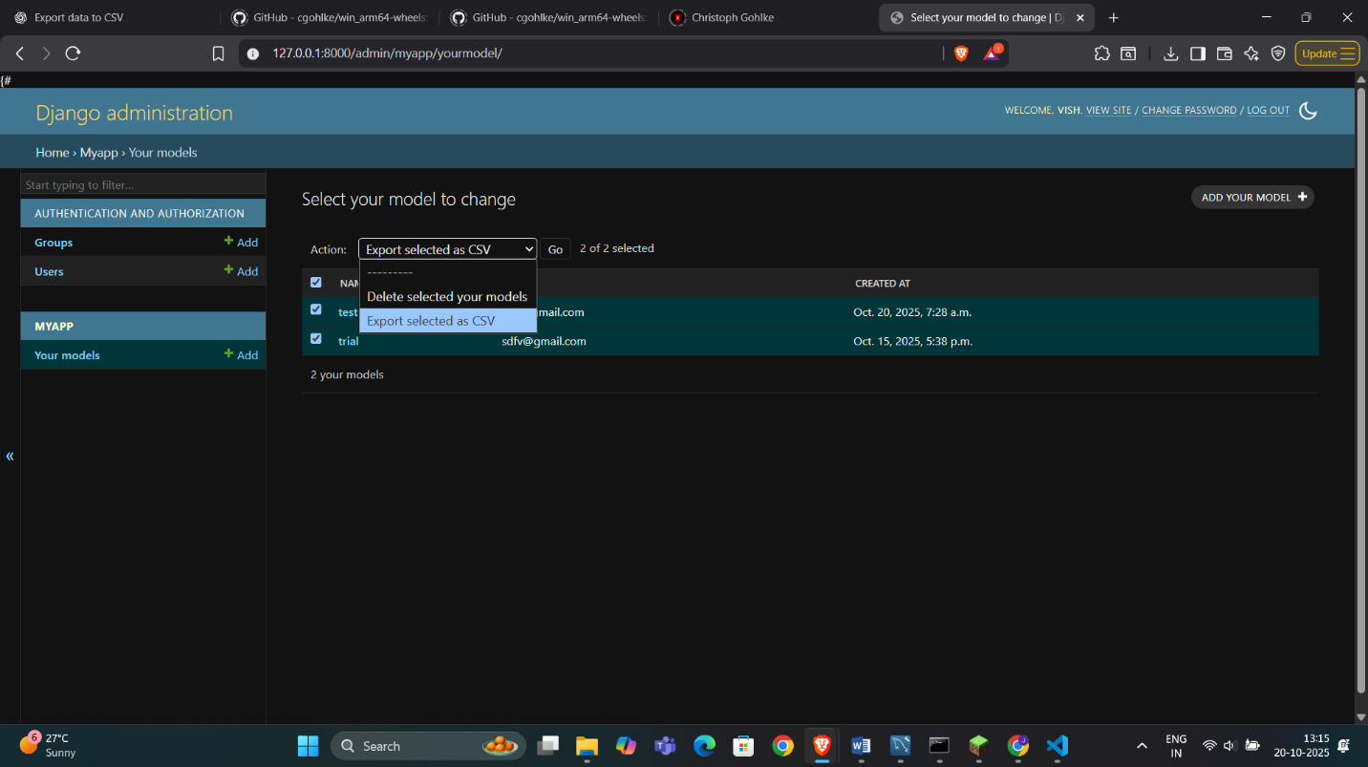

1. **Widget/Algorithm Used In Task**

* Used Django Admin’s ModelAdmin class to manage data records.
* Added custom admin action export_as_csv for exporting selected data.
* Implemented CSV generation using Python’s built-in csv module.
* Used HttpResponse to send CSV file as downloadable output.
* Defined export_csv() function in views.py for exporting all data.
* Retrieved data using YourModel.objects.all().
* Wrote headers and data rows dynamically from model fields.
* Used Content-Disposition header to prompt file download.
* Displayed fields in admin list view using list_display attribute.
* Model includes name, email, created_at fields with auto timestamp.