**Task-4: SQL**

1. **Task Description**

Build a Python program that connects to a MySQL database and updates data in a table using SQL queries. The program should allow users to modify existing records efficiently and verify the changes. It must include proper input validation and error handling to ensure safe and reliable database operations.

1. 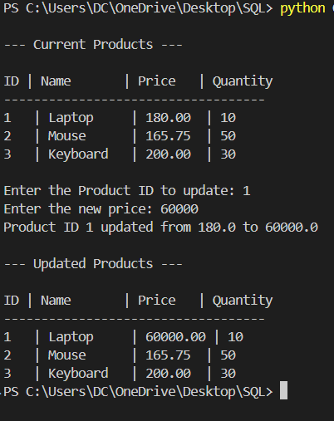**Task Output Screenshot**
2. **Widget/Algorithm Used In Task**

* Used mysql.connector library to connect Python with MySQL.
* Defined a database connection function (create_connection) using configuration parameters.
* Implemented SQL SELECT and UPDATE queries to read and modify data.
* Used cursor() for executing database commands.
* Applied error handling (try-except) to manage connection or query failures.
* Added commit() to save updated data permanently in the database.
* Used fetchone() and fetchall() to retrieve query results.
* Included input validation using try-except for numeric user input.
* Implemented conditional logic to check product existence and avoid redundant updates.
* Displayed data in formatted tabular output for user readability.