**Task-5: Quiz App**

1. **Task Description**

Build Quiz app in Django which have dynamic no. of options, e.g. few questions have 2 options, few may have 6 options, and must return the no. of right and wrong answers.

1. **Task Output Screenshot**

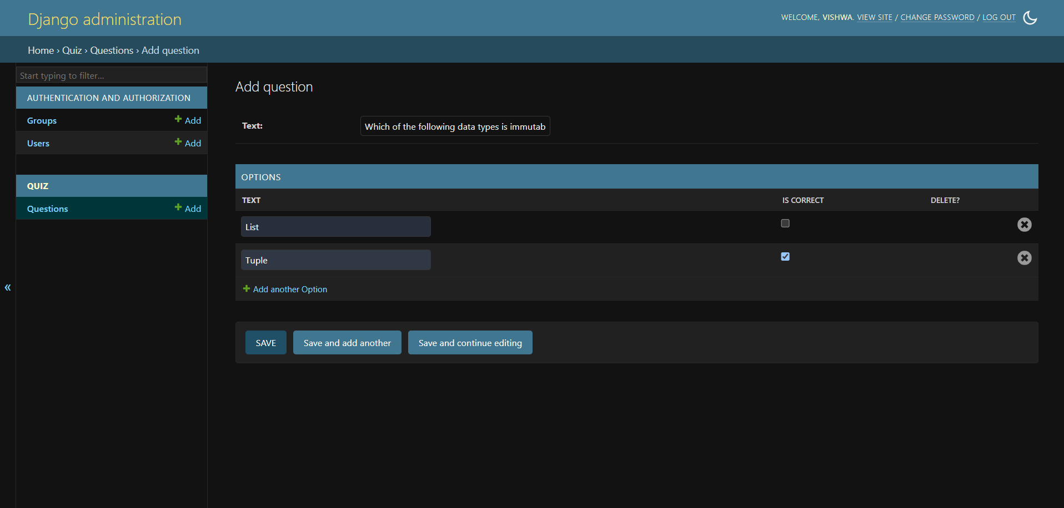

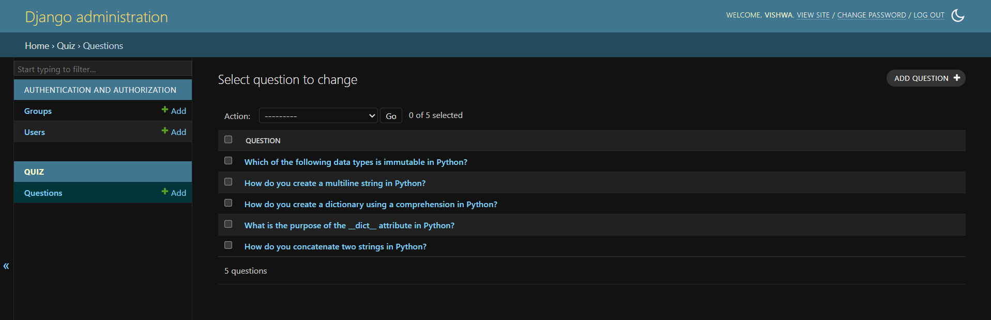

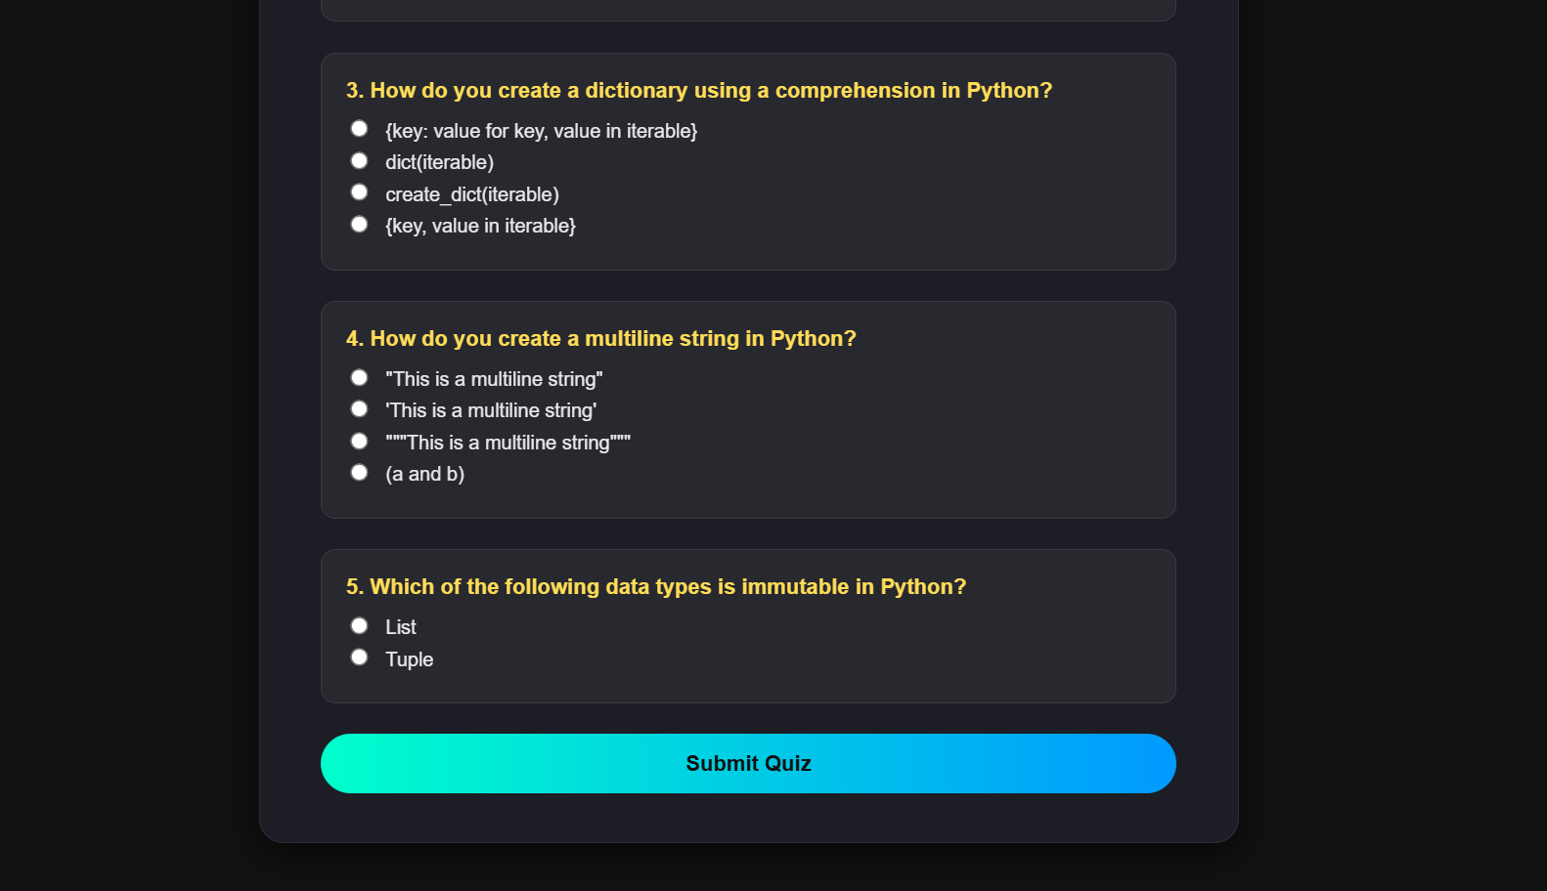

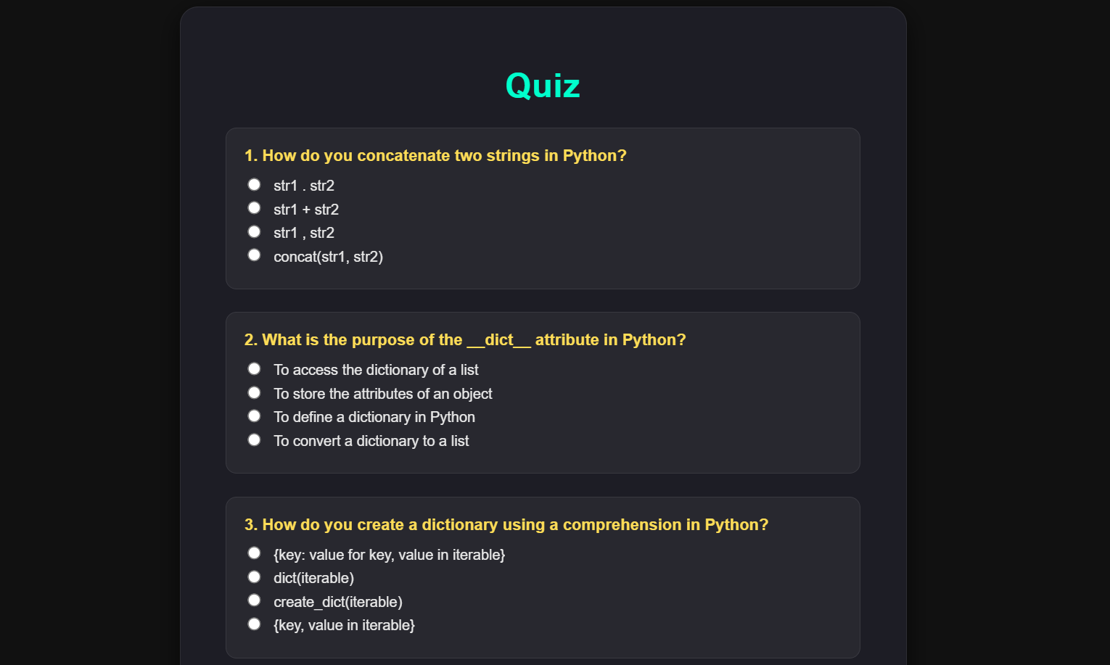

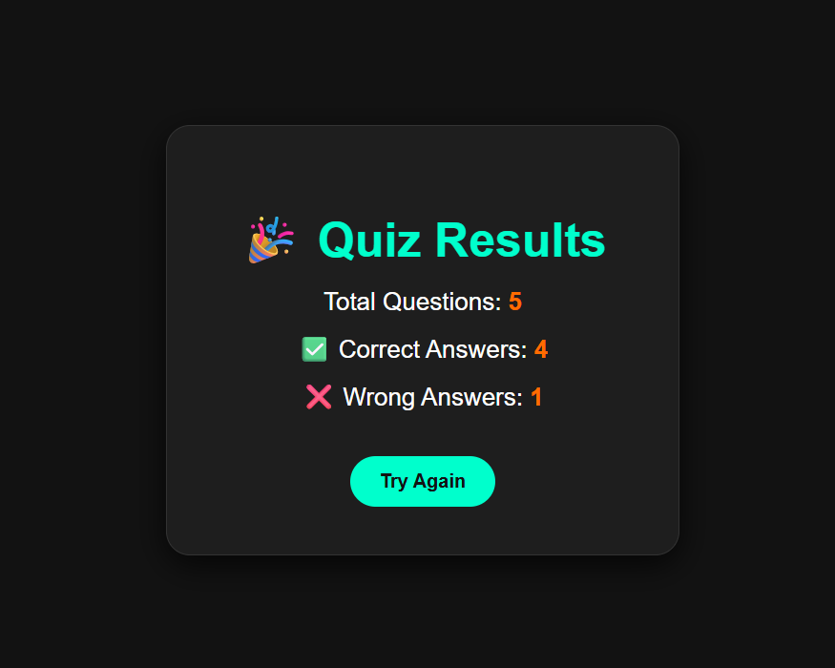

1. **Widget/Algorithm Used In Task**

* Used Google YouTube Data API v3 to fetch video data programmatically.
* Utilized googleapiclient.discovery.build to create a YouTube API client.
* Implemented API request with youtube.search().list() specifying q (query), part, type, and maxResults.
* Extracted video information (title and video ID) from the API response JSON.
* Constructed dynamic YouTube URLs using retrieved video IDs.
* Used Python dictionary and list structures to store and return video data.
* Handled environment variables with dotenv to securely load the YouTube API key.
* Provided a reusable function (get_youtube_links) to fetch results for any search term.