**DBMS - UE20CS301 Lab**

**Lab 10**

**Name**: Vishwa Mehul Mehta

**Sec**: F

**SRN**: PES2UG20CS389

1. Before populating table:

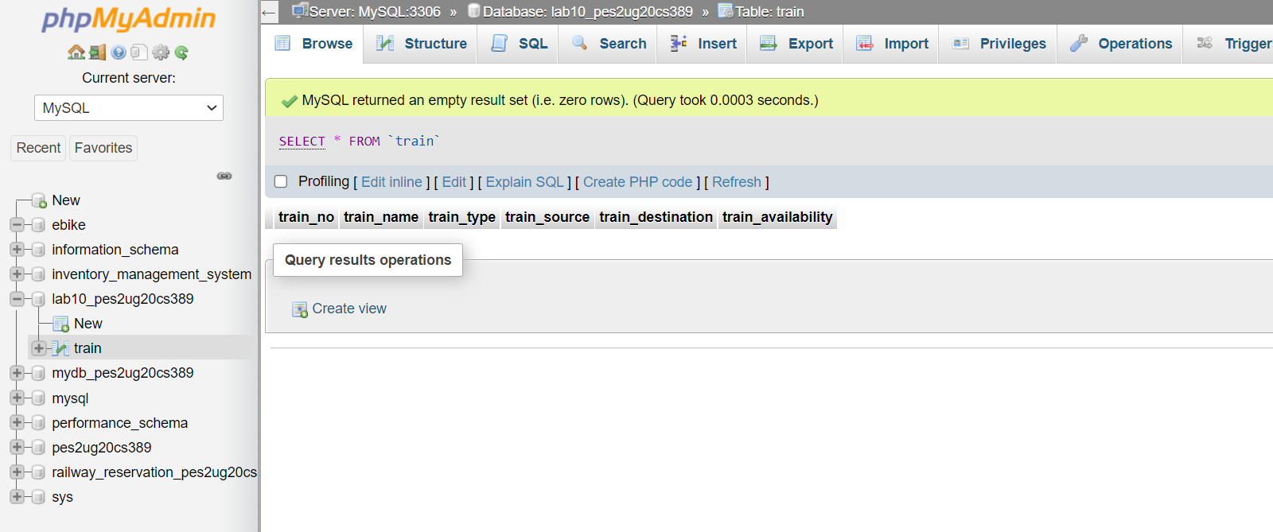

2. Screenshot of the User Interface:

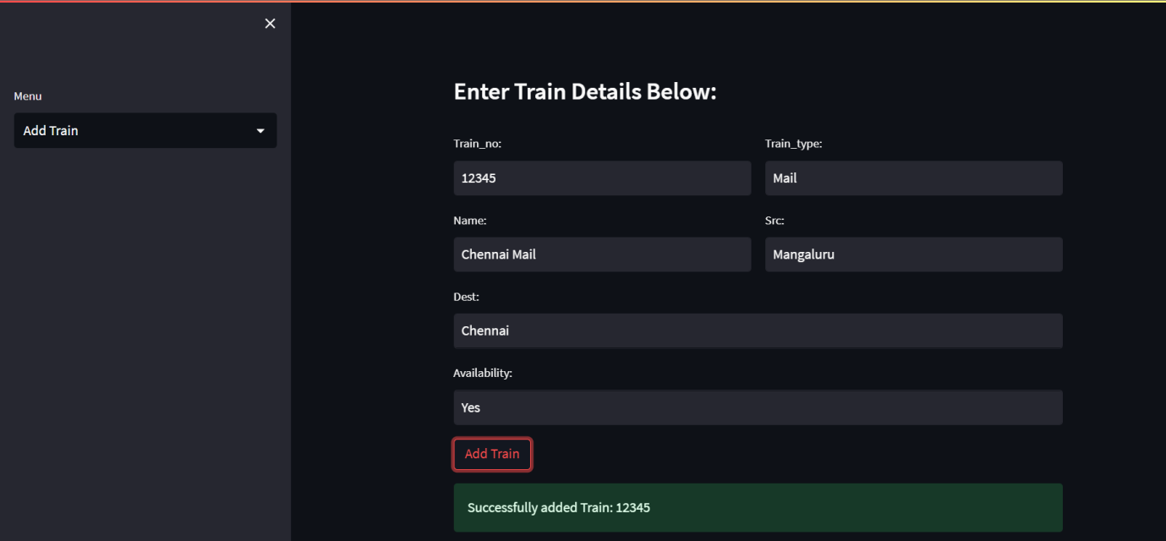

3. Screenshot of the 3 records in the train table from MySQL WorkBench:

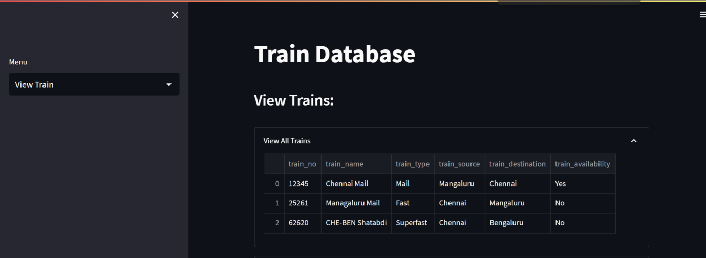

4. Screenshot of the same 3 records visualised in the User Interface:

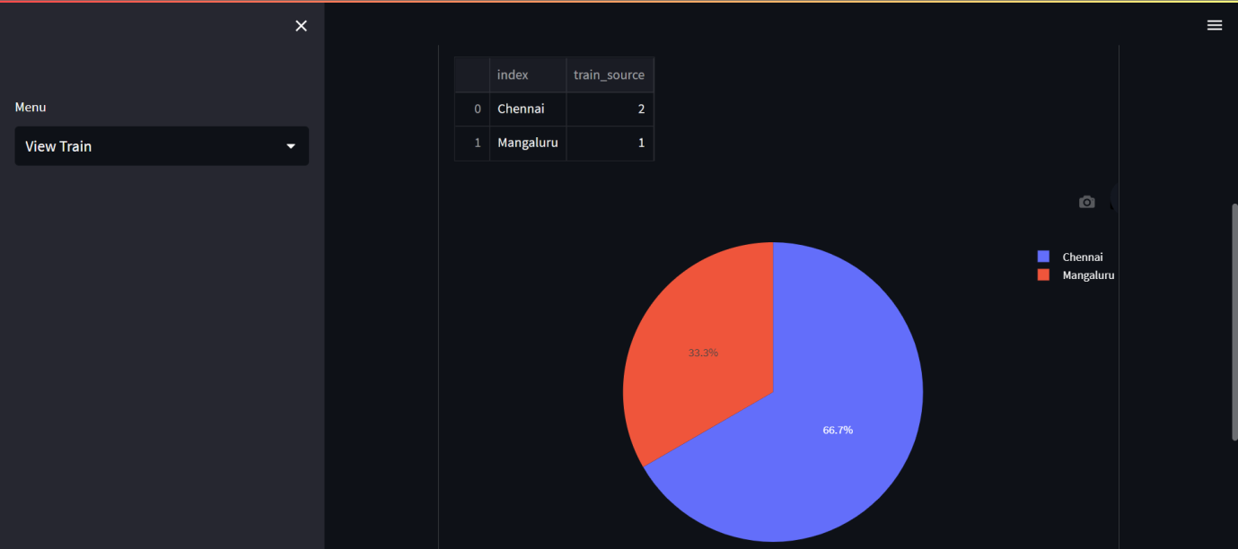

5. Screenshot of Updated Train_No 62620 in the User-Interface:

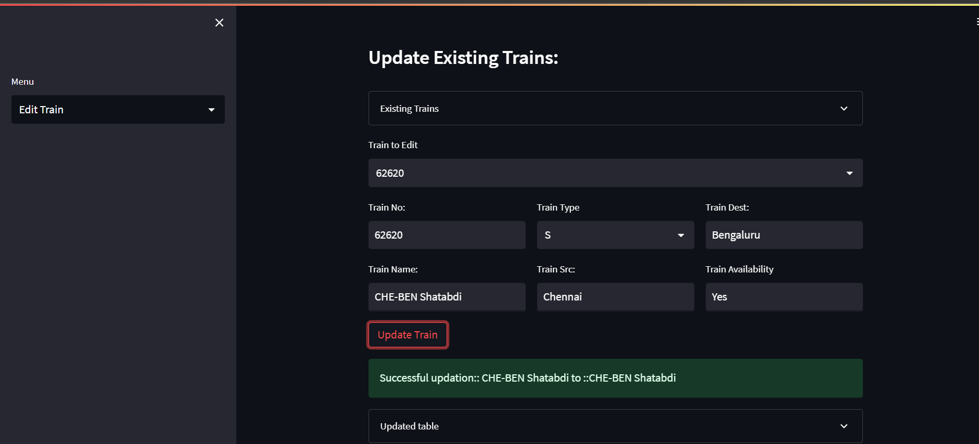

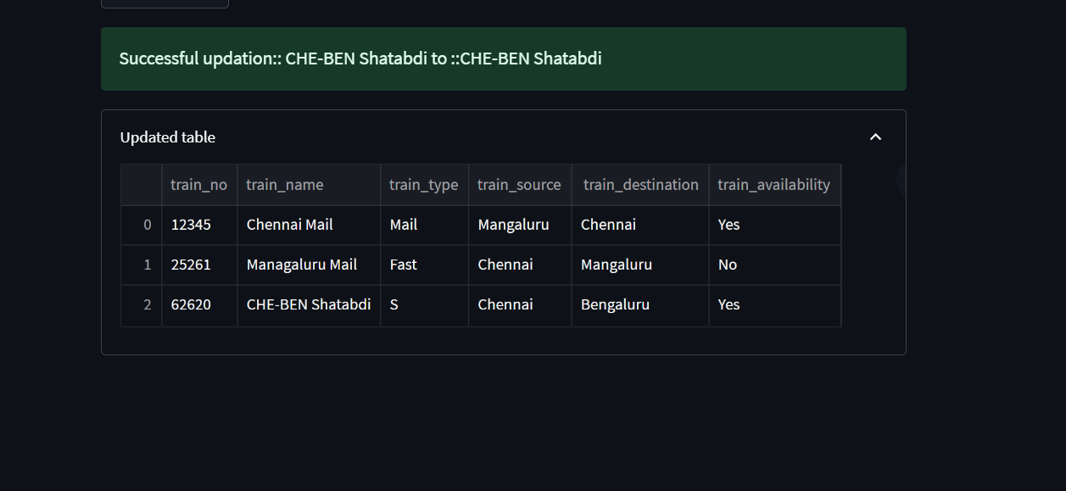

6. Screenshot of User-Interface after the Train_No 25261 has been deleted:

