**DBMS - UE20CS301 Lab**

**Lab 3**

**Name**: Vishwa Mehul Mehta

**Sec**: F

**SRN**: PES2UG20CS389

1. Create Tables:

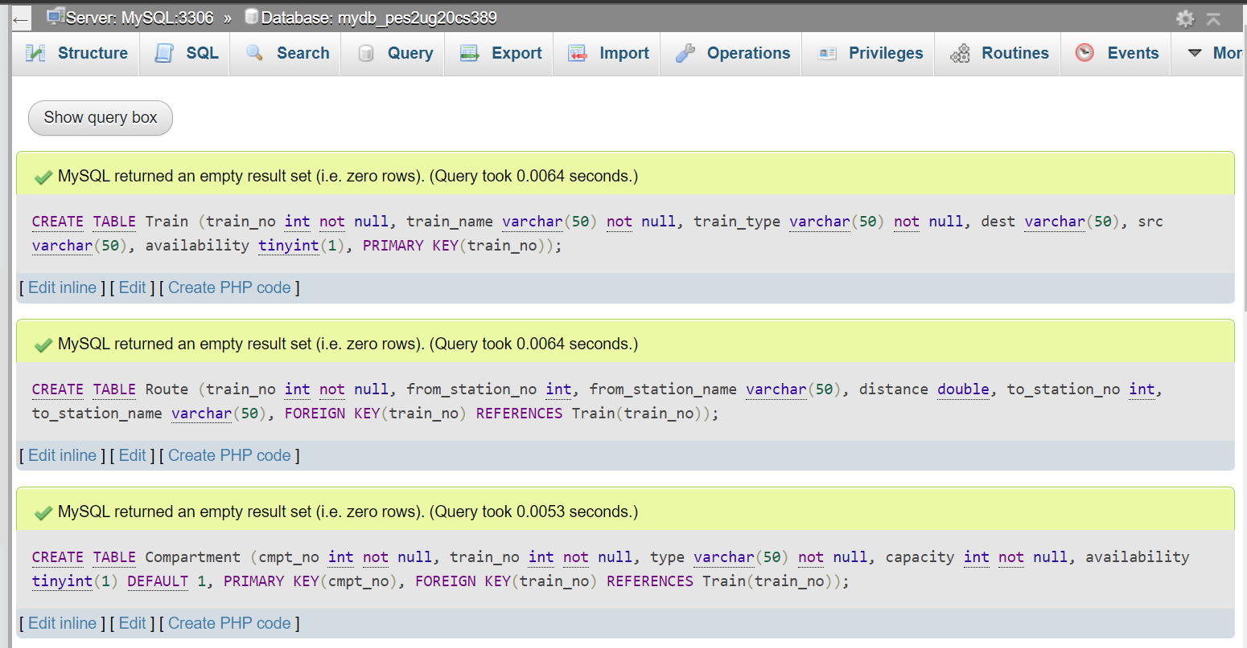

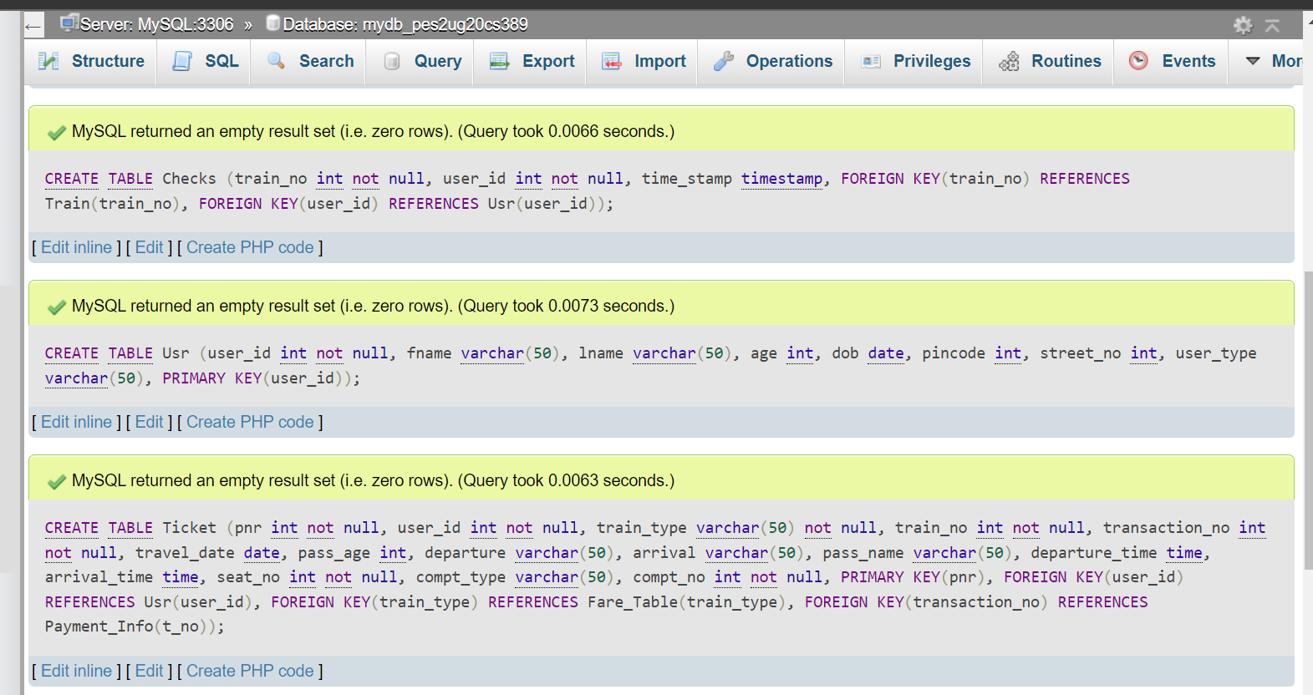

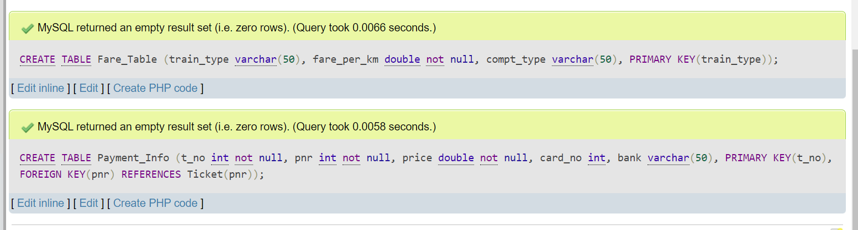

2. Alter Table:

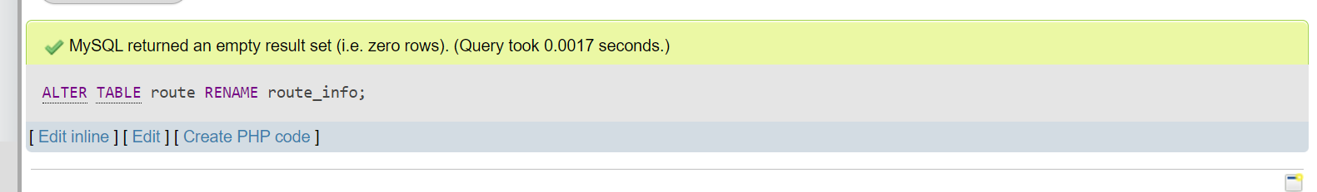

3. Creating View:

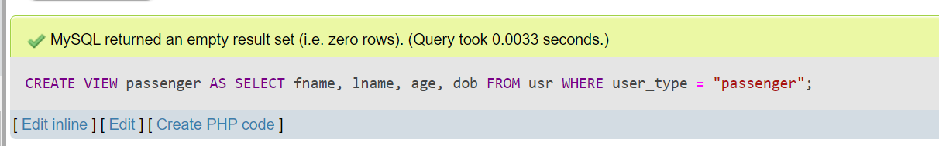

4. Truncate Table:

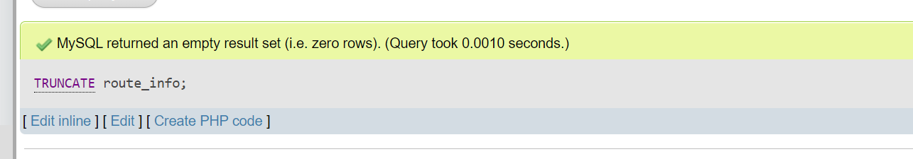

5. Drop Table:

