**DBMS - UE20CS301 Lab**

**Lab 4**

**Results**

**Name**: Vishwa Mehul Mehta

**Sec**: F

**SRN**: PES2UG20CS389

**Task 1:-**

1. Insert the shared data into the respective tables using appropriate insert query. • Show the usage of INSERT and LOAD DATA INFILE commands explicitly

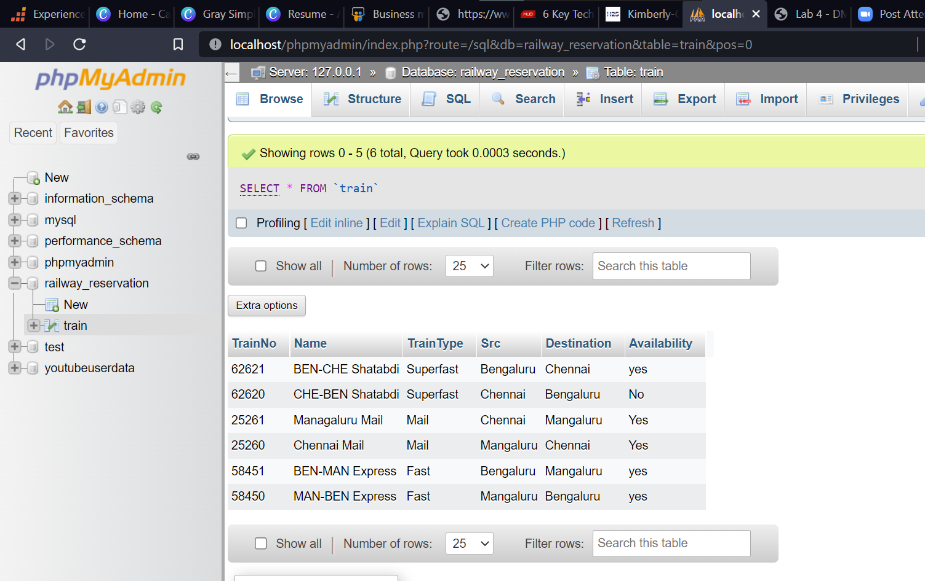

2. Calculate and update age attribute in User Table.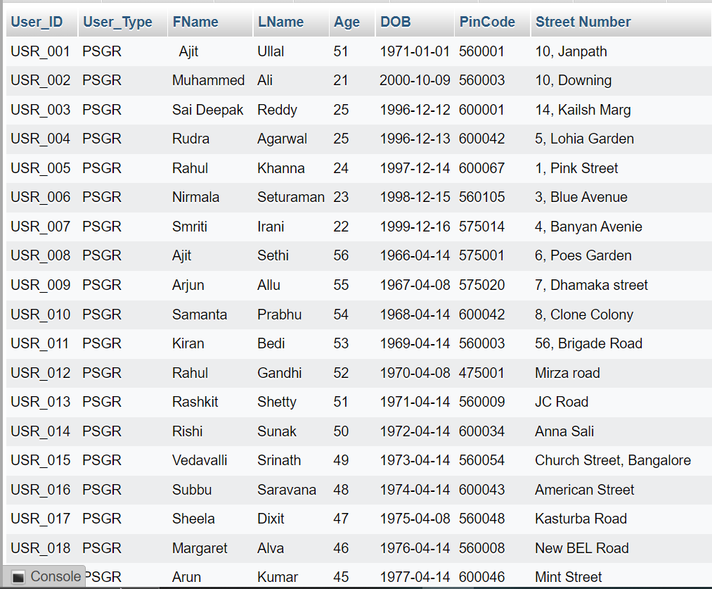

3. Display all the route information whose distance falls in a range from 70 to 150 km.

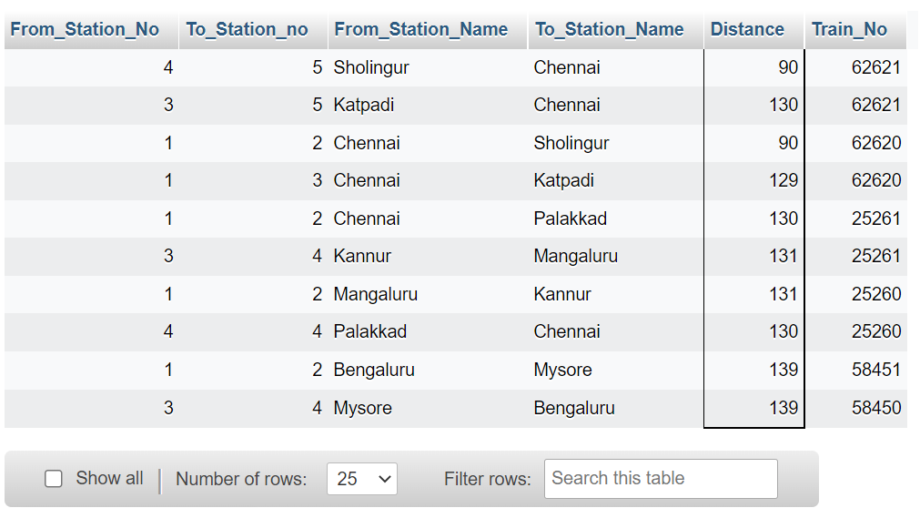

4. Display the train route information which are run between Chennai and Sholingur.

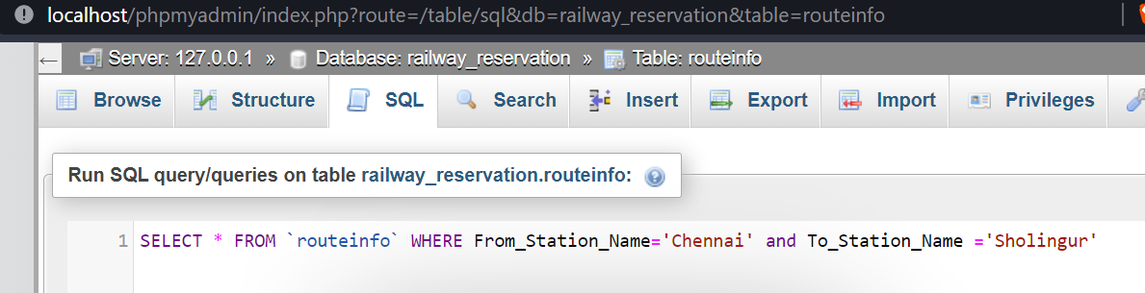

5. Display the train details whose type is not mail.

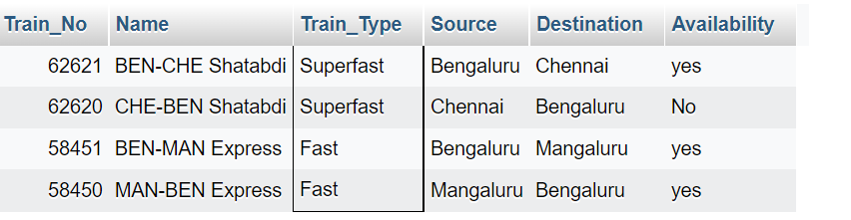

6. Display the train name which goes to Chennai from Bangalore.

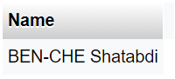

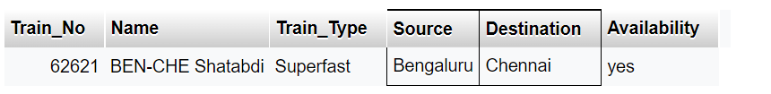

7. Display the list of trains starting from Chennai after 8:00.

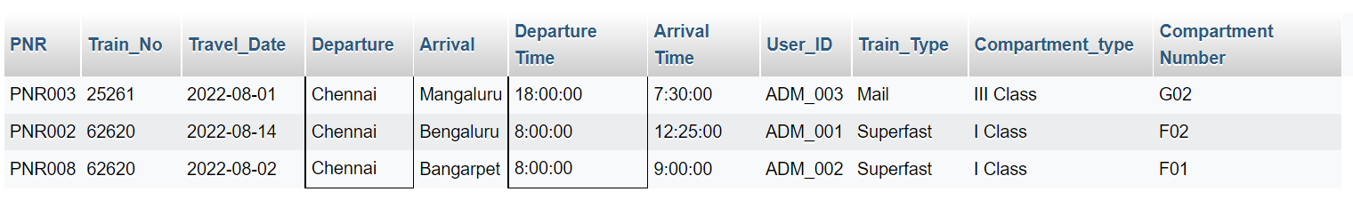

8. Display the list of users who are born between 1980 to 1990.

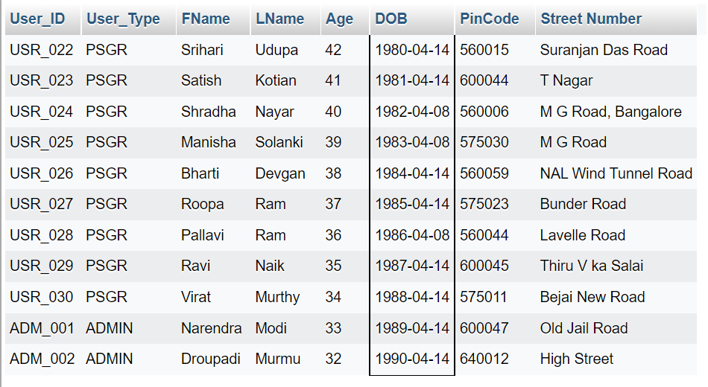

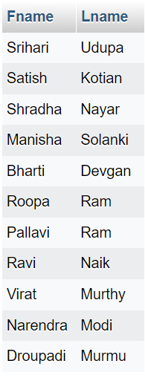

9. Display the train users whose name starts with the letter ‘S’

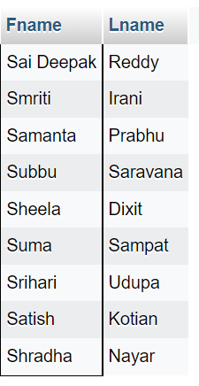

10. Find the availability of I Class compartment of the train number 62621

11. Find the PNR and Transaction ID of the users who made payment via Union Bank.

