**DBMS - UE20CS301 Lab**

**Lab 4**

**Results**

**Name**: Vishwa Mehul Mehta

**Sec**: F

**SRN**: PES2UG20CS389

**Task 2:-**

1. Grant privileges on different tables to users and observe the effect

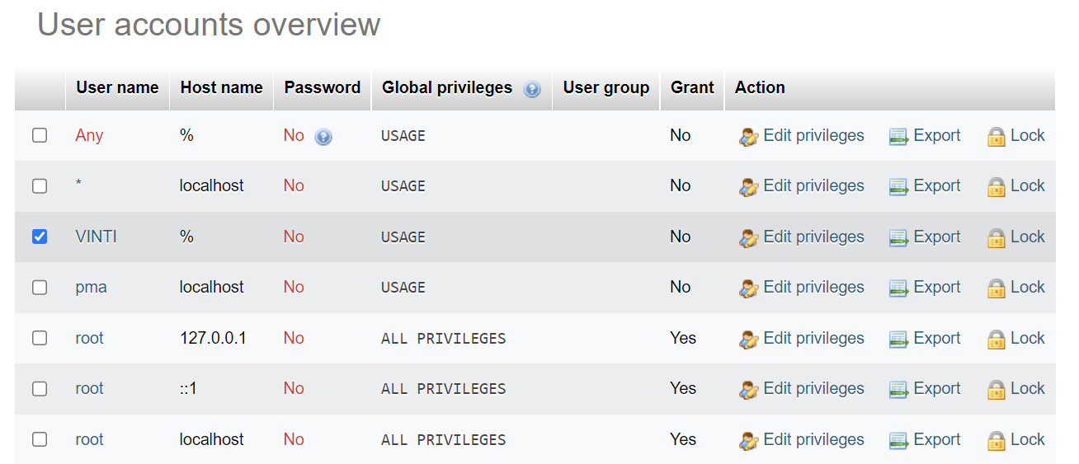

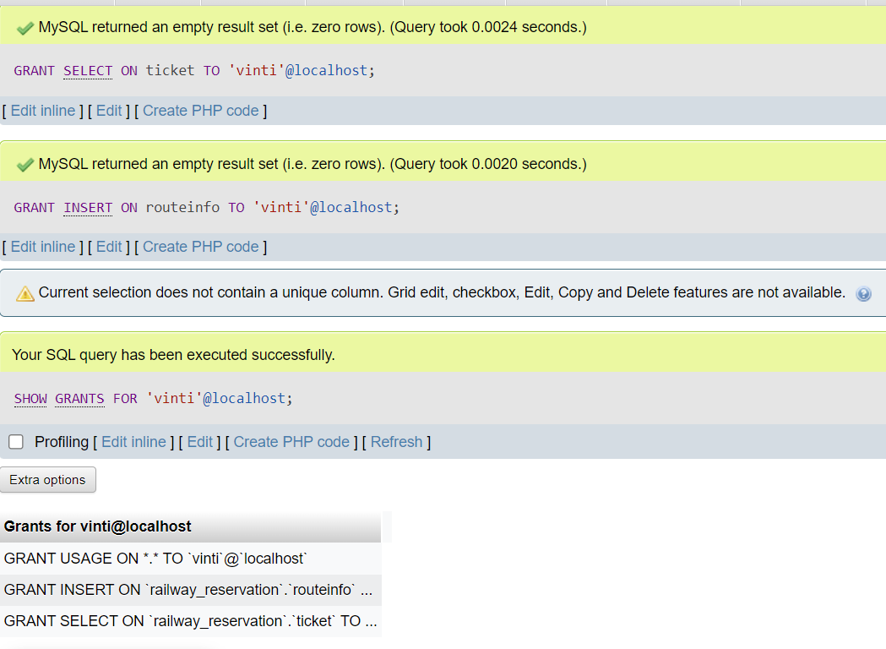

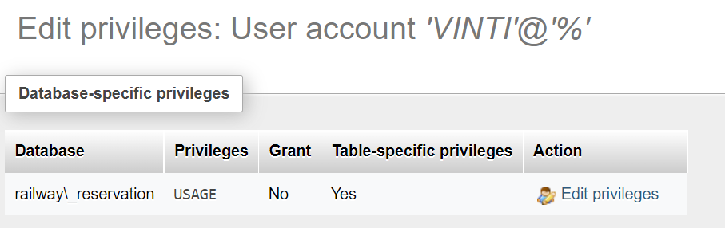

2. Revoke UPDATE & DELETE privileges on any tables and observe the effect if any deletion/updation is performed.

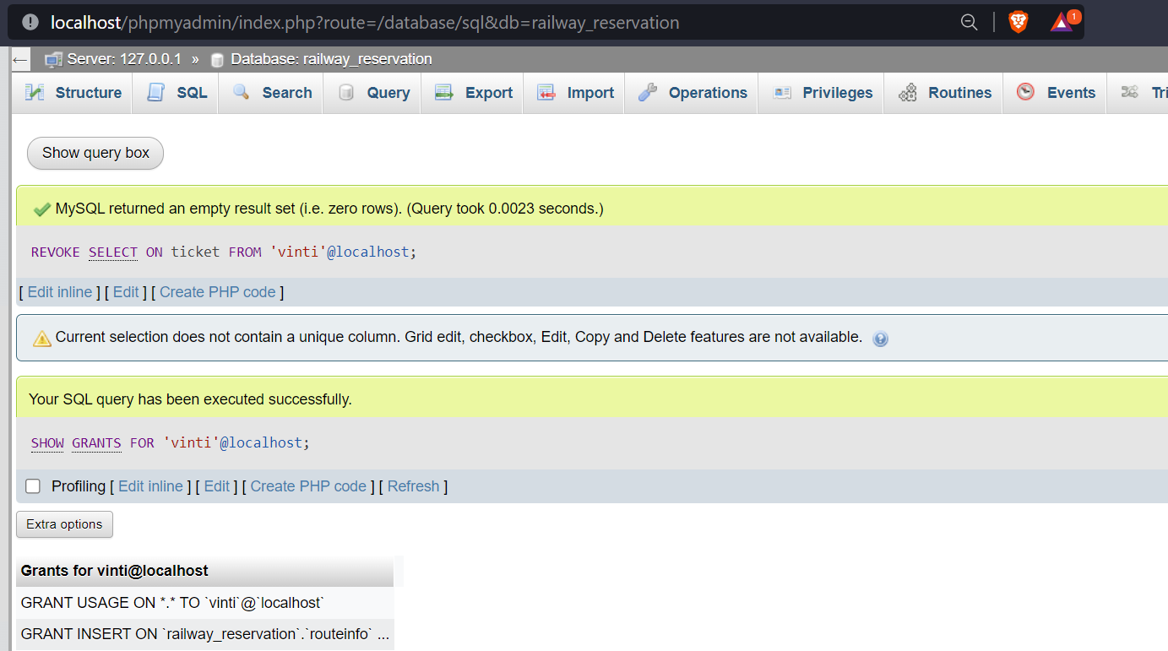

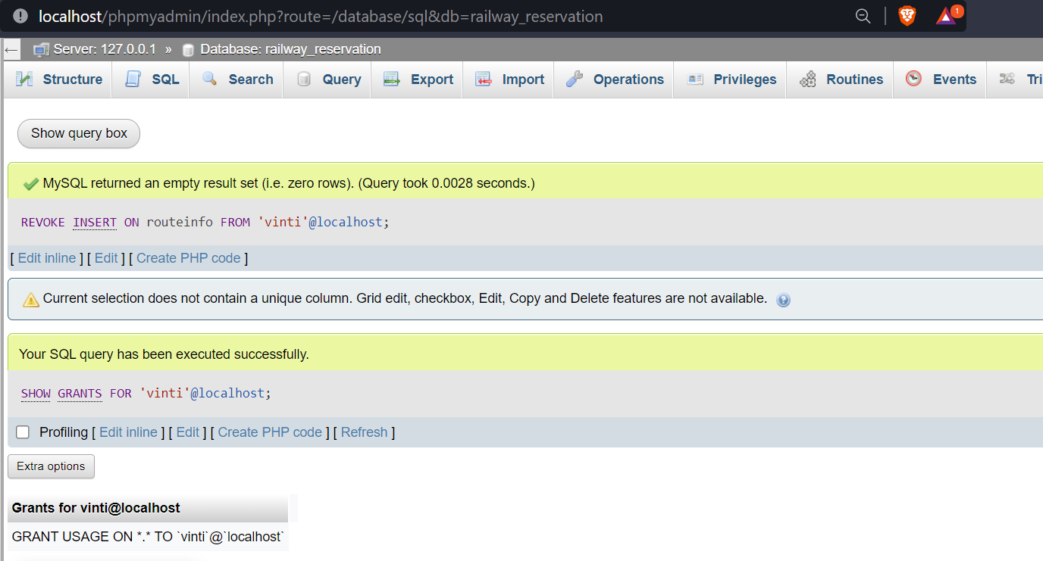

3. Create different save points and perform some insert/update/delete operations. Observe the effect of commit & rollback operations and release any created savepoints.

SavePoint:

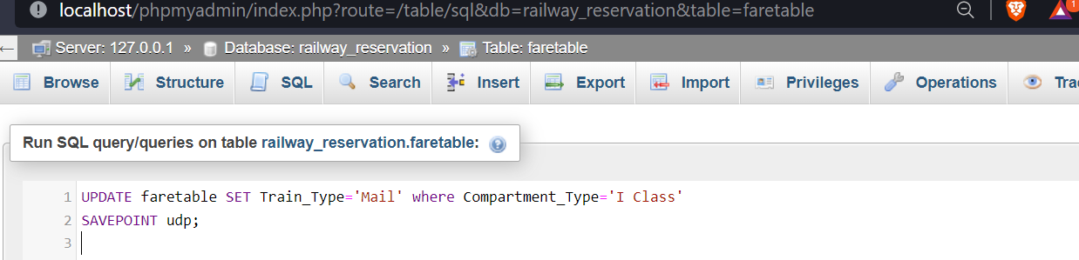

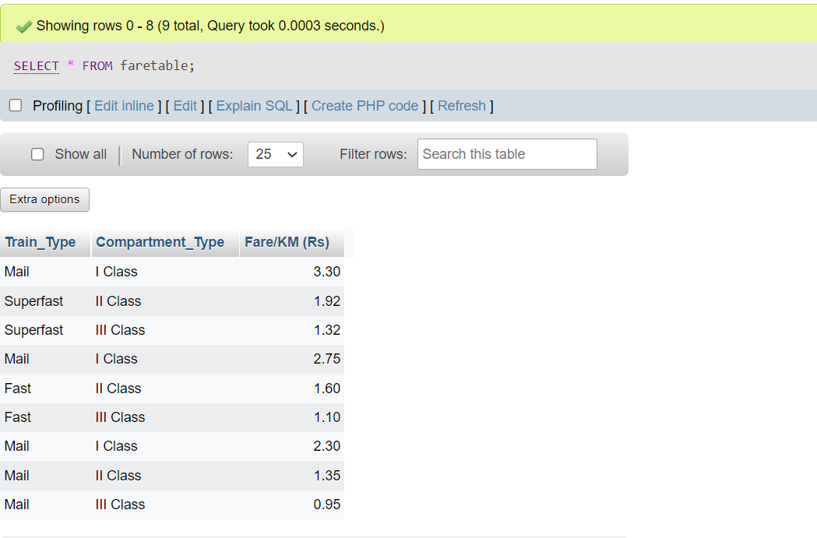

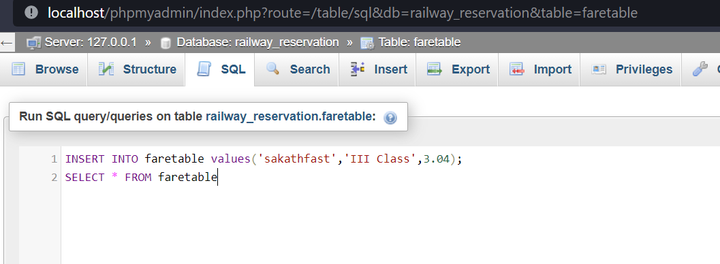

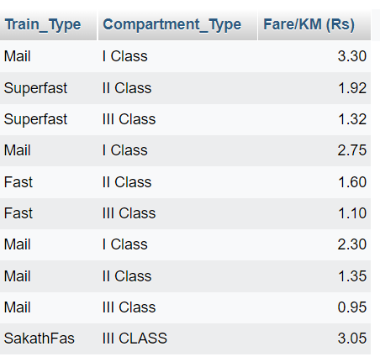

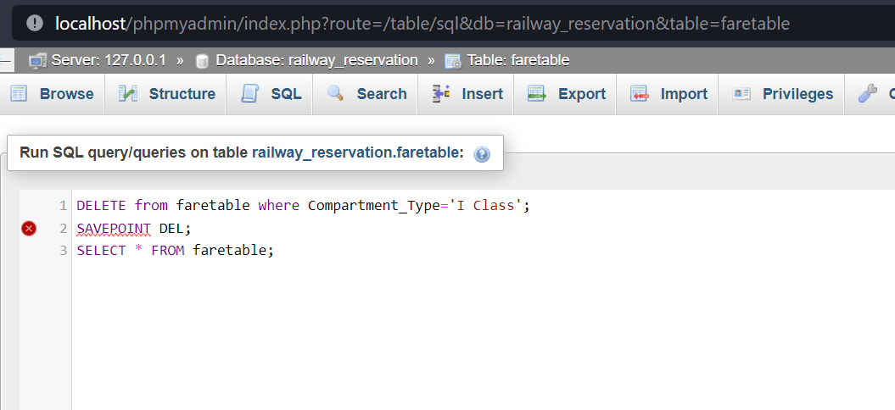

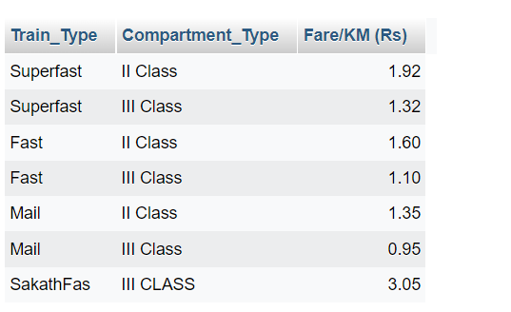

Rollback:

