**DBMS - UE20CS301 Lab**

**Lab 7**

**Name**: Vishwa Mehul Mehta

**Sec**: F

**SRN**: PES2UG20CS389

1.

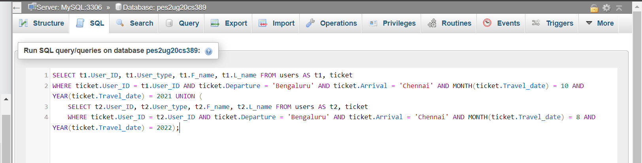

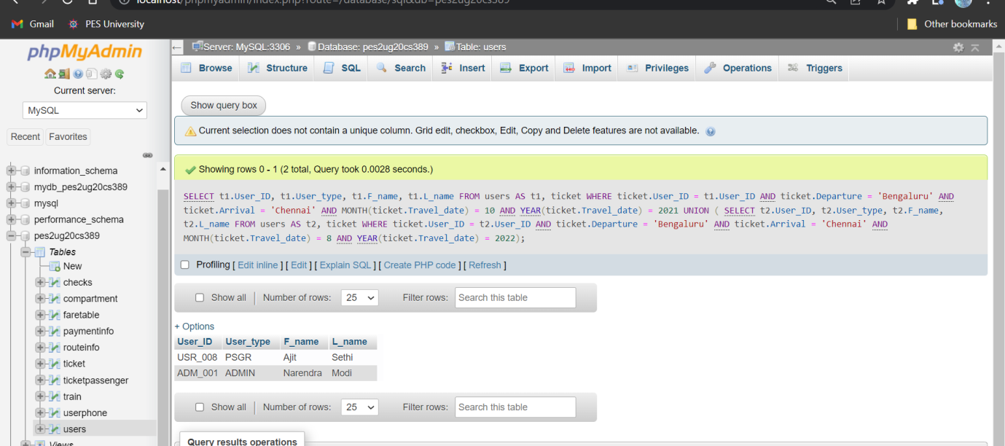

2.

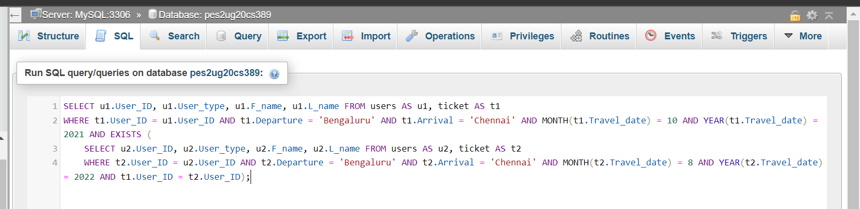

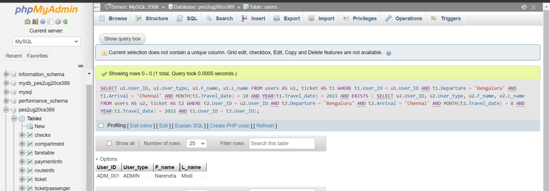

3.

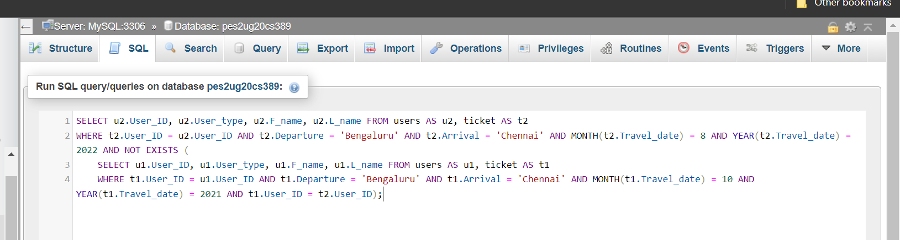

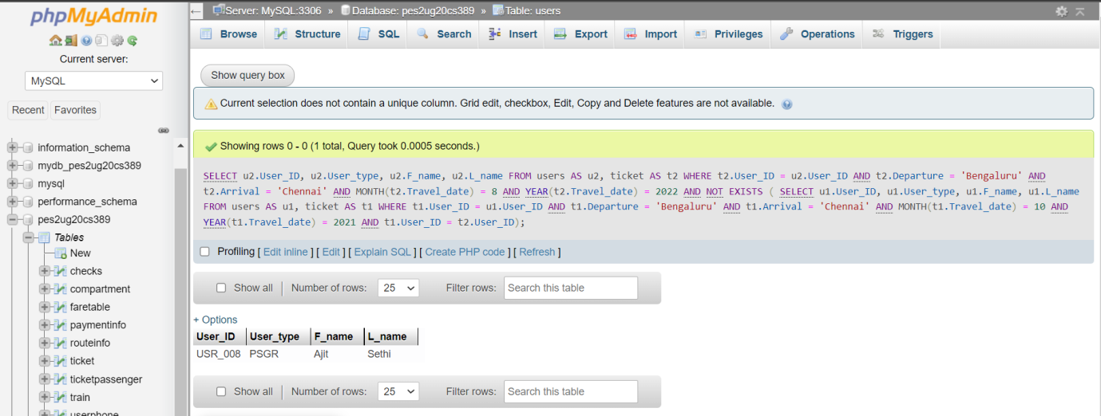

4.

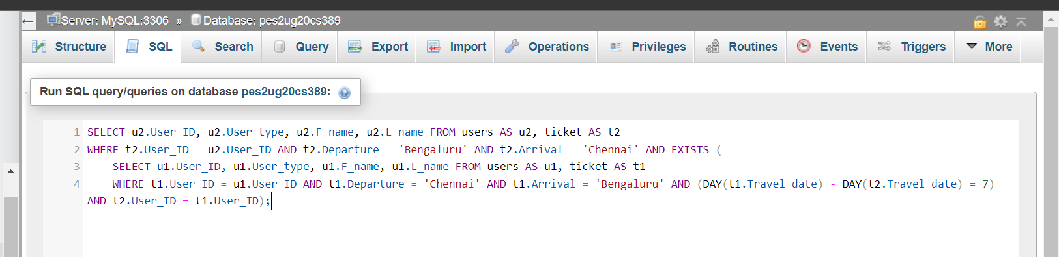

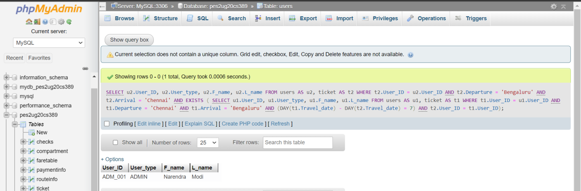

5.

